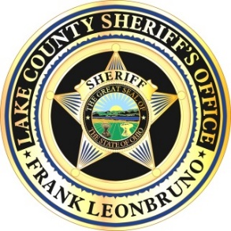
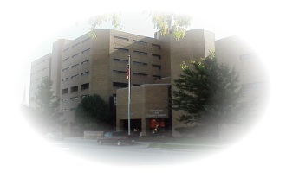
Lake County Sheriff’s Office
Sheriff Frank Leonbruno
104 East Erie St., Painesville, Ohio 44077 (440) 350-5503

2020 Corrections Division Annual Report
Captain Cynthia Brooks, Jail Administrator, CJM
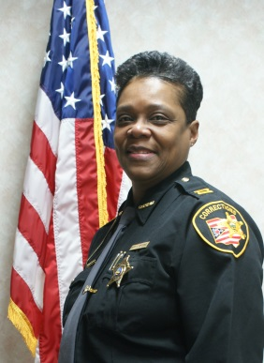 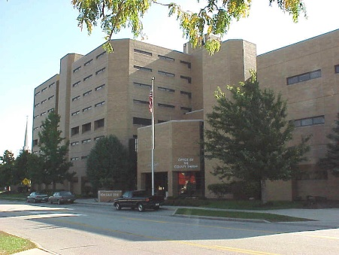

FACILITY OVERVIEW

Lake County Jail History
1859-1990 The first jail in Lake County was built in 1859. Its' design and plans were prepared by Col. Morse. Its' contractor, Harvey Woodworth, built a two-story
brick structure which had 8 cells, 4 on each floor. It was built on the property directly behind the court house that is now the rear parking lot of the court house, just west of the main jail. By 1975 the "old jail" had gone through an extensive renovation project increasing its housing space to accommodate an ever expanding inmate population. However, with the emergence of the Ohio Minimum Jail Standards the jail could not meet the standard without great expense. In 1982 the decision was made to build a new jail.

1990 - Present Once funding was approved the maximum security jail was built where the Kroger's supermarket once stood, just east of the "old jail". In January 1990 the Lake County Adult Detention Facility at 104 East Erie St in Painesville, Ohio opened its doors. The facility opened when it moved its 125 inmates out of the "Old" Jail and transferred them to the new facility. Since 1990 the Lake County inmate population has increased to an average of 350 inmates housed each day. In 2007 nearly 7,000 persons were booked into the detention facility. Lake County is a reflection of the national rate of incarceration. In the last 10 years the jail and prison population has doubled to its current housing of 2.3 million inmates in Federal, State and Local jails.

The Lake County Adult Detention Facility processed 3,799 inmates into the jail in 2020 compared to 4,350 inmates in 2019, 551 less inmates were processed in 2020. The decrease in inmates in 2020 is due to the decrease in jail population due to the pandemic of COVID-19. In March of 2020 the Judges of Lake County worked with the Lake County Adult Detention Facility to assist with the decrease of inmates. The Judges ceased in granting work release, furloughs and Transitional Day Reporting. In this manner inmates were not coming in and out of the jail with the threat to catch and pass COVID-19 on to other inmates and staff.

In 1993, 37% of the jail’s population was comprised of inmates from outside the Lake County courts, otherwise known as rented bed space. (1993 we averaged 120 billable inmates per day). In 2020 less than 0.9 % of the jail’s population was from rented bed space to outside agencies (0.9% of the 297 inmates per day). It also needs to be noted that the average jail population reached a monthly average of 348 inmates per day in 2020 compared to 362 in 2019 a total of 14 more inmates in 2019.

The dramatic increase of inmates incarcerated under the Lake County court system over the past 11 years has greatly impacted the availability of jail beds. The average daily population of inmates being housed on Lake County charges (i.e. not being housed for agencies outside of Lake County) averaged 289 Lake County inmates per day, a decrease of 4 Lake County inmates per day over 2011 that averaged 285 per day. This is a decrease of 29% over 1993 when the jail averaged 206 inmates charged under the Lake County courts.

In 2020 the Lake County Adult Detention Facility managed a daily population average of 297 inmates. (Reference the 2020 Daily Population Averages for overview). Of the 297 inmates housed each day, 227 were males and 70 were females. Our average male population reached its highest average of 258 per day in the year 2020 and 385 was the highest average population of males in 2019. Also, important to note is the fact that the female population has increased 200% above its 30 per day average in the year 1993. In 2020 the highest female population reached 90.

Felony vs Misdemeanor
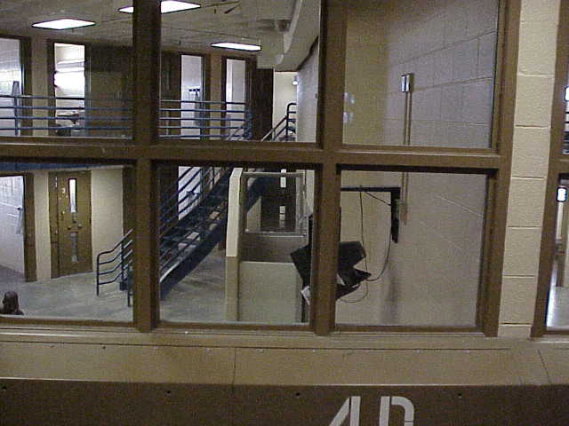
In studying the inmate population, in 2020 the jail system averaged 86 Misdemeanor inmates per day and in 2019 averaged 131 Misdemeanor inmates per day. In 2020, we averaged 211 Felony inmates per day compared to 232 per day in 2019. This is the thirteenth year in a row we have averaged more Felons per day then we did Misdemeanors. The Lake County jail once housed 2/3 misdemeanors, and 1/3 felons. Today, the jail houses 2/3 felons versus 1/3 misdemeanor inmates.

Billable Inmates

In 2020 we averaged 3 US Marshal Prisoners per day, and in 2019 we also averaged 2 US Marshal Prisoners per day (inmates charged under the Federal courts), as well as 0 Out-Of-County per day in 2020. These “billable” agencies reimbursed the County $66.54 for each day they had a prisoner incarcerated in the Lake County jail. The “billable population” returned $63,933.40 to the General Fund of Lake County in 2019. Due to the rising jail population we cannot house as many billable inmates as we normally would.
▸ Since 1993 over $40 million dollars has been generated and returned to the General Fund through rented jail bed space

Inmate Phone System

The inmate phone system GTL allows family members and friends of inmates the opportunity to set up a prepaid calling account using a credit card, check, money order or Western Union. The inmate phone system is turned on in the jail for use at 8:00 a.m. to 10:45p.m. so that inmates can call family, friends, clergy and attorneys. In 2020 the inmate phone system generated $372,032.81 that was returned to the general fund and in 2019 the inmate phone system generated $321,835.79 that was returned to the general fund. A difference of $50,197.02 more revenue was generated back to the general fund in 2020.

Inmate Video Visitation

In 2019 GTL installed Inmate Video Visitation Tablets in each housing unit throughout the jail. The tablets allow for a two-way visual non-obscured communication between the inmate and visitors. An account has to be created by the inmate’s family or friend with monies to secure the account so that the visitor can visit with the inmate from home, a computer, cell phone or any type of electronic communication device. If the inmate or the visitor abuse the system with any type of pornographic views the inmates account will be suspended for a specified amount of time determined by the Jail Administrator.

Pay-For-Stay Program

Court ordered inmates participate in The Pay-For-Stay Program on work release in order to return part of their pay to the jail to off-set their housing costs. In 2019 the Pay-For-Stay program collected a total pay in of $31,677.95 with 70 inmates participating in the pay-for-stay program. In 2020 the Pay-For-Stay program collected a total pay in of $4704.19 with 13 inmates participating in the pay-for-stay program.

Transitional Day Reporting

In 2019, 76 inmates were ordered to serve in the Transitional Day Reporting (TDR) program in an effort to reenter back into society. In 2020, 2 inmates participated in TDR due to COVID -19 the program has ceased in order to keep staff and inmates safe and healthy.
Inmate Food Service
The jail staff is using innovative ideas to control food costs, which is becoming increasingly difficult given the fact that rising fuel prices are significantly increasing the cost of food at every level of society. In 2019 the jail served 426,314 meals and in 2020 the jail served 352,605, in 2020 the jail served 73,709 less meals compared to 2019. This is due to the jail population decrease due to the COVID-19 Pandemic. The average cost per meal in 2019 was $1.69 and in 2020 it was $1.93 (this price includes supplies, salaries for kitchen staff) the average cost for the meal itself was $1.22 in 2019 and $1.35 in 2020, a increase of $.13 in 2020. It needs to be noted that this meal cost did not sacrifice quality or healthfulness given the fact that the meals served in the jail are approved by the State Dietician, and inspected by the Health Department on a monthly basis. The inmates receive between 2200 and 2800 calories per day.

Dispensary Operations
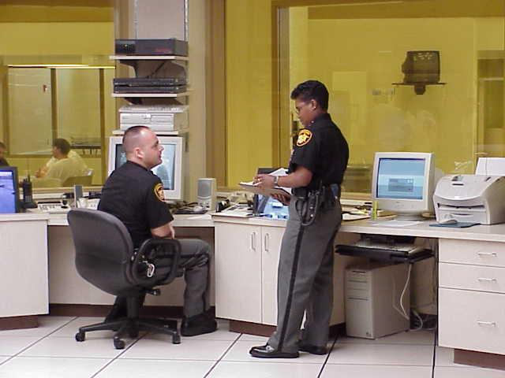
In 2020 the Dispensary of the jail examined over 5784 inmates that were seen by the doctor and nurses in the jail dispensary compared to 7479 in 2019 which is 1,695 less inmates. This is an average of 623 inmates seen per month. Besides the daily medical problems that normally exist (colds, flu, etc) the medical staff treated health conditions such as: numerous pregnant females at one time, pregnant females that are addicted to heroin, daily maintenance of numerous diabetic inmates (8-10) requiring daily insulin injections, treatment of inmates with HIV and/or AIDS, gunshot wounds received prior to incarceration, heart problems, an aging inmate population, and dental treatment. The medical staff has seen an enormous spike in inmates that are withdrawing from benzodiazepine, heroin, and alcohol. Jail Physician Dr. Karim Razmjouei, and medical programming coordinator Kristina Morse- RN, as well as Erin Boyle-RN, Patty Hammers- RN, Sabrina Watson- RN, Deedra, Basree- LPN and Vicki Kary-LPN work together to insure the best possible medical treatment to the inmate population that did not have a very good history of medical maintenance and care prior to their incarceration. They made such achievements through the best possible cost containment measures available to them without reducing the necessary quality of care that helped this facility achieve State certification. (Reference the 2020 Medical Services Report for overview)

Medical Services
The cost of medical services in 2020 was $993,771.91 and in 2019 the cost for medical services was $954,055.82. Note, that these costs include the salaries of the nurses, physician and dentist. This is a constant reminder of the increasing cost of medical programming in the coming years. Pressing issues in 2020 include responding to growing demands by the judiciary to provide 24-hour medical care by licensed doctors and nursing staff, as well as the continual plague of frivolous jail litigation by inmates. The Medical Staff continues to work diligently to reduce the costs of medical services. The pharmacy cost incurred by the jail was $302,104.23 in 2020. However, it needs to be noted that the jail psychotropic drugs cost was $155,600.22. The jail received reimbursements for psychotropic drugs in the amounts of $50,288.28 in March of 2019, $49,888.00 for December 2019, $71,515.34 February of 2020, 70, 571.60 and for August of 2020.

Dental Services

Dental Services are provided to the inmates every other week for four hours on Fridays. A basic dental assessment is conducted to determine any immediate intervention needed for relief of pain and\or infection. With prior consent from the inmate, dental x-rays are taken and the condition of teeth and recommendations for improvement are discussed, along with extraction of teeth if as determined by the Dentist. In 2020, 73 inmates were seen by the Dentist due to COVID-19 and 2019, 144 inmates were seen by the Dentist.

Juvenile Medical Care

The Lake County Sheriff’s Office Nursing staff assumed medical care of the Residents at the Lake County Juvenile Detention Center on March 11, 2019. Our mission is to supply experienced professional care in a courteous, compassionate, and timely manner as is offered at the Lake County Adult Detention Facility. Residents admitted to the Juvenile Detention Center for three days or longer are seen by Nursing for a baseline medical assessment. The attending Physician will see them for a physical exam and\or any medical concerns when she conducts sick call one day a week. Nursing staff conducts sick call seven days a week to assess any Resident needs when the Physician is not available. One Registered Nurse is responsible for ordering medical supplies and is on call seven days a week twenty-four hours a day, as is the attending Physician, for any emergencies. A total of 178 juveniles were seen by the Juvenile Physician and 691 were seen by the Nursing staff from the Lake County Adult Detention Facility. (Reference the 2020 Medical Services Report for overview)

Mental Health Services

Unfortunately, the Correctional Facilities throughout the USA continue to witness a dramatic increase in the mental health needs of the expanded inmate population. The Mental Health professionals received 2,140 referrals in 2019 and 1903 referrals in 2020. There was a decrease of 237 referrals in 2020. These referrals often come from inmates themselves but can also come from corrections staff and other entities outside of the jail. The majority of referrals came from inmate requests and corrections staff. Referrals are made for a number of reasons, primarily requests to see and talk with the mental health consultant and to obtain medication.
The psychiatric prescriber met with 490 inmates a total of 713 different times to evaluate and potentially prescribe psychotropic medications, which was an increase of 210 visits compared to 2019. There were four individuals referred for emergency admission to a medical /psychiatric facility. There was a total of 514 people on the caseload of the mental health consultants during 2020, which was an increase of approximately one percent from 2019. The internship positions screened 585 people from September through December. The case manager followed through with 224 people from throughout the year, minus three minus when she was providing services in the community.
According to National Alliance on Mental Health (NAMI) “In a mental health crisis, people are more likely to encounter police than get medical help. As a result, 2 million people with mental illness are booked into jails each year. Nearly 15% of men and 30% of women booked into jails have a serious mental health condition.

The vast majority of the individuals are not violent criminals—most people in jails are have not yet gone to trial, so they are not yet convicted of a crime. The rest are serving short sentences for minor crimes.
Once in jail, many individuals don't receive the treatment they need and end up getting worse, not better. They stay longer than their counterparts without mental illness. They are at risk of victimization and often their mental health conditions get worse. After leaving jail, many no longer have access to needed healthcare and benefits. A criminal record often makes it hard for individuals to get a job or housing. Many individuals, especially without access to mental health services and supports, wind up homeless, in emergency rooms and often re-arrested. At least 83% of jail inmates with a mental illness did not have access to needed treatment.
Jailing people with mental illness creates huge burdens on law enforcement, corrections and state and local budgets. It does not protect public safety. And people who could be helped are being ignored”. ( https://www.nami.org/Advocacy/Policy-Priorities/Divert-from-Justice-Involvement/Jailing-People-with-Mental-Illness)
Inmate Programming and Volunteers
Yet, the jail remains committed to the mission to return inmates back to society better than when they first came through our doors. To this end the Correctional facility continued to develop and expand programming intended to meet such goals.

Inmate Programming and Services decreased in the number of volunteers participating in Inmate Programming in 2020. Due to the COVID-19 Pandemic, programming was suspended on March 12th, 2020 to protect the Inmates, Staff and Volunteers.
In 2020, 140 volunteers from outside of the facility donated over 248 hours of service to the Correctional Facility. In total the combined attendance at all inmate programming throughout 2020 equaled 2552 inmates. The volunteers provided such valuable services as Alcoholics Anonymous, Narcotics Anonymous, Men and Women’s bible study, Non-Denominational Church services, Catholic Church services, Library Services, GED Programming, Men’s A.A. Recovery programming, Easter Programs - Stations of the Cross Easter Celebration Christmas Program, Sacrament of Reconciliation and W.I.T.T.S.
In addition to the above listed services, there are many more individual people that volunteer from the following Churches that support the Inmate programming services in Lake County:

St. Anthony - Fairport Harbor
St. Mary - Painesville
St. Gabriel - Concord
St. Noel - Willoughby Hills
St. John Vianney-Mentor
St. Cyprians-Perry
Immaculate Conception-Madison
East Heisley Church of God
New Mercies Community
Leroy Chappell
Painesville Assembly of God
Mentor Baptist
Islamic Center of Cleveland
Jehovah witness

During the pandemic of COVID-19, the jail continues to show exercise videos, pass out Bibles, Recovery Bibles, NA, AA Books and Library books to the inmates. Reverend Kenneth Hall who oversees jail ministry makes videos for religious services to be played for the inmates on Sundays. At the present time there is no set date to continue inmate programming with volunteers coming into the jail.

Jail Services ceased such programming through Anger Management Education groups and Anger Management Therapy provided by Signature Health. Beacon Health and Adult Probation assisted through Chemical Dependency Aftercare, as well as Mental Health Counseling and Consultation. Much of this was paid for through a grant through the Ohio Department of Rehabilitation and Corrections.

Jail Treatment Program
In August 1993 the Jail Treatment Program was established to reduce recidivism related to chemical dependency (Drugs and Alcohol), as well as other related behaviors. Further, it was established to link dependent inmates to services intended to increase their chances for recovery through services such as mental health, anger management, and community based rehabilitation programs. In November of 1994, the program admitted its first female client, representing a significant policy shift; this shift allowed the Lake County Jail Treatment Program to bridge a gap, to ensure that services were also available to incarcerated women. The Lake County Jail Treatment Program is able to house and treat 24 male and 12 female clients.
In 2020 a total of 283 inmates completed the program and 167 participated in the program in 2019. There was a total of 68% males completing the program, and 32% females. (Reference the 2020 Jail Treatment for over view).
According to the National Institute of Drug Abuse; An estimated 2.1 million people in the United States had a substance use disorder related to prescription opioid pain medicines in 2016. However, only a fraction of people with prescription opioid use disorders receive specialty treatment (17.5 percent in 2016). Overdose deaths linked to these medicines were five times higher in 2016 than 1999. There is now also a rise in heroin use and heroin use disorder as some people shift from prescription opioids to their cheaper street relative; 626,000 people had a heroin use disorder in 2016, and more than 15,000 Americans died of a heroin overdose in 2016. Besides overdose, consequences of the opioid crisis include a rising incidence of infants born dependent on opioids because their mothers used these substances during pregnancy and increased spread of infectious diseases, including HIV and hepatitis C (HCV), as was seen in 2015 in southern Indiana.
Effective prevention and treatment strategies exist for opioid misuse and use disorder but are highly underutilized across the United States. An initiative of the Secretary of Health and Human Services (HHS) began in 2015 to address the complex problem of prescription opioid and heroin use. In 2017, HHS announced five priorities for addressing the opioid crisis:
- Improving access to treatment and recovery services
- Promoting use of overdose-reversing drugs
- strengthening our understanding of the epidemic through better public health surveillance
- Providing support for cutting-edge research on pain and addiction
- Advancing better practices for pain management
Effective medications exist to treat opioid use disorder: methadone, buprenorphine, and naltrexone. These medications could help many people recover from opioid use disorder, but they remain highly underutilized. Fewer than half of private-sector treatment programs offer medications for opioid use disorders, and of patients in those programs who might benefit, only a third actually receive it. Overcoming the misunderstandings and other barriers that prevent wider adoption of these treatments is crucial for tackling the problem of opioid use disorder and the epidemic of opioid overdose in the United States. (NIDA National Institutes of Drug Abuse)
Women In Transition Through Support Program
The Jail’s Women In Transition Through Support Program has a mission to assist women in reuniting with a positive and healthy environment that minimizes the circumstances that lead to their repeated incarceration. Our focus is to increase their employment skills, develop positive relationship values and support, elevate their educational level, build self-esteem, control choices through anger management, build strength through drug and alcohol treatment, as well as developing strong family structures. Women who participated in the W.I.T.T.S. program for 2020 worked on their skills so that they could return back to society better than they were when they first came through our doors.

W.I.T.T.S. Groups

Vision Boarding is a monthly workshop that encourages the women to identify and strive towards their goals. The women make a collage of words and pictures (cut out from magazines) that convey personal goals and what they value in their lives.

Yoga is provided by a team of certified yoga instructors who take turns teaching as volunteers each Thursday. Students are provided with yoga mats and yoga blocks to use for the practice. Students are instructed in yoga postures, relaxation, meditation and breathing. The women report being very grateful for the program as it teaches them to cope with jail life by learning relaxing techniques. Recently, one of the women expressed to one of the instructors that yoga is what helped her make it through her period of incarceration. Some of the women have said they plan to continue with the practice of yoga upon their release. Books about the practice of yoga were donated by several of the teachers in the year for use by the women, since they have expressed an interest in learning more about yoga. The yoga teachers also report teaching yoga at the jail as being a very rewarding experience for them because the women are so appreciative.

Domestic Violence class is held on Tuesday afternoon. The session focuses on being a “Victim” and learning how to cope.

Zumba class focuses on using energy in a positive manner to release stress.

Life Recovery Bible Study is a 12-step Biblical based recovery program for drug/alcohol addicts and anyone dealing with problem behaviors that become an addiction.
This meeting is held every Tuesday morning.

How People Change is a Bible based book, workbook and DVD series which helps people explore why they behave the way they do and how to sustain a lasting change through Christian principles.

Money Management Class: is a class for both male and female inmates. Inmate must be eligible for release within the next 60 days and must have had a job, or have a job lined up upon release. The class goes over ways to:
  - Set your goals
  - Develop a budget to reach those goals
  - Track your progress once you start and figure out how to get back on track
  - Tips to avoid spending traps that throw off your plan and make your money disappear.
W.I.T.T.S. Statistics for 2020

W.I.T.T.S. assisted a total of 61 women from Lake County and 38 women from outside of Lake County. The average daily population of females decreased from 87 in 2019 to 70 in 2020.

- 0.99% of females had crimes of violence the year of 2020
- 60.38% of the participants are in county
- 48.51% of the charges are related to probation and fulfilling demands of the court
- 29.7% of the charges are drug/alcohol related
- 10.89% of the charges are theft related
- The average age in 2020 was 34. The average age in 2018 and 2019 was 33. The average days incarcerated decreased from last year. The average days sentenced in 2019 was 154 days. The average days sentenced in 2020 was 109 days.
- 7 women reported being homeless at the time of incarceration in 2020 which is down from 17 in 2019.

Officer and Staff Training

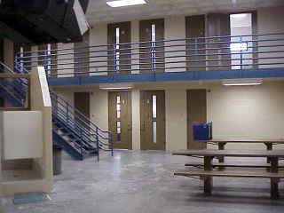
Training is the key to the development of detention facilities, as well as the best defense possible in achieving the safe and secure operations of jails. The State of Ohio demands that all Corrections Officers receive 8 hours of in-service training each year. Given the fact that there are 86 Corrections Officers and 20 Support staff this translates to 6708 hours of training. Such a demand could exert an enormous financial burden on the Sheriff’s budget should such required training not be approached in an innovative manner. I am happy to report that the average training hours per officer and support staff totaled 84 hours of in-service training each, with a total of 9660 hours of in-service training annually at a cost of less than $4,000. Translated, this is a cost of about $0.46 cents per training hours. (Reference the 2020 Training Report for Training overview). This training and financial success is due to the innovation of the Corrections Division Training Team members who used their skills to provide cost effective quality training to increase the professionalism of our staff. The training team continues to use on-line training for the Corrections Division. (www.classmarker.com). Classmarker is a training site which allows Correction Officers to complete all their training on-line. The Training Team also uses Corsa that offers free training for Corrections Officers and Support Staff. Officers and Support Staff are trained annually in First Aid/CPR, Suicide prevention, Fire safety, Policy and Procedures, Use of Force, Sexual Harassment, Report Writing, PREA and many other aspects in the Corrections field. Supervisors continue to have training with The American Jail Association (AJA), The National Institute of Corrections (NIC), Police Executive Leadership College (PELC) and FBI Law Enforcement Executive Development Association (LEEDA).

Inmate Commissary

The Inmate Commissary is designed to meet the basic hygienic and psychological needs of the inmate population by providing, for sale, a selection of toiletries, snack foods, reading and writing materials as well as some basic medical supplies. This in house Commissary helps to strengthen the security of the facility by decreasing the chances of contraband being introduced into the facility from these types of items being dropped off or brought in by visitors.

In the current economic environment it needs to be known that the inmate Commissary is solely for the benefit of the inmate population. No taxpayer dollars are used to fund our inmate Commissary here at the Lake County Sheriff’s Office. The profits made from Commissary sales are used to fund several programs that are specifically for the benefit of the inmate population.

The Inmate Commissary is designed to meet the basic hygienic and psychological needs of the inmate population by providing, for sale, a selection of toiletries, snack foods, reading and writing materials as well as some basic medical supplies. This in-house Commissary helps to strengthen the security of the facility by decreasing the chances of contraband being introduced into the facility from these types of items being dropped off or brought in by visitors.

In the current economic environment, it needs to be known that the inmate Commissary is solely for the benefit of the inmate population. No taxpayer dollars are used to fund our inmate Commissary here at the Lake County Sheriff’s Office. The profits made from Commissary sales are used to fund several programs that are specifically for the benefit of the inmate population.

In 2020, Inmate Commissary sales totaled $296,564.53 which generated a profit of $59,312.90. Commissary profits help to provide the following to the inmate population:

Indigent packages are distributed to inmates with no funds on their Commissary account on a weekly basis. These packages provide them with basic essentials to include deodorant, soap, toothbrush, toothpaste, pen, paper and two stamped envelopes for correspondence. The cost approximately is $2.50 per package. In 2020, on average 460 packages were distributed per month which totaled $1,150.00 for a grand total of $13,800.00 On average, $244.00 per month has been recovered through weekly inventory practices in inventory shrinkage i.e. missing and or replaced/credited products.

G.E.D. Program $8,000.00 annual cost. This program is designed to help those inmates who are incarcerated to attend classes and obtain their G.E.D. certificate thus preparing them to return to society and seek employment. Due to Covid-19 $0.00 were payable to Auburn Career Center in 2020.

Law Library $4692.00- providing two computer stations that inmates can use to access and review legal materials which is required by law. This system is supported by Lexis Nexis with updated hard drives that contain current state and federal law codes and receive regular updates.

Additional Services provided to inmates for 2020:

Time Warner Cable $1711.08
News Herald $6632.80
Swank Motion Picture License $1700.00
Netflix $153.96
Laketran Passes $525.00

Each inmate range receives access to the Lake County News Herald newspaper on a daily basis. Access to cable television is also given and provided by Time Warner Cable providing local and basic channels. The inmate Commissary profits also pay for the public performance licensing agreement with Swank Motion Pictures which permits the facility to rent two DVD movies from Netflix to play for the population on Friday nights.

Contraband Detection

For years inmates have tried and at times succeeded in bringing contraband into jails and prisons. Anything from syringes, pills, drugs and weapons have been smuggled into correctional facilities through the body cavities and other means from those incarcerated. Inmates will always try to smuggle contraband into correctional facilities knowing that officers cannot search for contraband hidden in body parts where drugs and weapons should never be hidden.
Although shakedowns are conducted on a monthly basis and officers perform pat-down searches and observation searches on inmates, this alone cannot cease contraband from entering the jail. The Lake County Commissioners purchased a Full Body Scanner for the jail in order to curb the amount of contraband that enters the security perimeter of the jail. The body scanner has a very low dose of radiation which is not harmful to the staff or inmates. The full body scanner will assist Lake County Adult Detention Facility in eliminating contraband from entering the secure perimeters of the jail. In 2020, 5914 scans were conducted in the jail. There were 4502 scans conducted on male inmates and 1416 scans conducted on female inmates. A total of 4 scan were positive for contraband of drug paraphernalia.

Inmates that were not Scanned:

Wheelchair: 7
Pregnant: 30
Chemo or Radiation Treatment: 18
Pacemaker: 13
Juvenile:1

Again, the annual report would be incomplete if it fails to mention the concerns for the physical plant issues with the current jail facility. The graphic panels are 25 + years old and have been replaced; the key card readers have been upgraded and installed. New and more cameras have been installed throughout the facility and inside housing units, kitchen, visiting and other areas of the jail for monitoring inmates, officers and the visitors. The jail management system will be replaced this year. The elevator doors on elevator #4 have been replaced. The walk-in cooler has been repaired. The freezer has been repaired. The Jail continues to have problems with plumbing at an astronomical cost. The sprinkler system has been replaced for leaky pipes. Four sally-port doors were replaced. The dampers for the HVAC system need to be replaced. The roof is a continues repair for holes and roof drains that continue to leak into the jail causing damage. The roof has been tuckpointed. The jail continues to deteriorate with many repairs being done on a daily basis.

I encourage everyone to review all of the detailed annual reports from all of jail programs which review in detail that which I have highlighted here in this annual report. Such collaborative efforts as I have highlighted here illustrate the dedication of the members of the Corrections Division and the Support Staff to meet the growing demands placed on it with an expanding jail population. Such confidence is marked by the proven excellence and dedication of the men and women that make up the Corrections staff (Correction Officers, Doctors, Nurses, Dentist, Cooks, Counselors, Maintenance Staff...). Our success is truly possible only through their efforts, labored over 24 hour days, 7 days a week, 365 days a year. Thanks to all of them, Corrections is working in Lake County, Ohio!

Capt.Cynthia L.Brooks
Capt. Cynthia L. Brooks CJM
Lake County Sheriff's Office
104 East Erie Street Painesville, Ohio 44077
(440)350-5503 sheriffwebmaster@lakecountyohio.org

