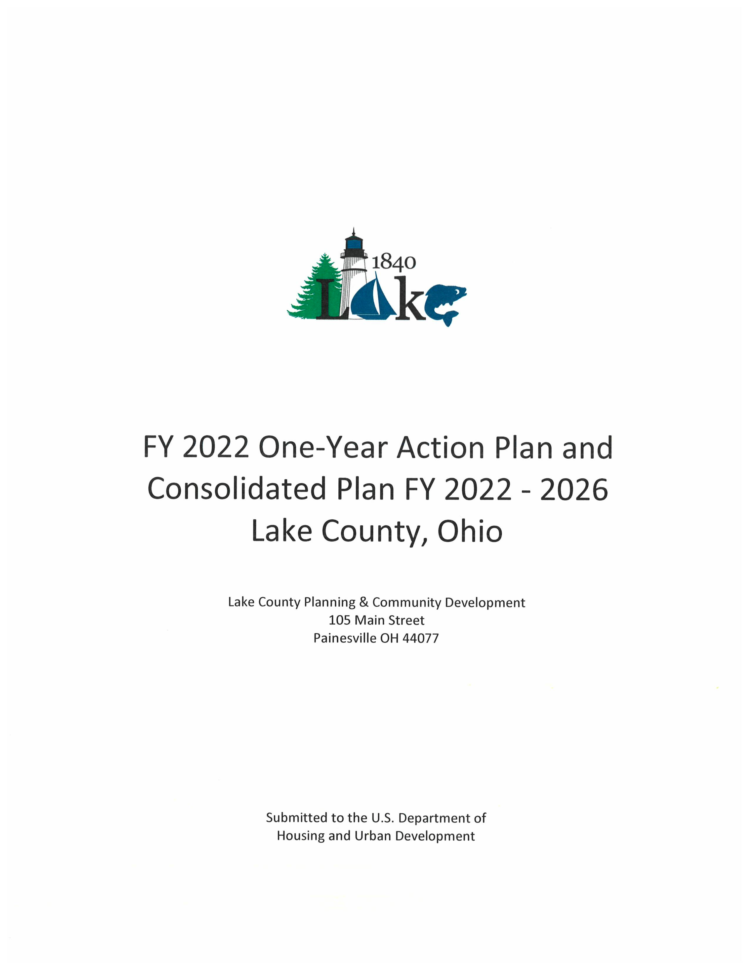

Executive Summary

ES-05 Executive Summary - 24 CFR 91.200(c), 91.220(b)
1. Introduction
The United States Department of Housing and Development (HUD) requires that all local jurisdictions seeking to participate in HUD’s formula grant programs complete and submit a Consolidated Plan which will be used to govern which local programs qualify to receive funding and how the impact of those programs will be measured. Here in Lake County the planning process included both an inventory and assessment of local economic development, community development and housing needs and broad local participation in the development of our county’s strategies and objectives for addressing those needs over the next five years.
The Lake County Assessment of Fair Housing (AFH) has been incorporated into the Consolidated Plan in four (4) key areas: Coordination and Citizen Participation, Needs Assessment/Market Analysis, Strategic Plan, and Annual Action Plan. The AFH planning process assisted Lake County in analyzing challenges to fair housing choice and establishing goals and priorities to address fair housing barriers found in the community. The AFH contributing factors became priority needs within the Consolidated Plan. Likewise, the AFH goals are identified as goals in the Consolidated Plan. HUD accepted and approved Lake County's AFH in a letter dated July 17, 2017.
The goal of this planning process is to help local communities identify needs and apply for funding that can be used to expand economic opportunities, essential public services, and decent and affordable housing for Lake County residents. Current annual allocations to Lake County include $1,375,761 in Community Development Block Grants (CDBG) and $493,713 in the Home Investment Partnership Program (HOME). Appropriation levels to these programs have been holding steady the past few years. Supplemental funding has been received to respond to the COVID-19 pandemic. Program regulations call for the principal beneficiaries to be low and moderate income persons.
The jurisdiction is utilizing HUD’s eConPlanning Suite tool for the development of this Consolidated Plan.
2. Summary of the objectives and outcomes identified in the Plan Needs Assessment Overview
The County has identified five (5) primary funding objectives:
OBJECTIVE #1: Offer Housing Programs to Provide Safe and Decent Housing for Low-to-Moderate Income Households – Promote safe and decent housing for low-to-moderate income households throughout the County by providing programs to meet the needs of varied household types and qualifying income levels. (130 households - housing rehabilitation)
OBJECTIVE #2: Targeted Infrastructure Improvements in Low-to-Moderate Income Residential Areas – Promote a suitable living environment by allocating CDBG resources to support infrastructure and public facility improvement activities that will assist with addressing the problem of aging and insufficient infrastructure and building rehabilitation in residential areas that have high concentrations of low-to-moderate income households. (15 communities assisted)
OBJECTIVE #3: Provide Appropriate Supportive Services for Low-to-Moderate Income Persons – Provide assistance to nonprofit organizations that offer needed programs with supportive services for low-to-moderate income persons living in the community. The County maintains a strong working relationship with the nonprofit organizations operating in the local community and has used CDBG and HOME funds to support many needed programs. (10,000 beneficiaries annually utilizing up to the 15% public services cap.)
OBJECTIVE # 4: Coordinate efforts between Public Agencies and Continuum of Care Agencies to Address the Issues of the Homeless and Special Needs Population – The County will continue efforts to participate and support the Coalition for Housing Organization and Continuum of Care Organization to facilitate efforts between public agencies and Continuum of Care agencies to provide housing assistance and other services to prevent and assist homelessness. (600 households - tenant based rental assistance/rapid rehousing)
OBJECTIVE # 5: Promote a Regionally Coordinated Economic Development planning strategy, which includes businesses, non-profits, officials from the County and its communities, officials from outside the County, and area residents that identify ways to create and maintain employment in lower to middle income sectors of the workforce. (Assistance to 5 businesses, creation of 7 jobs, and providing façade treatments/business building rehabilitation to 8 businesses)
3. Evaluation of past performance
The jurisdiction continues to meet expenditure deadlines, project accomplishments on an annual basis. The jurisdiction has and will continue to monitor all subrecipients receiving federal funds for performance and cost effectiveness. Past performance and cost effectiveness will be taken into account when evaluating subreceipients for subsequent funding requests. This jurisdiction has struggled with meeting CDBG timeliness guidelines as a result of the effects that the COVID-19 pandemic had on the supply-chain, material costs, and pool of employees for Subrecipient Agencies. These issues have caused construction projects to be delayed and public service programs have struggled with hiring and maintaining staff. This jurisdiction is working closely with Subrecipients to move forward with programs and projects as efficiently as possible.
The jurisdiction takes diligent action to properly train multiple staff members in the regulatory, programmatic and financial aspects of the grant programs. This includes offsite trainings, webinars, technical assistance and independent self-training. This methodology extended to our subrecipients and partners throughout Lake County with increased educational and regulatory training opportunities to ensure program compliance from a top-down approach.
The most recent HUD monitoring visit was completed in July, 2021 for the CDBG Program, and resulted in minimal compliance issues.
The jurisdiction has updated the following procedural documents to assist in effectively implementing HUD programs: Lake County Citizen Participation Plan for HUD Programs (2020), and Lake County Section 3 Policy (2021).
4. Summary of citizen participation process and consultation process
The Consolidated Plan/FY22 Annual Action Plan process continued with Public Hearing #1 on April 13, 2022, when the availability of funding was announced and those interested in applying for funds were briefed on the program requirements and application process. The notice was published in the newspaper, posted on the County's website, posted at local libraries, and was sent via email blast to an extensive email group. The notice requested comments for both the 5-year ConPlan and the FY22 Annual Action Plan. During PH#1, the Consolidated Plan was discussed and related back to the goals for the FY 2022 funding.
A public meeting targeting senior citizens was conducted on March 17, 2022 at the Madison Senior Center, and it was advertised through the Council on Aging Senior Newsletter. The meeting successfully encouraged the senior citizens to complete the online survey, collecting information for the Consolidated Plan. Similar public meetings were held at the Willowick Senior Center on June 28th, and the Mentor Senior Center on June 29th. On February 15, 2022 staff attended The Coalition for Housing and Support Services of Lake County, Inc. meeting and reported to attendees that the County is working on the Consolidated Plan and will be using a survey instrument to collect public input that will be distributed to Coalition members and widely throughout the County. On March 22, 2022 staff attended the quarterly Economic Development Luncheon hosted by the Lake Development Authority and requested public input from the local ED leaders in attendance by completing the Consolidated Plan survey. On July 14, 2022 staff hosted a table at the Lake County Resource Fair at the Lake County Administration Building. This fair was open to the public and offered a wide variety of information on housing resources and other services. Our table shared information about the Consolidated Plan and how to fill out the survey to provide public input, and also gave information about ERAP and housing rehabilitation.
Public Hearing #2, on July 13, 2022, announced proposed projects for FY 2022 and requested further comment on the 5-Year ConPlan. A notice was published in the newspaper, posted on the county website, and sent via email blast.
A successful online survey for the 5-Year ConPlan resulted in 248 survey submissions. A summary of the completed survey results is included within the Citizen Participation file. The survey contributed valuable information for the development of the Consolidated Plan/Annual Action Plan.
Written comments were collected during the 30-day comment period. All written comments received are attached to this online plan in the AD-25 Section.
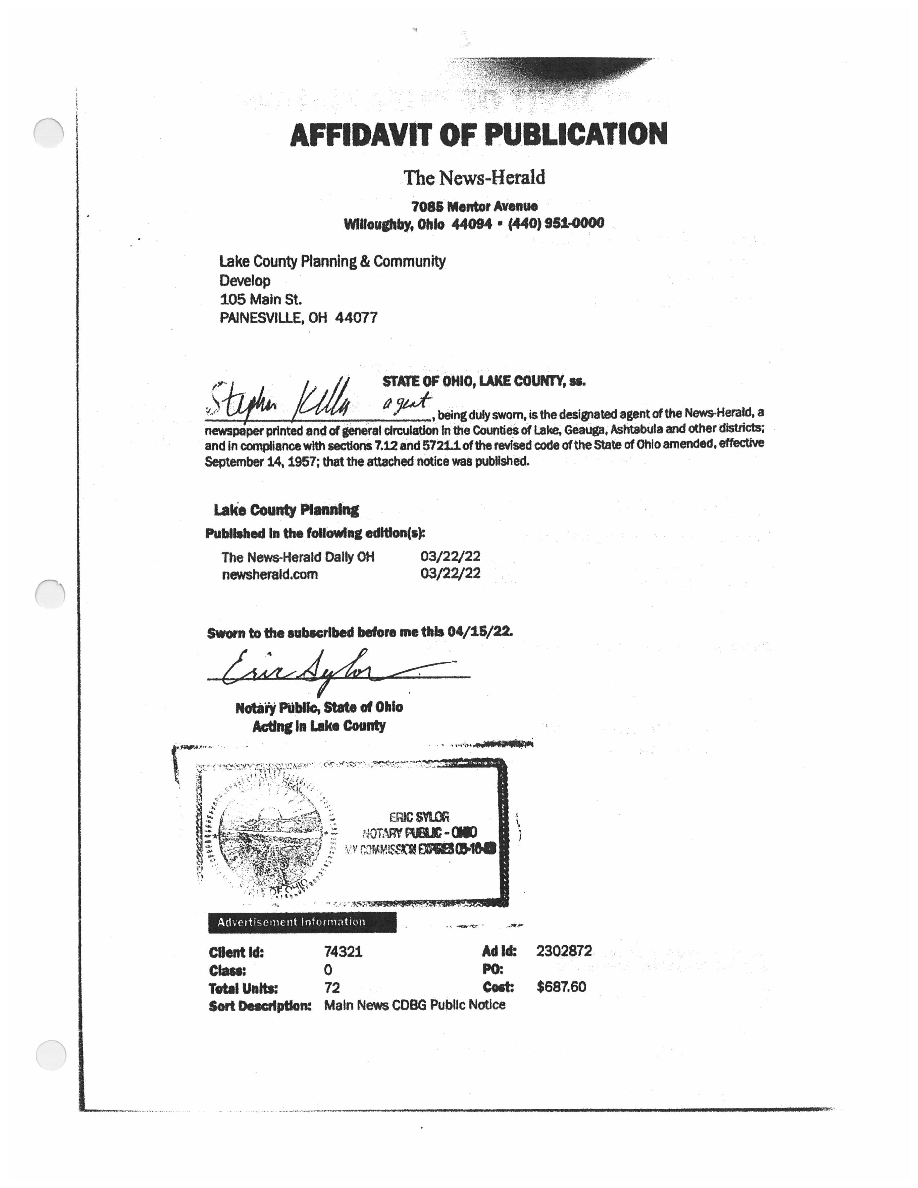
PH 1 Affidavit of Publication
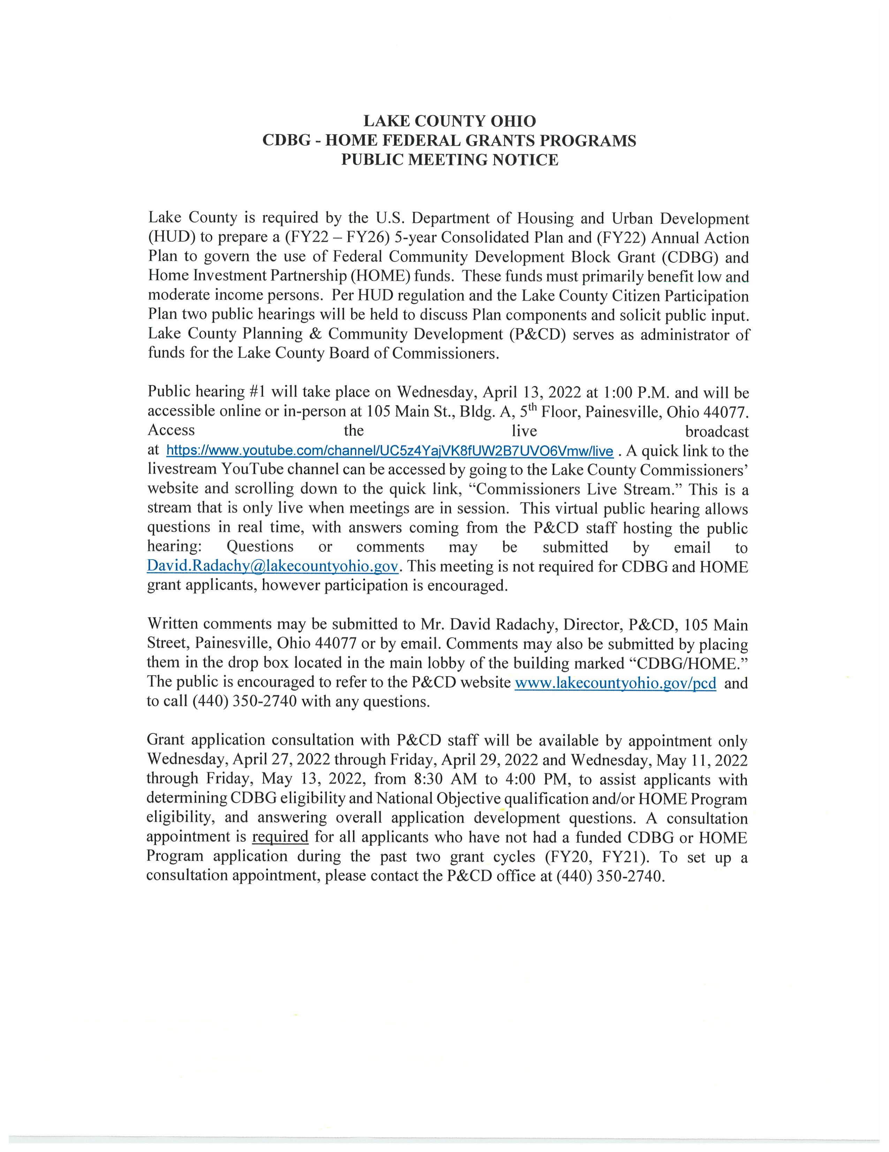
PH 1 Text of Notice
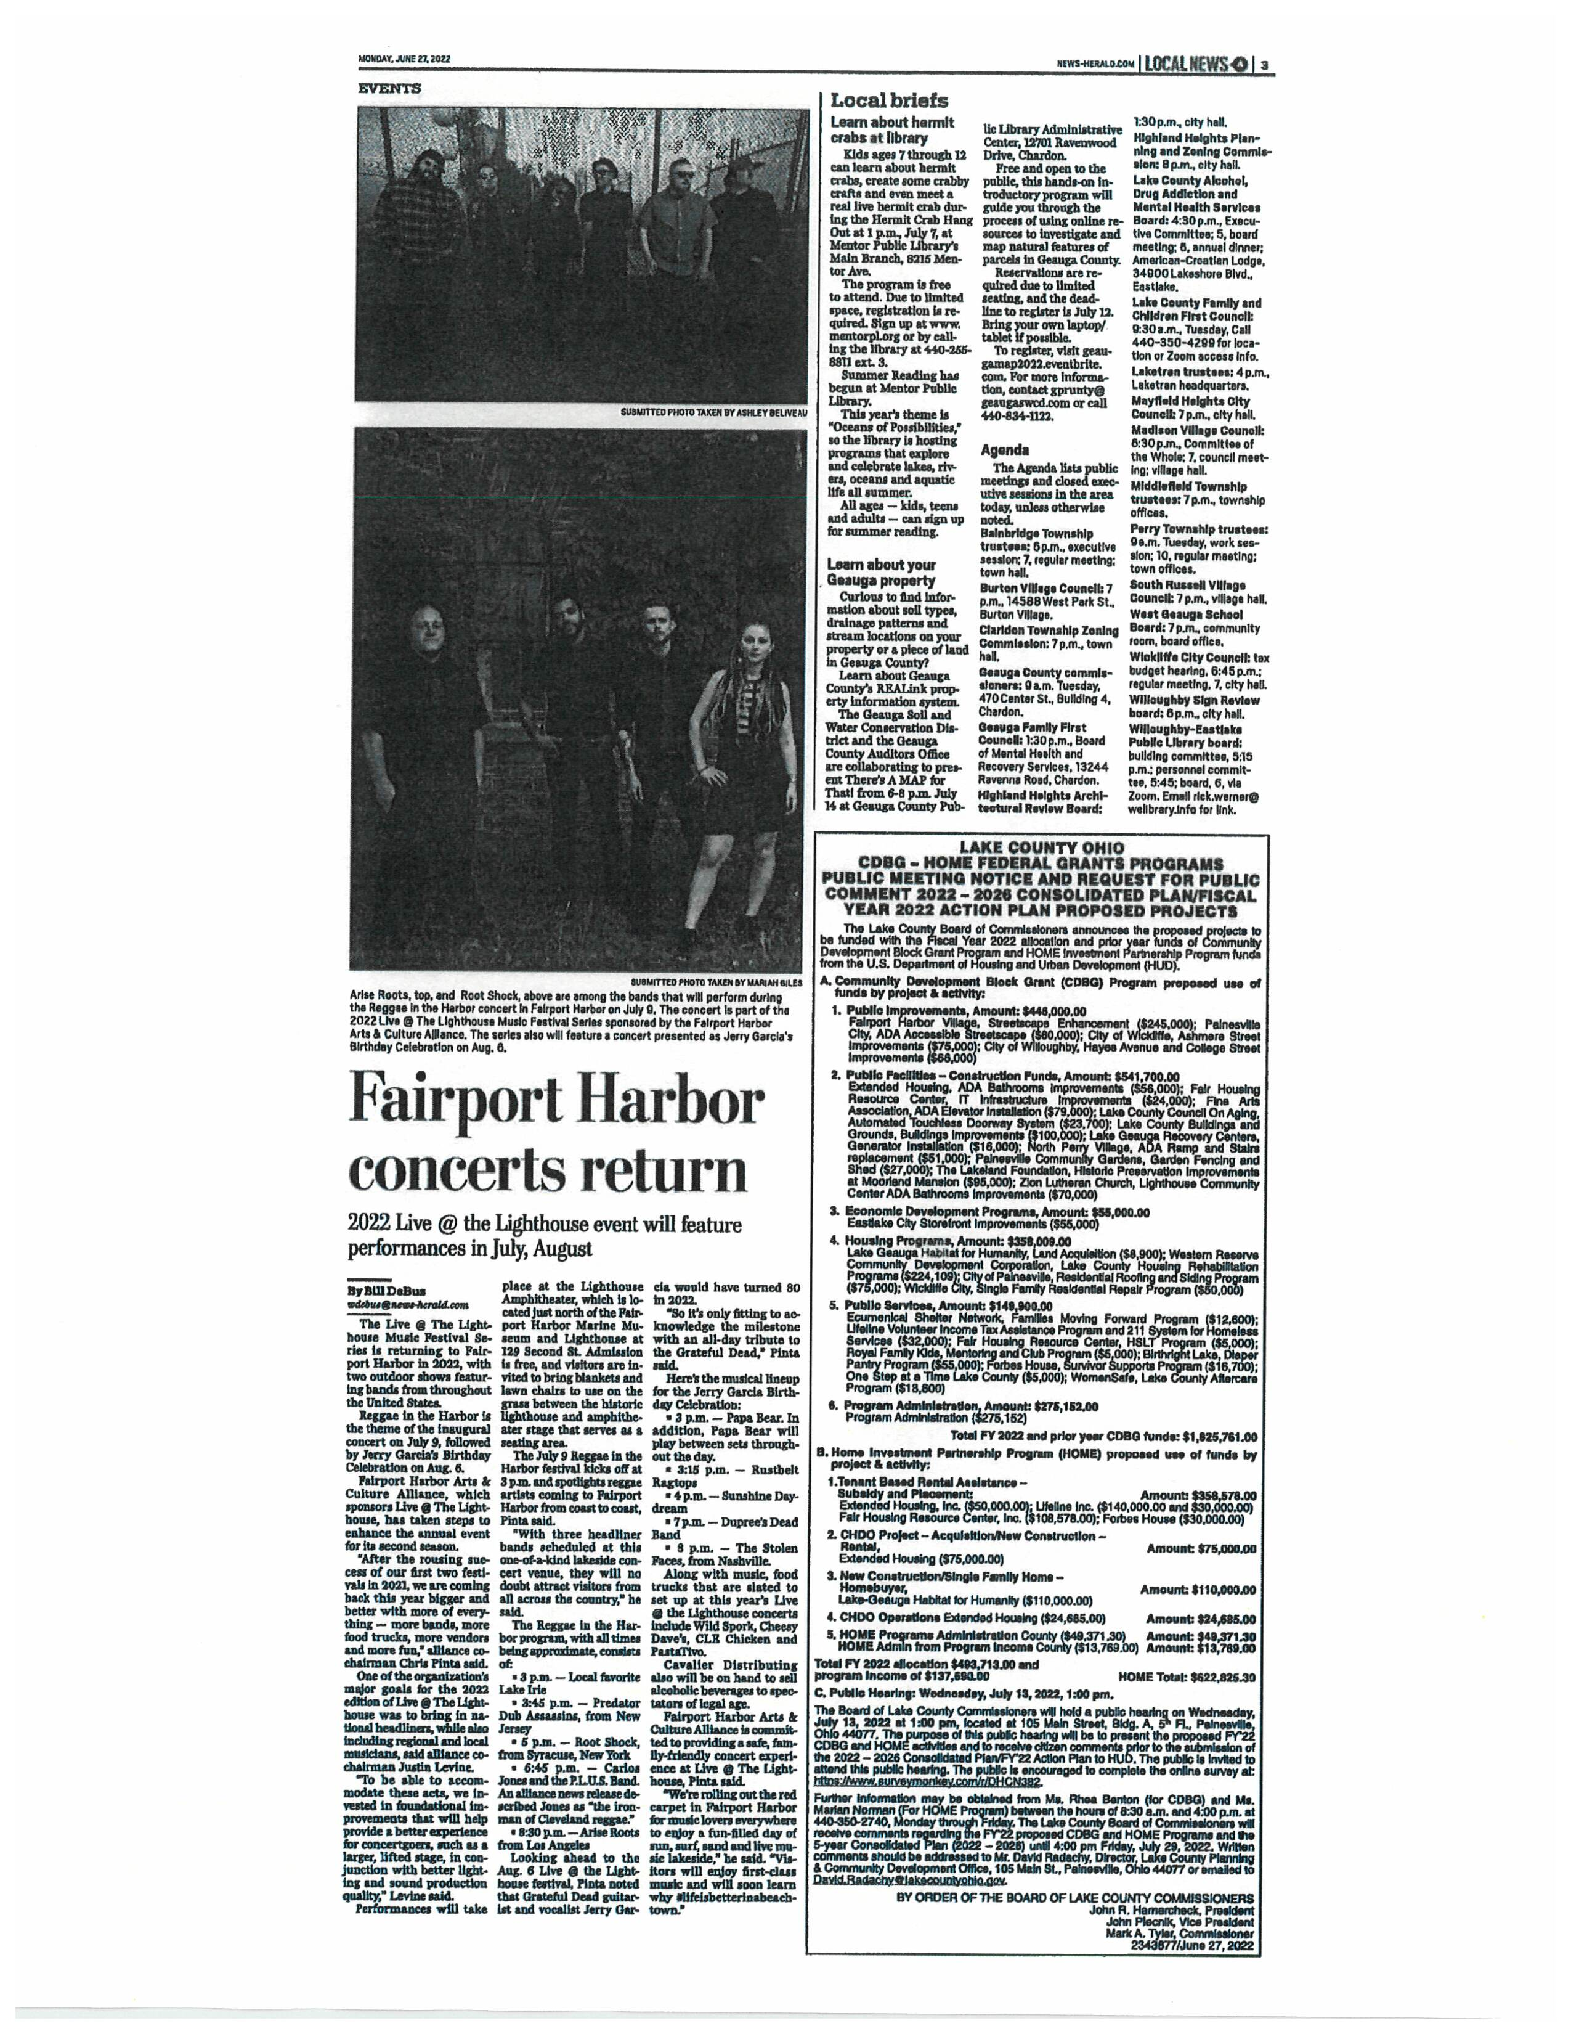
PH 2 Tear Sheet of Notice
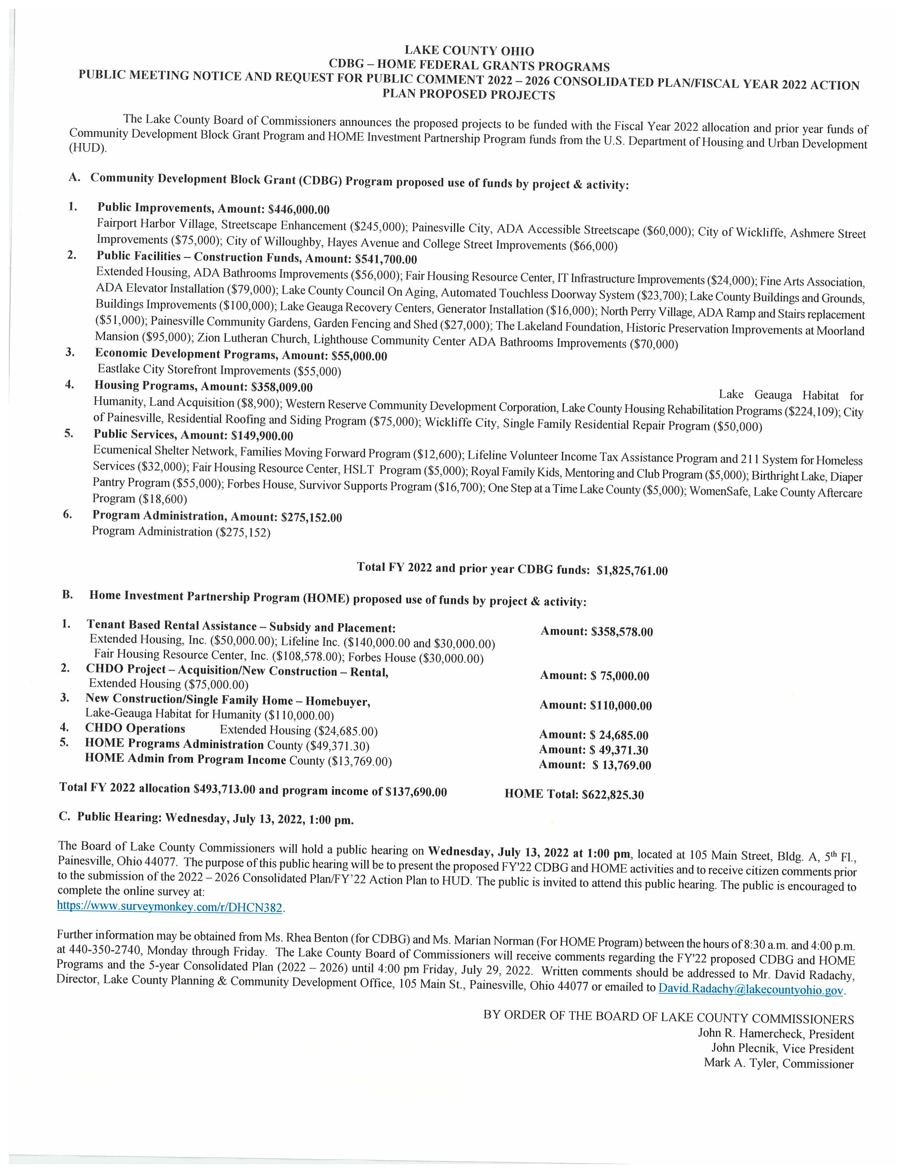
PH 2 Text of Notice
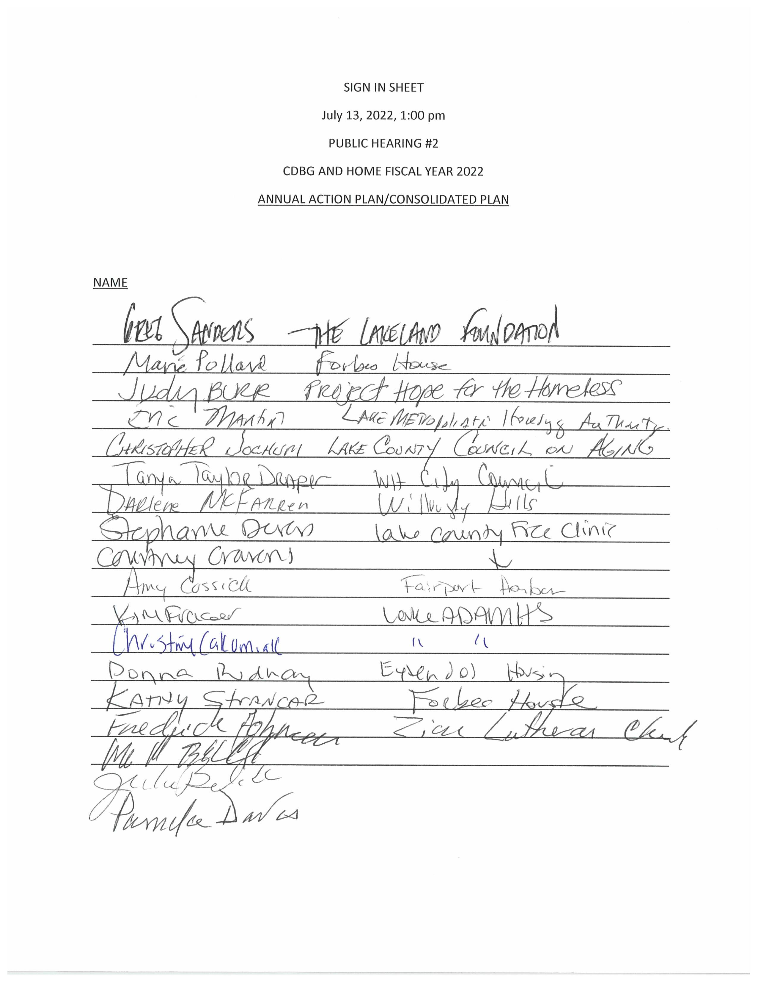
PH 2 Sign in Sheet
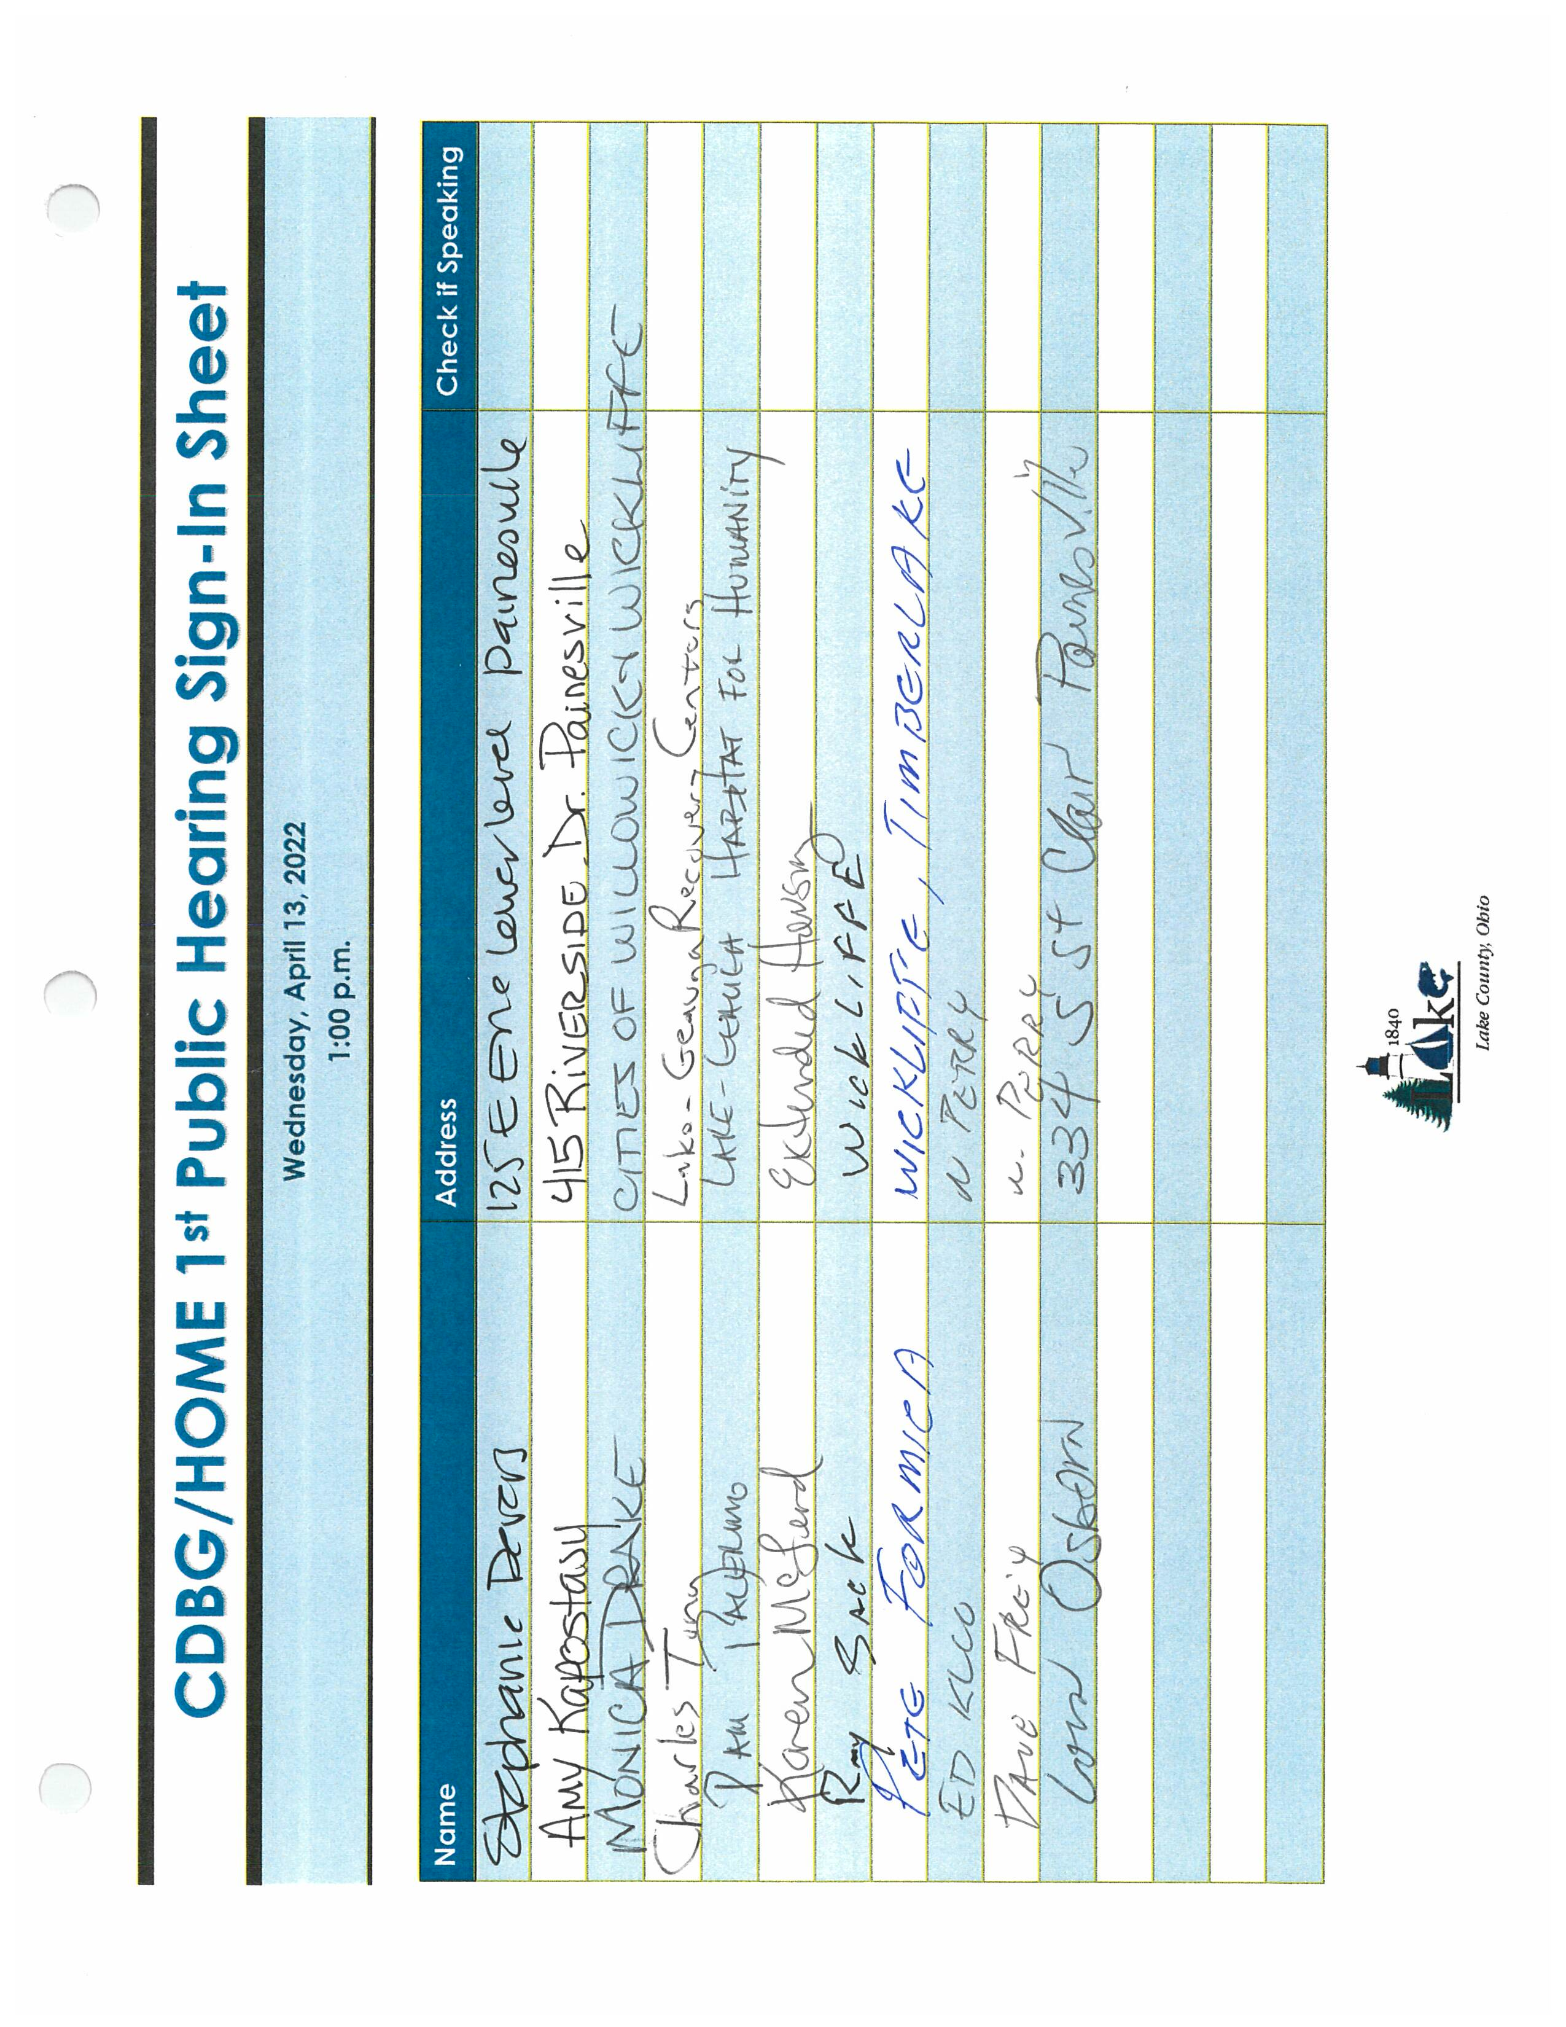
PH 1 Sign In Sheet
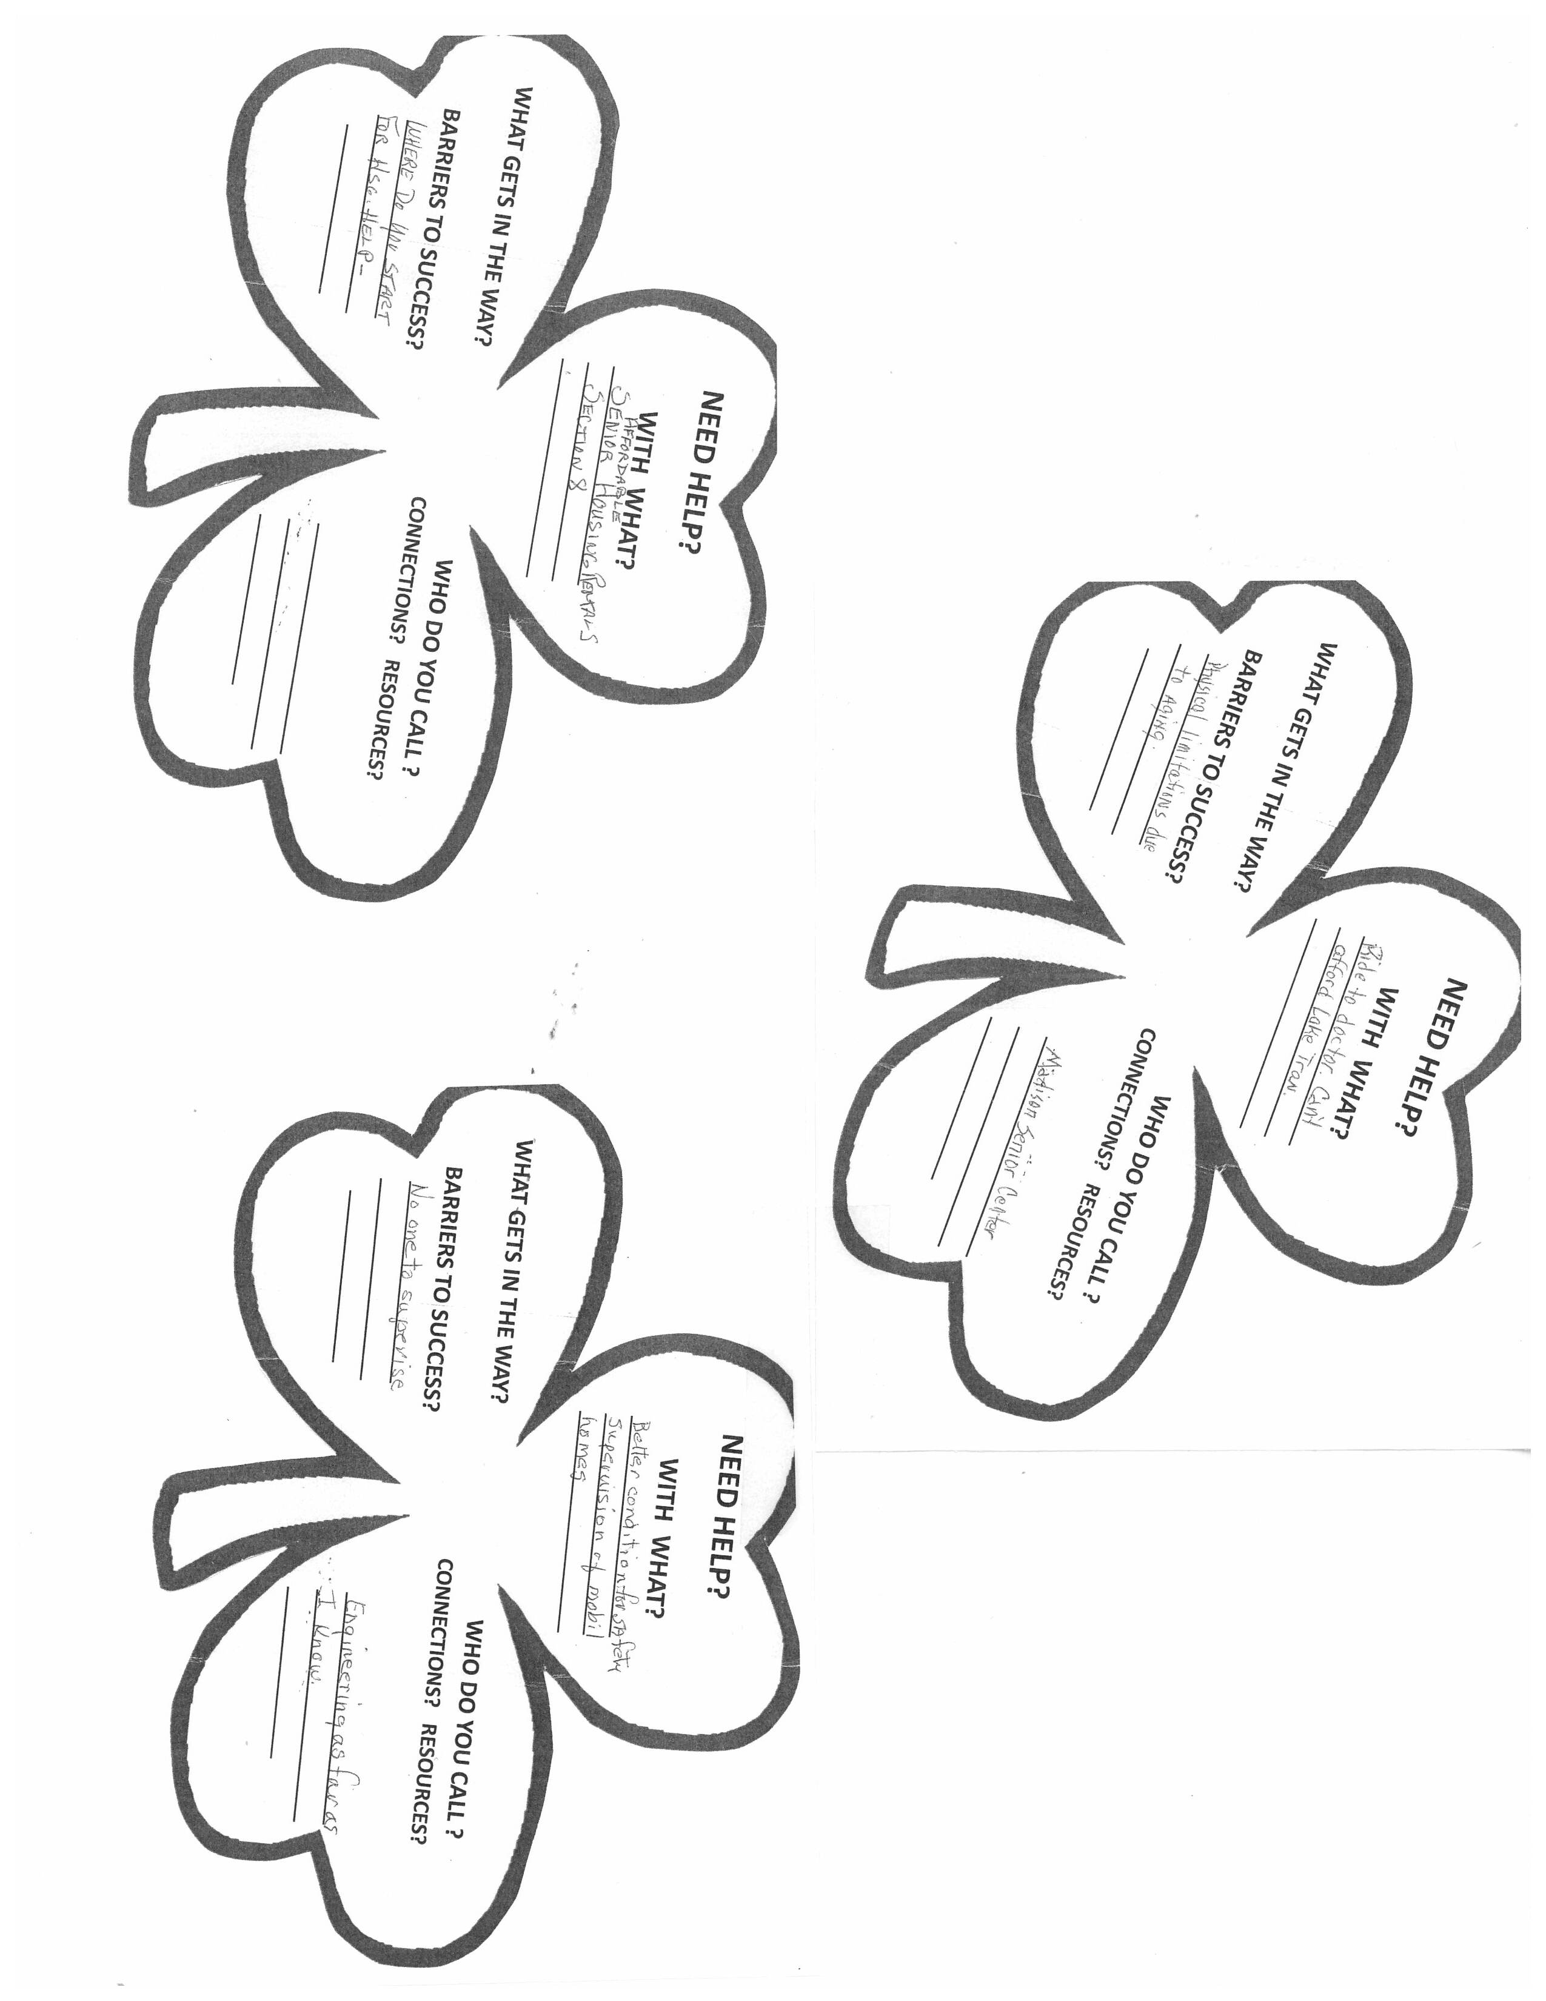
Madison Senior Center Activity
5. Summary of public comments
Citizen Participation Comments are attached to this online ConPlan/Annual Action Plan in the AD-25 Section. This jurisdiction received seven (7) written public comments and seven (7) verbal comments. The majority of public comments were in support of the proposed projects selected for FY22 funding. A lesser amount of public comments were funding requests for projects not selected during the FY22 grant period.
6. Summary of comments or views not accepted and the reasons for not accepting them
The majority of comments were in support of the projects selected for funding for the FY22 grant period. These comments were accepted. Comments were received that requested reconsideration for funding projects that were not selected for FY22 funding. Because CDBG funding is limited, the response to these comments was to pursue additional American Rescue Plan funding that is currently going through the legislative process and will become available to the County. One comment was a request for an increase to a proposed award to allow for additional funding towards program staffing costs. This comment was accepted. One commenter asked that proposed funding for an activity be partially directed towards an alternate activity, serving the same population. This action would require additional information regarding the activity.
7. Summary
Lake County experienced a robust response from the public during the outreach process for the Consolidated Plan/1-Year Action Plan. The online survey was well marketed, and resulted in responses from nearly every community in the County, including residents, business owners, local officials, and those employed in the County in private or public sectors. Additionally, public meetings were well attended and verbal and written comments were received. The valuable input from the community was incorporated into the Consolidated Plan/1-Year Action Plan.

The Process

PR-05 Lead & Responsible Agencies 24 CFR 91.200(b)
1. Describe agency/entity responsible for preparing the Consolidated Plan and those responsible for administration of each grant program and funding source
The following are the agencies/entities responsible for preparing the Consolidated Plan and those responsible for administration of each grant program and funding source.
Agency Role | Name | Department/Agency
Lead Agency | LAKE COUNTY

CDBG Administrator | LAKE COUNTY | Lake County
HOPWA Administrator
HOME Administrator | LAKE COUNTY | Lake County
HOPWA-C Administrator
Table 1 – Responsible Agencies

Narrative
The Consolidated Plan guides the use of HUD funding under the Community Development Block Grant Program and Home Investment Partnership Program (CDBG/HOME) that is awarded annually to the Board of Lake County Commissioners. Staff efforts to administer these funds is primarily conducted by the Lake County Planning and Community Development Department with assistance from the Board of Lake County Commissioners Office.
Consolidated Plan Public Contact Information
Consolidated Plan Public Contact Information: David Radachy, Director, Lake County Planning & Community Development, 105 Main Street, Painesville, OH 44077. Phone: (440) 350-2740, Fax: (440) 350-2606, Email: David.Radachy@lakecountyohio.gov, website:https://www.lakecountyohio.gov/planning-community-development/.
As of the date of the submission the following personnel are present in the Planning & Community Development department: David Radachy, Rhea Benton, Marian Norman, Beth Young, Alanna Ciancibello, Jackie Irwin.
As of the date of the submission the following persons are serving as elected County Commissioners: John R. Hamercheck, President; John Plecnik, Vice-President; Mark Tyler, Commissioner. The County Administrator is Jason Boyd. The phone number for the County Commissioners Office is (440) 350-2745.

PR-10 Consultation – 91.100, 91.110, 91.200(b), 91.300(b), 91.215(I) and 91.315(I)
1. Introduction

Provide a concise summary of the jurisdiction’s activities to enhance coordination between public and assisted housing providers and private and governmental health, mental health and service agencies (91.215(I)).
Jurisdiction provides staff of the Lake County Planning & Community Development (LCPCD) to the Coalition of Housing & Support Services of Lake County, Inc. and to the local/regional Continuum of Care. These two entities serve as a means of facilitating coordination of housing and services between agencies involved. Membership rosters, minutes and recent projects are noted on the respective websites: www.chsslc.org & www.homeisinsight.org
Describe coordination with the Continuum of Care and efforts to address the needs of homeless persons (particularly chronically homeless individuals and families, families with children, veterans, and unaccompanied youth) and persons at risk of homelessness
Jurisdiction staff from LCPCD provide leadership at the local level and are actively involved in the Continuum of Care at the regional and state level. This involvement is described in the next paragraph and AP 65.
The Lake County Continuum successfully implemented a response to provide for food, day shelter, transportation and overnight shelter for homeless persons in severe winter weather. CODE BLUE was activated several times in 2021-2022.
Describe consultation with the Continuum(s) of Care that serves the jurisdiction's area in determining how to allocate ESG funds, develop performance standards and evaluate outcomes, and develop funding, policies and procedures for the administration of HMIS
Lake County is not a direct recipient of ESG funding. Lake County is a part of Region 5 of the Ohio Balance of State Continuum of Care (OH-BOSCOC). The County staff person serving as Program Manager/HOME Administrator has served as chairperson of the Lake County Continuum of Care (CofC) for several years. Efforts will continue to increase the responsibility of those ESG funded agencies to guide the Continuum.
Allocation of ESG funds is made at the OH-BOSCOC level with bi-annual awards of approximately $180,000 made directly to Ecumenical Shelter Network of Lake County, Inc. (Project Hope for the Homeless). The development of performance standards also is made at the state level through the OH-BOSCOC. Those standards have been disseminated through The OH-BOSCOC Performance Management Plan adopted by Ohio Development Services Agency and COHHIO. It can be viewed at www.cohhio.org/information_resource/trainingmaterial#BoS20%CoC . Local agencies and staff involved are encouraged to maintain current skills in the field through participation in pertinent listserv, meetings and webinars. State directives are also shared through Lake County Continuum meetings and regular email communication. The implementation of HEARTH regulations has and will likely continue to be challenging especially as the population served by these funds faces numerous and severe barriers to obtaining and retaining housing. For the Homeless Crisis Response Program the Ohio DSA and the OH-BOSCOC have adopted a contract model that consists of agreements with the Region 5 lead agency who in turn contracts with the direct service providers. As a result Lake County government’s role has been curtailed. Advice and historic perspective will be made available to service provider agencies as requested.
OH-BOSCOC uses the HMIS known as ServicePoint 5. Agencies’ staffs as well as contracted consultants have completed the requisite training. Provider agencies recognize that the outcome measures have changed and are working to align existing programs to comply with expected outcome measures. OH-BOSCOC has established a fee per user on HMIS that was instituted in 2017.
The roster of agencies and communities involved in the Lake County Continuum of Care is as follows: Lake County Planning & Community Development, Ecumenical Shelter Network of Lake County, Inc. (Project Hope for the Homeless & Families Moving Forward), Extended Housing, Inc., Forbes House, New Directions for Living, Fair Housing Resource Center, Inc., Lifeline, Inc., Salvation Army, Lake MHA, Lake County Community Network, St. James Episcopal Church, LC Free Clinic, LC Veterans Service Center, LC Job & Family Services, United Way of Lake County, LC ADAMHS, Crossroads, Lake Geauga Recovery Center, Beacon Health, LC General Health District, Advocate Advisors, Lake Tran.
2. Describe Agencies, groups, organizations and others who participated in the process and describe the jurisdictions consultations with housing, social service agencies and other entities

Table 2 – Agencies, groups, organizations who participated
1 | Agency/Group/Organization | Fair Housing Resource Center
1 | Agency/Group/Organization Type | Housing  Services - Housing  Services-Children  Services-Elderly Persons  Services-Persons with Disabilities  Service-Fair Housing
1 | What section of the Plan was addressed by Consultation? | Housing Need Assessment  Public Housing Needs  Non-Homeless Special Needs
1 | How was the Agency/Group/Organization consulted and what are the anticipated outcomes of the consultation or areas for improved coordination? | Fair Housing Resource Center , Inc. is a member of both the CoC and the Coalition. The agency implements federal Housing Counseling FHIP grants for Private Enforcement and Education/Outreach. They served as main consultant for the preparation of AFH. joint applicant with county for LBP grant application in 2015. They have operated state, federal and locally funded rental subsidy programs.
2 | Agency/Group/Organization | Extended Housing Inc.
2 | Agency/Group/Organization Type | Housing  Services-Persons with Disabilities  Services-homeless
2 | What section of the Plan was addressed by Consultation? | Housing Need Assessment  Homelessness Strategy  Homeless Needs - Chronically homeless  Homeless Needs - Families with children  Homelessness Needs - Veterans  Homelessness Needs - Unaccompanied youth
2 | How was the Agency/Group/Organization consulted and what are the anticipated outcomes of the consultation or areas for improved coordination? | Extended Housing , Inc. is a member of both the CoC and the Coalition. The agency implements federal S+C and PSH grants. They have operated state, federal and locally funded rental subsidy programs with a focus on persons with severe mental illness.
3 | Agency/Group/Organization | Ecumenical Shelter Network
3 | Agency/Group/Organization Type | Housing  Services-homeless
3 | What section of the Plan was addressed by Consultation? | Housing Need Assessment  Homelessness Strategy  Homeless Needs - Chronically homeless  Homeless Needs - Families with children
3 | How was the Agency/Group/Organization consulted and what are the anticipated outcomes of the consultation or areas for improved coordination? | Ecumenical Shelter Network of Lake County, Inc. consists of Project Hope for the Homeless and Families Moving Forward. The organization is a member of both the CoC and the Coalition.
4 | Agency/Group/Organization | Lifeline
4 | Agency/Group/Organization Type | Housing  Services - Housing  Services-Elderly Persons  Services-homeless  Services-Employment
4 | What section of the Plan was addressed by Consultation? | Housing Need Assessment  Homelessness Strategy  Anti-poverty Strategy
4 | How was the Agency/Group/Organization consulted and what are the anticipated outcomes of the consultation or areas for improved coordination? | Lifeline is a member of both the CoC and the Coalition. They are the local Community Action Agency and operate the 2-1-1 information & referral service. They administer a variety of state and federal funding including: HEAP and CSBG. Recipient of both CDBG & HOME funds.
5 | Agency/Group/Organization | LAKE METROPOLITAN HOUSING AUTHORITY
5 | Agency/Group/Organization Type | Housing  PHA
5 | What section of the Plan was addressed by Consultation? | Housing Need Assessment  Public Housing Needs  Homelessness Strategy  Non-Homeless Special Needs  Anti-poverty Strategy
5 | How was the Agency/Group/Organization consulted and what are the anticipated outcomes of the consultation or areas for improved coordination? | Lake MHA is a member of both the CoC and the Coalition.

Identify any Agency Types not consulted and provide rationale for not consulting
Input from all agency types was sought and accepted.

Other local/regional/state/federal planning efforts considered when preparing the Plan
Name of Plan | Lead Organization | How do the goals of your Strategic Plan overlap with the goals of each plan?
Continuum of Care | Ohio BOSCOC & Region 5 | The policies and procedures of the Ohio BOSCOC and the Region 5 to which Lake County is assigned impact homeless programming
Lake County Assessment of Fair Housing | Lake County | The goals and accomplishment measures of the AFH are incorporated in the Consolidated Plan
Table 3 – Other local / regional / federal planning efforts
Describe cooperation and coordination with other public entities, including the State and any adjacent units of general local government, in the implementation of the Consolidated Plan (91.215(l))
The State of Ohio through their Development Services Agency administers some HUD funding for parts of the state. For Lake County much of the homeless programming funding originates or passes through that office and or through a related contracted statewide organization COHHIO - Coalition for Housing and Homelessness in Ohio.
The Lake Metropolitan Housing Authority executed a collaboration agreement with Lake County for the preparation and submission of the Assessment of Fair Housing.
Lake County government acts as responsible entity for the preparation and submission of standard environmental assessments. It performs this work for itself, for Lake Metropolitan Housing Authority and for the Shelter Plus Care and Permanent Supportive Housing projects of the Lake ADAMHS Board that are implemented by Extended Housing, Inc.
Narrative (optional):
ConPlan: The jurisdiction maintains ongoing outreach to the community as a whole and agencies that provide for households in need through the organizations noted in the preceding paragraphs and through regular local government meetings and local press. The Lake County Continuum of Care meets monthly and key organizations attend the Region 5 and State mandatory meetings as indicated. Input and involvement from housing, social service agencies and other entities is routinely sought and received. Continuum communications and documentation is maintained largely through email. The Ecumenical Shelter Network of Lake County, Inc. completed a significant expansion of the homeless shelter. Funds are needed to expand staff so that additional beds can be put into use.
AFH: The jurisdiction continues to incorporate the goals established by the AFH (approved in 2017) into Consolidated Plan and Action Plans.

PR-15 Citizen Participation – 91.105, 91.115, 91.200(c) and 91.300(c)
1. Summary of citizen participation process/Efforts made to broaden citizen participation
Summarize citizen participation process and how it impacted goal-setting

Revisions to the Citizen Participation Plan may occur periodically to maintain compliance with changes to statutes and regulations, or to accommodate other changing conditions that necessitate modifications. With at least every Consolidated Plan five-year cycle, staff will review Citizen Participation Plan for the need to make modifications. A revised Citizen Participation Plan was adopted by Commissioners on April 30, 2020.
This revision to the Citizen Participation Plan incorporated the changes to process brought about by the CARES Act (Public Law 116-136) providing grantees with flexibilities that make it easier to use CDBG-CV grants and fiscal years 2019 and 2020 CDBG Program Grants for coronavirus response and authorizes HUD to grant waivers and alternative requirements, are detailed in HUD Memo dated April 9, 2020.
Regarding CDBG-CV funds, this jurisdiction followed HUD guidance to ensure eligible activities met the PPR tieback goal, focusing on documented coronavirus effects or risks to overall economic, service, housing and infrastructure serving LMI neighborhoods and communities, and to consider both backward-looking and potential forward-looking risks or vulnerabilities to coronavirus. Regarding fair housing, the guidance provided by HUD regarding the incorporation of the AFH with the Consolidated Plan called for the identification of all AFH goals as Consolidated Plan goals.
In addition to the public meetings listed below, staff of Planning & Community Development (P&CD) attended other community meetings and provided information on how to access the Consolidated Plan Survey. Staff also met one-on-one with various community agencies to discuss the Consolidated Plan.

Citizen Participation Outreach
Sort Order | Mode of Outreach | Target of Outreach | Summary of  response/attendance | Summary of  comments received | Summary of comments not accepted and reasons | URL (If applicable)
1 | Public Meeting | Persons with disabilities  Elderly | This public meeting took place on March 17, 2022 at the Madison Senior Center in Madison, Ohio. The meeting was advertised in the Lake County Senior Citizens Newsletter. The meeting was attended by approximately 50 people. | Two staff members of the Lake County P&CD office made a presentation on the Consolidated Plan and discussed the Con Plan Survey, which includes questions on the needs and priorities in Lake County. Attendees asked questions relating to the consolidated plan, and staff answered all questions. Three written comments were received and the needs listed included transportation needs for medical appointments; resources to make improvements to mobile homes; and affordable rental housing for seniors. Staff handed out flyers with the survey and contact information. | All verbal and written comments were accepted.
2 | Online Survey | Non-targeted/broad community | The online Con Plan Survey was composed by Lake County P&CD office. This survey was created through Survey Monkey. The survey included questions that addressed all of the major sections of the Con Plan. The survey was advertised throughout Lake County and was shared widely through email blasts. A QR Code was created to allow for easy access to the survey and a graphic was created to display on social media. The survey received 248 total responses. Summary analysis charts are available for the following segments: "All respondents", "Completed surveys", and "Low Income respondents." | The largest percentage of responses came from "Residents of Lake County" followed by "Leader/Employee of a business serving Lake County." The area of the County with the highest number of responses was Painesville City, followed by Painesville Township and City of Willoughby. Top housing priorities include Owner Rehabilitation, Add affordable owner units, and Add affordable renter units. The survey recorded responses in several other categories. | All comments from completed surveys were accepted.
3 | Public Hearing | Non-targeted/broad community | Public Hearing #1 for the 5-Year Consolidated Plan (2022 - 2026)/FY22 Annual Action Plan took place on April 13, 2022 at the public meeting room at 105 Main Street, Painesville, OH. The meeting site was centrally located in the County and near a major highway. The meeting was advertised in the News Herald on March 22, 2022. In addition to the newspaper ad, the notice was emailed to over 100 organizations in Lake County and was posted on the department's website and Facebook page. The public hearing was moderately attended by 11 people (documented with sign-in sheet). | The verbal comments received were general questions regarding the CDBG and HOME Program grants such as questions about the grant period and eligibility guidelines. No written comments were received. | All verbal comments were accepted.
4 | Public Meeting | Persons with disabilities  Elderly | This public meeting took place on June 28, 2022 at the Willowick Senior Center in Willowick, Ohio. The meeting was advertised at the Center. The meeting was attended by approximately 30 people. | Staff of the Lake County P&CD office made a presentation on the Consolidated Plan and discussed the Con Plan Survey, which includes questions on the needs and priorities in Lake County. Attendees asked questions relating to the consolidated plan, and staff answered all questions. Staff handed out flyers with the survey and contact information. | All verbal comments were accepted.
5 | Public Meeting | Persons with disabilities  Elderly | This public meeting took place on June 29, 2022 at the Mentor Senior Center in Mentor, Ohio. The meeting was advertised at the Center. The meeting was attended by approximately 25 people. | Staff of the Lake County P&CD office made a presentation on the Consolidated Plan and discussed the Con Plan Survey, which includes questions on the needs and priorities in Lake County. Attendees asked questions relating to the consolidated plan, and staff answered all questions. Staff handed out flyers with the survey and contact information. Staff assisted senior to complete the online survey and others took information to complete at a later time. | All verbal comments were accepted.
6 | Public Meeting | Non-targeted/broad community | Public Hearing #2 for the 5-Year Consolidated Plan (2022 - 2026)/FY22 Annual Action Plan took place on July 13, 2022 at the Lake County Administration Building, 105 Main Street, Painesville, OH. This public hearing was advertised in the News-Herald newspaper on June 27, 2022. It was also posted to the County website and was sent via email blast to community agencies. There were 18 people in attendance (documented with sign-in sheet). | There were seven (7) written comments and seven (7) verbal comments received. | Four of the seven written comments were in favor of the proposed FY22 CDBG-funded projects, and three written comments were not in favor and were asking for Commissioners to reconsider projects that were not selected for funding. Commissioners commented that additional funding from American Rescue Plan will be available to communities for projects. One of the commenters was an agency that had received partial funding and requested that the amount be increased. This comment was accepted. The majority of verbal comments were in favor of proposed FY22 projects and one commenter requested reconsideration for funding of program costs from the CDBG program. CDBG funds are limited and the County received more requested funds that are available.
7 | Online Survey | Non-targeted/broad community | Staff of the P&CD office hosted a table at the Lake County Resource Fair on July 14, 2022 at the Lake County Administration Building in Painesville, OH. The Resource Fair was open to Lake County residents to learn what housing resources and other services area available, how to access those resources and how they can benefit as a resident/homeowner. Staff promoted the Consolidated Plan Survey, the Lake County Housing Rehabilitation Program, and the Emergency Rental Assistance Program. | Staff answered questions regarding the programs listed above. | All verbal comments were accepted.
Table 4 – Citizen Participation Outreach

Needs Assessment

NA-05 Overview
Needs Assessment Overview
The jurisdiction of this plan is the Lake County Urban County (LCUC). This LCUC includes all communities in Lake County with the exception of the City of Mentor and the Village of Waite Hill. Dependent upon the information source, data presented will either be for the entire County or for the LCUC. Tables labeled with numbers are auto-populated with data and drawn from the eConPlanning Tool.
The level of need far outpaces the allocation of funds to the jurisdiction from HUD under the CDBG and HOME entitlement programs thus the establishment of realistic priorities for program investment is a necessity. Priorities for investment and other forms of support will be discussed in the Strategic Plan portion of this document. The jurisdiction may note something as a priority need but may acknowledge that it is unable to identify sufficient resources to address it. In such circumstances the County’s recognition of the need within the Consolidated Plan shall allow the pursuance of funds by other stakeholders and partners to address that need and certify it as consistent with the Consolidated Plan.
Population in the county as a whole and in the jurisdiction (Lake County Urban County – LCUC) is stable but increasing slightly. Lake County is home to 232,603 residents, according to the 2020 U.S. Census Bureau. The new population figure represents a 1.1 percent increase from 230,041 reported in the 2010 Census. 12 of Lake County’s 23 communities increased in population. Concord township and Willoughby represent a significant amount of the county’s growth since 2010. After the 2000 Census the City of Mentor reached above 50,000 persons and became an entitlement jurisdiction for CDBG. The data source in section NA-10 is 2000 Census (base year) and 2013 – 2017 ACS (most recent year).

NA-10 Housing Needs Assessment - 24 CFR 91.205 (a,b,c)
Summary of Housing Needs
While there was a negligible change in population there was modest growth in the number of households in LCUC and in median income. The data seems to accurately reflect the actual LCUC in the prepopulated tables in this cycle. The previous ConPlan cycle showed a marked decreased population and households which was actually simply those data points from the City of Mentor being subtracted from the LCUC.
Previous Consolidated Plan noted total households in LCUC as 74,803 compared to 75,418 in this cycle. Of the total households 37.95% are of Low-mod income.
Various segments of the population show a need. Households with persons 62 and over comprise 36% of all LCUC households but 47.8% of them are LMI.
Total substandard units number 514 with a 75%/25% renter/owner mix. Of all the substandard units 64% are LMI renters. While overcrowded and severely overcrowded is not a prevalent issue throughout LCUC, when it shows in the data it is primarily a renter issue.
Demographics | Base Year: 2009 | Most Recent Year: 2017 | % Change
Population | 182,460 | 182,355 | -0%
Households | 73,336 | 75,430 | 3%
Median Income | $54,616.00 | $61,137.00 | 12%
Table 5 - Housing Needs Assessment Demographics

Data Source: | 2000 Census (Base Year), 2013-2017 ACS (Most Recent Year)

Number of Households Table
 | 0-30% HAMFI | >30-50% HAMFI | >50-80% HAMFI | >80-100% HAMFI | >100% HAMFI
Total Households | 6,598 | 8,160 | 13,865 | 7,754 | 39,050
Small Family Households | 1,768 | 2,092 | 3,832 | 2,842 | 21,355
Large Family Households | 246 | 316 | 856 | 548 | 2,934
Household contains at least one person 62-74 years of age | 1,251 | 1,783 | 3,686 | 1,895 | 8,529
Household contains at least one person age 75 or older | 1,254 | 2,329 | 2,736 | 1,153 | 2,574
Households with one or more children 6 years old or younger | 798 | 736 | 1,696 | 983 | 3,411

Table 6 - Total Households Table
Data Source: | 2013-2017 CHAS

Housing Needs Summary Tables
1. Housing Problems (Households with one of the listed needs)
 | Renter |  |  |  |  | Owner
 | 0-30% AMI | >30-50% AMI | >50-80% AMI | >80-100% AMI | Total | 0-30% AMI | >30-50% AMI | >50-80% AMI | >80-100% AMI | Total
NUMBER OF HOUSEHOLDS
Substandard Housing - Lacking complete plumbing or kitchen facilities | 135 | 49 | 145 | 55 | 384 | 40 | 50 | 20 | 20 | 130
Severely Overcrowded - With >1.51 people per room (and complete kitchen and plumbing) | 20 | 45 | 95 | 25 | 185 | 0 | 25 | 0 | 0 | 25
Overcrowded - With 1.01-1.5 people per room (and none of the above problems) | 85 | 30 | 69 | 29 | 213 | 0 | 15 | 89 | 0 | 104
Housing cost burden greater than 50% of income (and none of the above problems) | 2,622 | 739 | 179 | 35 | 3,575 | 1,756 | 1,082 | 711 | 133 | 3,682
Housing cost burden greater than 30% of income (and none of the above problems) | 265 | 2,077 | 1,864 | 185 | 4,391 | 442 | 1,596 | 2,227 | 980 | 5,245
Zero/negative Income (and none of the above problems) | 300 | 0 | 0 | 0 | 300 | 351 | 0 | 0 | 0 | 351
Table 7 – Housing Problems Table
Data Source: | 2013-2017 CHAS

2. Housing Problems 2 (Households with one or more Severe Housing Problems: Lacks kitchen or complete plumbing, severe overcrowding, severe cost burden)
 | Renter |  |  |  |  | Owner
 | 0-30% AMI | >30-50% AMI | >50-80% AMI | >80-100% AMI | Total | 0-30% AMI | >30-50% AMI | >50-80% AMI | >80-100% AMI | Total
NUMBER OF HOUSEHOLDS
Having 1 or more of four housing problems | 2,862 | 864 | 494 | 144 | 4,364 | 1,791 | 1,167 | 811 | 153 | 3,922
Having none of four housing problems | 659 | 2,854 | 4,638 | 2,217 | 10,368 | 637 | 3,272 | 7,920 | 5,244 | 17,073
Household has negative income, but none of the other housing problems | 300 | 0 | 0 | 0 | 300 | 351 | 0 | 0 | 0 | 351
Table 8 – Housing Problems 2
Data Source: | 2013-2017 CHAS

3. Cost Burden > 30%
 | Renter |  |  |  | Owner
 | 0-30% AMI | >30-50% AMI | >50-80% AMI | Total | 0-30% AMI | >30-50% AMI | >50-80% AMI | Total
NUMBER OF HOUSEHOLDS
Small Related | 1,051 | 1,083 | 788 | 2,922 | 536 | 703 | 921 | 2,160
Large Related | 109 | 88 | 42 | 239 | 67 | 155 | 144 | 366
Elderly | 773 | 802 | 531 | 2,106 | 1,098 | 1,558 | 1,283 | 3,939
Other | 1,130 | 953 | 773 | 2,856 | 525 | 314 | 614 | 1,453
Total need by income | 3,063 | 2,926 | 2,134 | 8,123 | 2,226 | 2,730 | 2,962 | 7,918
Table 9 – Cost Burden > 30%
Data Source: | 2013-2017 CHAS

4. Cost Burden > 50%
 | Renter |  |  |  | Owner
 | 0-30% AMI | >30-50% AMI | >50-80% AMI | Total | 0-30% AMI | >30-50% AMI | >50-80% AMI | Total
NUMBER OF HOUSEHOLDS
Small Related | 942 | 340 | 0 | 1,282 | 507 | 272 | 104 | 883
Large Related | 109 | 10 | 0 | 119 | 67 | 62 | 65 | 194
Elderly | 698 | 250 | 169 | 1,117 | 729 | 579 | 384 | 1,692
Other | 1,040 | 177 | 85 | 1,302 | 491 | 202 | 168 | 861
Total need by income | 2,789 | 777 | 254 | 3,820 | 1,794 | 1,115 | 721 | 3,630
Table 10 – Cost Burden > 50%
Data Source: | 2013-2017 CHAS

5. Crowding (More than one person per room)
 | Renter |  |  |  |  | Owner
 | 0-30% AMI | >30-50% AMI | >50-80% AMI | >80-100% AMI | Total | 0-30% AMI | >30-50% AMI | >50-80% AMI | >80-100% AMI | Total
NUMBER OF HOUSEHOLDS
Single family households | 105 | 75 | 144 | 29 | 353 | 0 | 25 | 69 | 0 | 94
Multiple, unrelated family households | 0 | 0 | 15 | 25 | 40 | 0 | 15 | 20 | 0 | 35
Other, non-family households | 0 | 0 | 10 | 0 | 10 | 0 | 0 | 0 | 0 | 0
Total need by income | 105 | 75 | 169 | 54 | 403 | 0 | 40 | 89 | 0 | 129
Table 11 – Crowding Information – 1/2
Data Source: | 2013-2017 CHAS

 | Renter |  |  |  | Owner
 | 0-30% AMI | >30-50% AMI | >50-80% AMI | Total | 0-30% AMI | >30-50% AMI | >50-80% AMI | Total
Households with Children Present | 0 | 0 | 0 | 0 | 0 | 0 | 0 | 0
Table 12 – Crowding Information – 2/2

Data Source Comments:

Describe the number and type of single person households in need of housing assistance.
Household type "other" is generally the single person households. They comprise roughly a third of the LMI households with burden.
Estimate the number and type of families in need of housing assistance who are disabled or victims of domestic violence, dating violence, sexual assault and stalking.
The primary DV provider is
What are the most common housing problems?

Cost burden (30%) continues to be the most common housing problem. As the housing stock, both owner-occupied and renter occupied, continues to age there is a need for rehabilitation and or replacement
Renter households - 94% of the lmi renters with severe cb are below 50% ami and 73% are below 30%ami
Similarly for the owners that are severe cb 77% are below 50%ami and 48% are below 30%ami.
With simple cost burden, the concentrations shift to those with incomes ranging above 30% ami to 80% ami.
For the 4391 renters with cb 90% are in that income range and of the 5245 cb owners 73% are in that range of incomes.
Consistently across income levels the primary housing problem is cost burden.
Are any populations/household types more affected than others by these problems?

Renter households are more affected by the cost burden and severe cost burden.
Racial and Ethnic disparities of need and problems are addressed in following sections.
About 14732 hh in the renter lmi categories with about 30% having a severe housing problem About 20995 hh owner with about 18.7% having a severe housing problem
Total need of low income renter hh 8,123. This is 40% of the total renter househlds. But the 7,918 is only about 15% of the total owner households.
So of these 3820 severe cost burdened low income renters they are fairly evenly divided among small families 33.5 , Elderly 29% and ¿other¿ 34% households.
Whereas the 3630 li owners are disproportionately (47%) elderly hh compared to 24% for each the small families and the other hh

Describe the characteristics and needs of Low-income individuals and families with children (especially extremely low-income) who are currently housed but are at imminent risk of either residing in shelters or becoming unsheltered 91.205(c)/91.305(c)). Also discuss the needs of formerly homeless families and individuals who are receiving rapid re-housing assistance and are nearing the termination of that assistance
Data and statistics have not kept up with the experience of the low income household. A snapshot of units availble for rent in early August 2022 revealed 52 in the one or two bedroom size and 0 in the three bedroom isze.
Anecdotes were shared at a recent meeting with US Congressman Joyce at Extended Housing's PSH McKinley Grove:
After getting an HCV and getting it renewed three times tenant still needed to port to Cleveland to find a unit.
Elderly man (80y/o) with cancer had lived with longtime girlfriend but needed to find new housing unit but due to nothing being available even with assistance plans to move into car.
If a jurisdiction provides estimates of the at-risk population(s), it should also include a description of the operational definition of the at-risk group and the methodology used to generate the estimates:

Specify particular housing characteristics that have been linked with instability and an increased risk of homelessness
Prior evictions, prior incarceration, poor work history, presence of children
Discussion
It is perhaps not so much housing characteristics that are linked to instability as income, health, disability, and demographic characteristics that are linked to instability coupled with housing stock that is aging but still demanding and receiving top dollar

NA-15 Disproportionately Greater Need: Housing Problems – 91.205 (b)(2)
Assess the need of any racial or ethnic group that has disproportionately greater need in comparison to the needs of that category of need as a whole.
Introduction
Assess the need of any racial or ethnic group that has disproportionately greater need in comparison to the needs of that category of need as a whole.
The individual income category data involving Asian, Pacific Islander and American Indian/Alaska Native do not represent a significant number of households.
In these HUD tables the combined income categories of housing problems involving Black/African Americans represents 4.3% (1,564) of all households (36,403) at those income levels, but consistently across the three lower income levels Black/African American households represent 10% of the households with problems. Black / African Americans represent 3.8% of the LCUC population in the CPD Maps Demographic table. In the AFFH Tool version 0006 Table 9 lists 3,302 Black households with 1,499 or 45.4% of them having a housing problem.
Similarly Hispanic households in these income levels total 1,539 by these tables with 662 (43%) of those households experiencing some problem. AFFH Table 9 notes 36.5% of Hispanic households having a problem.
Of those housing problems considered relevant by HUD cost burden and severe cost burden are relevant in lake County while others listed below in parentheses are not. (lack of complete plumbing facilities, a lack of complete kitchen facilities, and occupancy of more than one person per room)
Households paying more than 30% of income for housing costs is the prevalent issue across income, tenure, race and ethnicity categories.
0%-30% of Area Median Income
Housing Problems | Has one or more of four housing problems | Has none of the four housing problems | Household has no/negative income, but none of the other housing problems
Jurisdiction as a whole | 5,354 | 617 | 651
White | 4,634 | 406 | 522
Black / African American | 555 | 80 | 55
Asian | 10 | 10 | 4
American Indian, Alaska Native | 0 | 0 | 0
Pacific Islander | 0 | 0 | 0
Hispanic | 90 | 115 | 40
Table 13 - Disproportionally Greater Need 0 - 30% AMI
Data Source: | 2013-2017 CHAS

*The four housing problems are:
1. Lacks complete kitchen facilities, 2. Lacks complete plumbing facilities, 3. More than one person per room, 4.Cost Burden greater than 30%

30%-50% of Area Median Income
Housing Problems | Has one or more of four housing problems | Has none of the four housing problems | Household has no/negative income, but none of the other housing problems
Jurisdiction as a whole | 5,715 | 2,433 | 0
White | 4,719 | 2,273 | 0
Black / African American | 560 | 35 | 0
Asian | 59 | 0 | 0
American Indian, Alaska Native | 10 | 0 | 0
Pacific Islander | 0 | 0 | 0
Hispanic | 268 | 85 | 0
Table 14 - Disproportionally Greater Need 30 - 50% AMI
Data Source: | 2013-2017 CHAS

*The four housing problems are:
1. Lacks complete kitchen facilities, 2. Lacks complete plumbing facilities, 3. More than one person per room, 4.Cost Burden greater than 30%

50%-80% of Area Median Income
Housing Problems | Has one or more of four housing problems | Has none of the four housing problems | Household has no/negative income, but none of the other housing problems
Jurisdiction as a whole | 5,388 | 8,480 | 0
White | 4,713 | 7,670 | 0
Black / African American | 419 | 295 | 0
Asian | 35 | 24 | 0
American Indian, Alaska Native | 0 | 29 | 0
Pacific Islander | 0 | 0 | 0
Hispanic | 229 | 334 | 0
Table 15 - Disproportionally Greater Need 50 - 80% AMI
Data Source: | 2013-2017 CHAS

*The four housing problems are:
1. Lacks complete kitchen facilities, 2. Lacks complete plumbing facilities, 3. More than one person per room, 4.Cost Burden greater than 30%
80%-100% of Area Median Income
Housing Problems | Has one or more of four housing problems | Has none of the four housing problems | Household has no/negative income, but none of the other housing problems
Jurisdiction as a whole | 1,459 | 6,306 | 0
White | 1,349 | 5,496 | 0
Black / African American | 34 | 365 | 0
Asian | 0 | 115 | 0
American Indian, Alaska Native | 0 | 8 | 0
Pacific Islander | 0 | 0 | 0
Hispanic | 75 | 303 | 0
Table 16 - Disproportionally Greater Need 80 - 100% AMI
Data Source: | 2013-2017 CHAS

*The four housing problems are:
1. Lacks complete kitchen facilities, 2. Lacks complete plumbing facilities, 3. More than one person per room, 4.Cost Burden greater than 30%
Discussion

NA-20 Disproportionately Greater Need: Severe Housing Problems – 91.205 (b)(2)
Assess the need of any racial or ethnic group that has disproportionately greater need in comparison to the needs of that category of need as a whole.
Introduction

These issues affect only about 1% of households. There are some instances in the LCUC where cost burden and severe cost burden is more concentrated
In terms of specific housing condition issues considered relevant by HUD, a lack of complete plumbing facilities, a lack of complete kitchen facilities, and occupancy of more than one person per room are not significant issues within the LCUC (see MA – 20, Condition of Housing
0%-30% of Area Median Income
Severe Housing Problems* | Has one or more of four housing problems | Has none of the four housing problems | Household has no/negative income, but none of the other housing problems
Jurisdiction as a whole | 4,653 | 1,296 | 651
White | 4,033 | 1,011 | 522
Black / African American | 485 | 150 | 55
Asian | 10 | 10 | 4
American Indian, Alaska Native | 0 | 0 | 0
Pacific Islander | 0 | 0 | 0
Hispanic | 90 | 115 | 40
Table 17 – Severe Housing Problems 0 - 30% AMI
Data Source: | 2013-2017 CHAS

*The four severe housing problems are:
1. Lacks complete kitchen facilities, 2. Lacks complete plumbing facilities, 3. More than 1.5 persons per room, 4.Cost Burden over 50%

30%-50% of Area Median Income
Severe Housing Problems* | Has one or more of four housing problems | Has none of the four housing problems | Household has no/negative income, but none of the other housing problems
Jurisdiction as a whole | 2,031 | 6,126 | 0
White | 1,745 | 5,236 | 0
Black / African American | 179 | 409 | 0
Asian | 10 | 49 | 0
American Indian, Alaska Native | 0 | 10 | 0
Pacific Islander | 0 | 0 | 0
Hispanic | 83 | 270 | 0
Table 18 – Severe Housing Problems 30 - 50% AMI
Data Source: | 2013-2017 CHAS

*The four severe housing problems are:
1. Lacks complete kitchen facilities, 2. Lacks complete plumbing facilities, 3. More than 1.5 persons per room, 4.Cost Burden over 50%

50%-80% of Area Median Income
Severe Housing Problems* | Has one or more of four housing problems | Has none of the four housing problems | Household has no/negative income, but none of the other housing problems
Jurisdiction as a whole | 1,305 | 12,558 | 0
White | 1,100 | 11,283 | 0
Black / African American | 85 | 634 | 0
Asian | 20 | 39 | 0
American Indian, Alaska Native | 0 | 29 | 0
Pacific Islander | 0 | 0 | 0
Hispanic | 105 | 463 | 0
Table 19 – Severe Housing Problems 50 - 80% AMI
Data Source: | 2013-2017 CHAS

*The four severe housing problems are:
1. Lacks complete kitchen facilities, 2. Lacks complete plumbing facilities, 3. More than 1.5 persons per room, 4.Cost Burden over 50%

80%-100% of Area Median Income
Severe Housing Problems* | Has one or more of four housing problems | Has none of the four housing problems | Household has no/negative income, but none of the other housing problems
Jurisdiction as a whole | 297 | 7,461 | 0
White | 222 | 6,606 | 0
Black / African American | 15 | 385 | 0
Asian | 0 | 115 | 0
American Indian, Alaska Native | 0 | 8 | 0
Pacific Islander | 0 | 0 | 0
Hispanic | 60 | 318 | 0
Table 20 – Severe Housing Problems 80 - 100% AMI
Data Source: | 2013-2017 CHAS

*The four severe housing problems are:
1. Lacks complete kitchen facilities, 2. Lacks complete plumbing facilities, 3. More than 1.5 persons per room, 4.Cost Burden over 50%

Discussion

NA-25 Disproportionately Greater Need: Housing Cost Burdens – 91.205 (b)(2)
Assess the need of any racial or ethnic group that has disproportionately greater need in comparison to the needs of that category of need as a whole.
Introduction:
The disproportionate cost burden of Black/African American and of Hispanic households has been noted previously. Additional data is found in AFFH Tool - Version 0006 Table 9.
Housing Cost Burden
Housing Cost Burden | <=30% | 30-50% | >50% | No / negative income (not computed)
Jurisdiction as a whole | 55,898 | 11,030 | 7,822 | 706
White | 50,960 | 9,561 | 6,922 | 577
Black / African American | 1,789 | 909 | 684 | 55
Asian | 808 | 75 | 20 | 4
American Indian, Alaska Native | 85 | 10 | 0 | 0
Pacific Islander | 0 | 0 | 0 | 0
Hispanic | 1,752 | 349 | 148 | 40
Table 21 – Greater Need: Housing Cost Burdens AMI
Data Source: | 2013-2017 CHAS

Discussion:

NA-30 Disproportionately Greater Need: Discussion – 91.205(b)(2)
Are there any Income categories in which a racial or ethnic group has disproportionately greater need than the needs of that income category as a whole?
Yes. Disproportionate needs have been discussed in previous sections of this and previous Consolidated Plans and in the Assesment of Fair Housing (AFH).
If they have needs not identified above, what are those needs?
Needs have been identified in previous sections.
Are any of those racial or ethnic groups located in specific areas or neighborhoods in your community?
Black/African American and Hispanic populations continue to be more concentrated in Painesville City but over time both populations have secured housing throughout the LCUC.
Greater detail and visual representation of race/ethnicity housing patterns is found within the AFH.

NA-35 Public Housing – 91.205(b)
Introduction
Lake MHA collaborated with LCUC in the submission of the AFH.
They have completed a RAD so that their public housing is now within the multi-family portfolio. They may have completed the process to divest Parkway Place in Willoughby due to environmenatl issues.
They have participated in this ConPlan's outreach and survey efforts and has submitted proposals for consideration to CDBG in past cycles and to current American Rescue Plan funds managed by the county.
That the data shown below is identical to that in the FY17-21 Consolidated Plan is somewhat disconcerting knowing the challenges they have faced.
Totals in Use
Program Type
 | Certificate | Mod-Rehab | Public Housing | Vouchers
 |  |  |  | Total | Project -based | Tenant -based | Special Purpose Voucher
 |  |  |  |  |  |  | Veterans Affairs Supportive Housing | Family Unification Program | Disabled  *
# of units vouchers in use | 0 | 0 | 238 | 1,293 | 0 | 1,275 | 0 | 9 | 0

Table 22 - Public Housing by Program Type
*includes Non-Elderly Disabled, Mainstream One-Year, Mainstream Five-year, and Nursing Home Transition

Data Source: | PIC (PIH Information Center)

Characteristics of Residents

Program Type
 | Certificate | Mod-Rehab | Public Housing | Vouchers
 |  |  |  | Total | Project -based | Tenant -based | Special Purpose Voucher
 |  |  |  |  |  |  | Veterans Affairs Supportive Housing | Family Unification Program
Average Annual Income | 0 | 0 | 10,483 | 11,231 | 0 | 11,140 | 0 | 10,021
Average length of stay | 0 | 0 | 4 | 6 | 0 | 6 | 0 | 7
Average Household size | 0 | 0 | 1 | 2 | 0 | 2 | 0 | 3
# Homeless at admission | 0 | 0 | 0 | 0 | 0 | 0 | 0 | 0
# of Elderly Program Participants (>62) | 0 | 0 | 56 | 222 | 0 | 221 | 0 | 0
# of Disabled Families | 0 | 0 | 115 | 461 | 0 | 453 | 0 | 4
# of Families requesting accessibility features | 0 | 0 | 238 | 1,293 | 0 | 1,275 | 0 | 9
# of HIV/AIDS program participants | 0 | 0 | 0 | 0 | 0 | 0 | 0 | 0
# of DV victims | 0 | 0 | 0 | 0 | 0 | 0 | 0 | 0
Table 24 – Characteristics of Public Housing Residents by Program Type

Data Source: | PIC (PIH Information Center)

Race of Residents
Program Type
Race | Certificate | Mod-Rehab | Public Housing | Vouchers
 |  |  |  | Total | Project -based | Tenant -based | Special Purpose Voucher
 |  |  |  |  |  |  | Veterans Affairs Supportive Housing | Family Unification Program | Disabled  *
White | 0 | 0 | 193 | 1,014 | 0 | 997 | 0 | 9 | 0
Black/African American | 0 | 0 | 45 | 275 | 0 | 274 | 0 | 0 | 0
Asian | 0 | 0 | 0 | 1 | 0 | 1 | 0 | 0 | 0
American Indian/Alaska Native | 0 | 0 | 0 | 3 | 0 | 3 | 0 | 0 | 0
Pacific Islander | 0 | 0 | 0 | 0 | 0 | 0 | 0 | 0 | 0
Other | 0 | 0 | 0 | 0 | 0 | 0 | 0 | 0 | 0

*includes Non-Elderly Disabled, Mainstream One-Year, Mainstream Five-year, and Nursing Home Transition
Table 25 – Race of Public Housing Residents by Program Type
Data Source: | PIC (PIH Information Center)

Ethnicity of Residents
Program Type
Ethnicity | Certificate | Mod-Rehab | Public Housing | Vouchers
 |  |  |  | Total | Project -based | Tenant -based | Special Purpose Voucher
 |  |  |  |  |  |  | Veterans Affairs Supportive Housing | Family Unification Program | Disabled  *
Hispanic | 0 | 0 | 13 | 37 | 0 | 37 | 0 | 0 | 0
Not Hispanic | 0 | 0 | 225 | 1,256 | 0 | 1,238 | 0 | 9 | 0

*includes Non-Elderly Disabled, Mainstream One-Year, Mainstream Five-year, and Nursing Home Transition
Table 26 – Ethnicity of Public Housing Residents by Program Type
Data Source: | PIC (PIH Information Center)

Section 504 Needs Assessment: Describe the needs of public housing tenants and applicants on the waiting list for accessible units:
Discussion of accessible units operated by the Lake MHA is included in the AFH.
Waiting list characteristics of accessible units is not known.

Most immediate needs of residents of Public Housing and Housing Choice voucher holders
Applications for vouchers opens periodically - every couple of years. The system in place most recently was online/automated with addition provisions and accommodations made for those that would be using a case manager, or other type of assistance to complete an applicaiton. The opening still generates a greater volume of applications than openings and a wait list is the result. Lake MHA then works through the list. A continuing and increasing problem is having private landlords willing to accept vouchers.
COVID increased the level of competitiveness for rental housing across all income sectors. Lake MHA and others are formulating a response. The Lake MHA allows for additional time for tenants that have secured a voucher to locate an acceptable unit with a agreeable participating landlord.
Lake MHA went through the RAD process and what had been public housing units are listed within the multifamily inventory.
How do these needs compare to the housing needs of the population at large
As 37% of the households in LCUC are below 80% of AMI the experience of scarcity of affordable housing is one shared beyond those that have secured a unit or a voucher managed by Lake MHA.
All income sectors have been impacted by COVID with many rental units of small private landlords being sold to larger management companies.
Discussion

NA-40 Homeless Needs Assessment – 91.205(c)
Introduction:
HUD requires communities receiving federal homelessness assistance funds to conduct annual counts of sheltered and unsheltered homeless. County satff has participated in and at various point led CoC efforts. The Lake ADAMHS Board has participated and led as well. While LCADAMHS' funding stream is partly HUD, Lake CPD staff do not have privileges in the various data systems that monitor homeless programming or ADAMHS. COVID had a serious impact on all homeless services and shelter operations. At this time the tables below are beyond the scope of Lake PCD but will be helpful in preparing the HOME- ARP planning and programming as we work with those that are more directly involved with homeless services.
Homeless Needs Assessment
Population | Estimate the # of persons experiencing homelessness on a given night |  | Estimate the # experiencing homelessness each year | Estimate the # becoming homeless each year | Estimate the # exiting homelessness each year | Estimate the # of days persons experience homelessness
 | Sheltered | Unsheltered
Persons in Households with Adult(s) and Child(ren) | 0 | 0 | 0 | 0 | 0 | 0
Persons in Households with Only Children | 0 | 0 | 0 | 0 | 0 | 0
Persons in Households with Only Adults | 0 | 0 | 0 | 0 | 0 | 0
Chronically Homeless Individuals | 0 | 0 | 0 | 0 | 0 | 0
Chronically Homeless Families | 0 | 0 | 0 | 0 | 0 | 0
Veterans | 0 | 0 | 0 | 0 | 0 | 0
Unaccompanied Child | 0 | 0 | 0 | 0 | 0 | 0
Persons with HIV | 0 | 0 | 0 | 0 | 0 | 0
Table 27 - Homeless Needs Assessment

Data Source Comments:

Indicate if the homeless population is: | Has No Rural Homeless

If data is not available for the categories "number of persons becoming and exiting homelessness each year," and "number of days that persons experience homelessness," describe these categories for each homeless population type (including chronically homeless individuals and families, families with children, veterans and their families, and unaccompanied youth):
See most recent PIT results in discussion below and historic data in the www.COHHIO.org Tableau for 2019.

Nature and Extent of Homelessness: (Optional)
Race: | Sheltered: | Unsheltered (optional)
White | 0 | 0
Black or African American | 0 | 0
Asian | 0 | 0
American Indian or Alaska Native | 0 | 0
Pacific Islander | 0 | 0
Ethnicity: | Sheltered: | Unsheltered (optional)
Hispanic | 0 | 0
Not Hispanic | 0 | 0

Data Source Comments:

Estimate the number and type of families in need of housing assistance for families with children and the families of veterans.

Families of Veterans may connect with Veteran Service Commisison.
Families with children may stay in special part of Project Hope. Usually there is more demand than space.
Describe the Nature and Extent of Homelessness by Racial and Ethnic Group.
See prior PIT counts on COHHIO website.
Describe the Nature and Extent of Unsheltered and Sheltered Homelessness.
Sheltered homelessness data and characteristics is kept by Project Hope for the Homeless.
Unshetered data is reported in PIT and through data reported by the severe winter weather response called CODE BLUE. See attached alternate data in homeless assessment. The county has provided a former administrative office for use as a severe winter weather overnight and day warming center. There are cots, blankets, and other necessities to keep people safe. Transportation is provided through Laketran and priviate church bus.
Discussion:
PIT from 2022 revealed sheltered 33 and unsheltered 19. Of the Sheltered: Project Hope ES had 23, Forbes House ES/DV had 8 and Senior Hope House TH had 2.
OHIO BoSCoC publishes a variety of Homeless Management Information System reports to track progress and compliance with federal and state level directives that are focused on reducing and eliminating homelessness especially among certain population groups, namely, the chronically homeless, veterans and families with children. Since the County currently has no direct homeless grant awards it does not have a license to access the HMIS data necessary to complete the tables in this section. Monthly and quarterly performance reports published by COHHIO provide some measure of the number of persons and households served as well as the providers' progress in complying with various homeless programming directives such as housing first, centralized intake, and reduced length of stay.
Lake County participates in homeless programming through the Ohio Balance of State Continuum of Care (OH-BOSCOC). Lake County is a part of Region 5 of the OH-BOSCOC and can draw from reports released by COHHIO. Sometimes data is avaialbe at the county level but more recently it is only at the BOSCOC level or Regional level. Other counties in Region 5 include Ashtabula, Geauga, Portage and Trumbull. Lake County participates Point-in-Time Counts (PIT) and Housing Inventory Counts (HIC). The PIT data is submitted to HUD on behalf of the full BoSCoC.
Reportedly a county-level PIT report will be published later in 2022 but the following figures have been provided by emailL

NA-45 Non-Homeless Special Needs Assessment - 91.205 (b,d)
Introduction:

Describe the characteristics of special needs populations in your community:

What are the housing and supportive service needs of these populations and how are these needs determined?

Discuss the size and characteristics of the population with HIV/AIDS and their families within the Eligible Metropolitan Statistical Area:

Discussion:

NA-50 Non-Housing Community Development Needs – 91.215 (f)
Describe the jurisdiction’s need for Public Facilities:
How were these needs determined?

Describe the jurisdiction’s need for Public Improvements:
How were these needs determined?

Describe the jurisdiction’s need for Public Services:
How were these needs determined?

Housing Market Analysis

MA-05 Overview
Housing Market Analysis Overview:
Roughly three fourths of the housing units in Lake County are 1-unit detached structures with the majority of those owner-occupied.

MA-10 Number of Housing Units – 91.210(a)&(b)(2)
Introduction
Lake County provides rehabilitation assistance to assist single family homeowners with immediate need items such as non-working furnaces, leaking roofs, etc. as well as modifications including ADA bathrooms, widening of doorways to accommodate a wheel chair. These programs assist approximately thirty-five homeowners each year and are funded through the County’s CDBG grant.
All residential properties by number of units
Property Type | Number | %
1-unit detached structure | 58,035 | 71%
1-unit, attached structure | 4,778 | 6%
2-4 units | 3,954 | 5%
5-19 units | 7,384 | 9%
20 or more units | 5,874 | 7%
Mobile Home, boat, RV, van, etc | 1,325 | 2%
Total | 81,350 | 100%
Table 31 – Residential Properties by Unit Number
Data Source: | 2013-2017 ACS

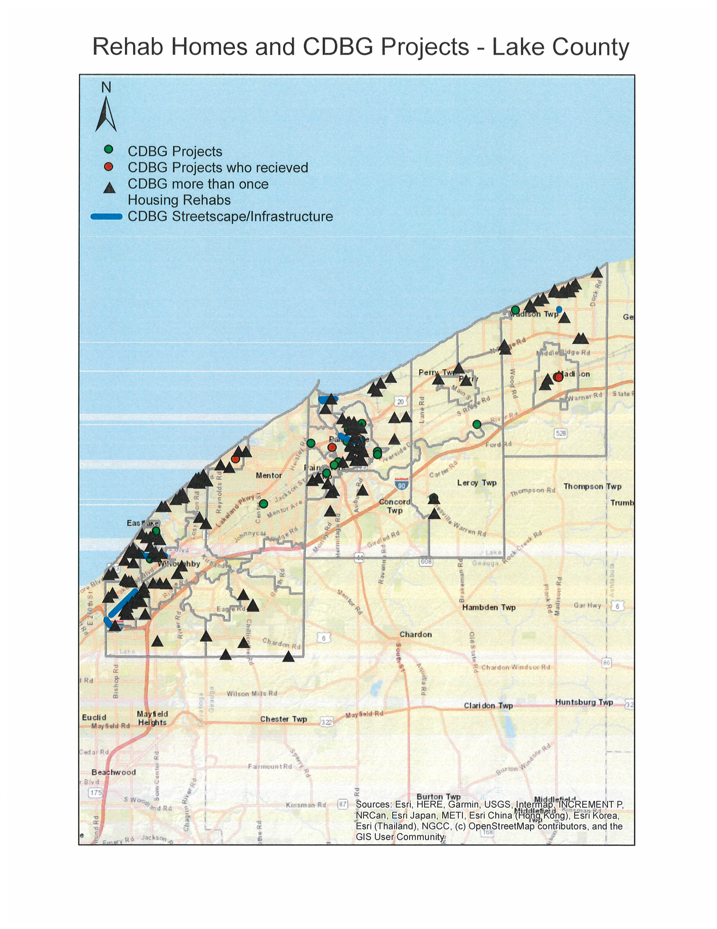
Map Rehab Homes and CDBG Projects
Unit Size by Tenure
 | Owners |  | Renters
 | Number | % | Number | %
No bedroom | 25 | 0% | 757 | 4%
1 bedroom | 584 | 1% | 4,986 | 23%
2 bedrooms | 7,563 | 14% | 9,308 | 44%
3 or more bedrooms | 45,891 | 85% | 6,316 | 30%
Total | 54,063 | 100% | 21,367 | 101%
Table 32 – Unit Size by Tenure
Data Source: | 2013-2017 ACS

Describe the number and targeting (income level/type of family served) of units assisted with federal, state, and local programs.
Lake County provides rehabilitation assistance to assist single family homeowners with immediate need items such as non-working furnaces, leaking roofs, etc. as well as modifications including ADA bathrooms, widening of doorways to accommodate a wheel chair. These programs assist approximately thirty-five homeowners each year and are funded through the County’s CDBG grant.
Provide an assessment of units expected to be lost from the affordable housing inventory for any reason, such as expiration of Section 8 contracts.
No loss anticipated.
Does the availability of housing units meet the needs of the population?
No.
Describe the need for specific types of housing:
Need exists for additional accessible and affordable housing for very low income persons and persons with physical disability.
Discussion
Housing rehabilitation is a key strategy. The goal of Lake County's housing rehabilitation program is to improve housing conditions for income eligible families living in Lake County (excluding the city of Mentor and Waite Hill), and to extend the economic life of the existing housing stock; to provide safe, basic, and sound housing.

MA-15 Housing Market Analysis: Cost of Housing - 91.210(a)
Introduction

Cost of Housing
 | Base Year: 2009 | Most Recent Year: 2017 | % Change
Median Home Value | 159,100 | 150,100 | (6%)
Median Contract Rent | 653 | 748 | 15%
Table 33 – Cost of Housing

Data Source: | 2000 Census (Base Year), 2013-2017 ACS (Most Recent Year)

Rent Paid | Number | %
Less than $500 | 3,274 | 15.3%
$500-999 | 15,322 | 71.7%
$1,000-1,499 | 2,298 | 10.8%
$1,500-1,999 | 122 | 0.6%
$2,000 or more | 367 | 1.7%
Total | 21,383 | 100.0%
Table 34 - Rent Paid
Data Source: | 2013-2017 ACS

Housing Affordability
% Units affordable to Households earning | Renter | Owner
30% HAMFI | 767 | No Data
50% HAMFI | 3,980 | 4,052
80% HAMFI | 12,902 | 13,945
100% HAMFI | No Data | 19,742
Total | 17,649 | 37,739
Table 35 – Housing Affordability
Data Source: | 2013-2017 CHAS

Monthly Rent
Monthly Rent ($) | Efficiency (no bedroom) | 1 Bedroom | 2 Bedroom | 3 Bedroom | 4 Bedroom
Fair Market Rent | 569 | 678 | 836 | 1,102 | 1,158
High HOME Rent | 569 | 678 | 836 | 1,102 | 1,158
Low HOME Rent | 569 | 678 | 830 | 958 | 1,068
Table 36 – Monthly Rent
Data Source: | HUD FMR and HOME Rents

Is there sufficient housing for households at all income levels?

How is affordability of housing likely to change considering changes to home values and/or rents?

How do HOME rents / Fair Market Rent compare to Area Median Rent? How might this impact your strategy to produce or preserve affordable housing?

Discussion

MA-20 Housing Market Analysis: Condition of Housing – 91.210(a)
Introduction

Definitions
The policy manual for the Lake County Housing Rehabilitation Program statest that units must, at a minimum, be able to comply with the County's Residential Rehabilitation Standards and Housing Quality Standards (HQS) at the completion of rehabilitation. Current HQS regulations consist of 13 key aspects of housing quality, performance requirements, and acceptability criteria to meet each performance requirements. It is the program's objectives to bring all units up to applicable Housing Quality Standards, at a minimum. Homes that are in poor overall condition and/or have numerous serious problems that cannot be corrected within the limit of financial assistance ($25,000 cap on General Property Protection Program) will not be rehabilitated at the discretion of the County.
Condition of Units
Condition of Units | Owner-Occupied |  | Renter-Occupied
Condition of Units | Number | % | Number | %
With one selected Condition | 10,625 | 20% | 8,688 | 41%
With two selected Conditions | 93 | 0% | 290 | 1%
With three selected Conditions | 8 | 0% | 120 | 1%
With four selected Conditions | 0 | 0% | 0 | 0%
No selected Conditions | 43,325 | 80% | 12,290 | 57%
Total | 54,051 | 100% | 21,388 | 100%
Table 37 - Condition of Units
Data Source: | 2013-2017 ACS

Year Unit Built
Year Unit Built | Owner-Occupied |  | Renter-Occupied
Year Unit Built | Number | % | Number | %
2000 or later | 7,050 | 13% | 1,579 | 7%
1980-1999 | 11,245 | 21% | 4,481 | 21%
1950-1979 | 26,243 | 49% | 12,086 | 57%
Before 1950 | 9,528 | 18% | 3,203 | 15%
Total | 54,066 | 101% | 21,349 | 100%
Table 38 – Year Unit Built
Data Source: | 2013-2017 CHAS

Risk of Lead-Based Paint Hazard
Risk of Lead-Based Paint Hazard | Owner-Occupied |  | Renter-Occupied
Risk of Lead-Based Paint Hazard | Number | % | Number | %
Total Number of Units Built Before 1980 | 35,771 | 66% | 15,289 | 72%

Housing Units build before 1980 with children present | 3,117 | 6% | 2,405 | 11%
Table 39 – Risk of Lead-Based Paint
Data Source: | 2013-2017 ACS (Total Units) 2013-2017 CHAS (Units with Children present)

Vacant Units
 | Suitable for Rehabilitation | Not Suitable for Rehabilitation | Total
Vacant Units | 0 | 0 | 0
Abandoned Vacant Units | 0 | 0 | 0
REO Properties | 0 | 0 | 0
Abandoned REO Properties | 0 | 0 | 0
Table 40 - Vacant Units
Data Source: | 2005-2009 CHAS

Need for Owner and Rental Rehabilitation
Based on the age of housing stock in Lake County (majority built prior to 1980, including many 1950's-1960's bungalow style houses), there is a need for rehabilitation. Due to the rising number of senior citizens and the desire to "age in place" there is a demand for making ADA improvements to housing including the addition of entryway ramps, ADA bathroom improvements, etc. Lake County has allocated funding through both the CDBG Program and Senior Levy for ADA-type improvements to houses.
Estimated Number of Housing Units Occupied by Low or Moderate Income Families with LBP Hazards
Considering the majority of the housing stock in Lake County was built prior to 1978, we can assume that a large percentage of housing may contain lead-based paint hazards.
Discussion

MA-25 Public and Assisted Housing – 91.210(b)
Introduction
Lake MHA has transitioned to RAD. They are working to make a nonprofit branch-off active (RAISE). They have expressed an interest in project based incentives.
Totals Number of Units
Program Type
 | Certificate | Mod-Rehab | Public Housing | Vouchers
 |  |  |  | Total | Project -based | Tenant -based | Special Purpose Voucher
 |  |  |  |  |  |  | Veterans Affairs Supportive Housing | Family Unification Program | Disabled  *
# of units vouchers available |  |  | 241 | 1,457 |  |  | 0 | 193 | 0
# of accessible units

*includes Non-Elderly Disabled, Mainstream One-Year, Mainstream Five-year, and Nursing Home Transition
Table 41 – Total Number of Units by Program Type
Data Source: | PIC (PIH Information Center)

Describe the supply of public housing developments:
Describe the number and physical condition of public housing units in the jurisdiction, including those that are participating in an approved Public Housing Agency Plan:
Lake MHA has sought to maintain and improve their units at Woodlawn (family), Jackson Towers and Washington Square (senior/disabled) and ParkView Place through lighting, security, window replacement and HVAC improvements.

Public Housing Condition
Public Housing Development | Average Inspection Score
Table 42 - Public Housing Condition

Describe the restoration and revitalization needs of public housing units in the jurisdiction:
Additional details to be provided from Lake MHAs plans
Describe the public housing agency's strategy for improving the living environment of low- and moderate-income families residing in public housing:
Additional details to be provided from Lake MHAs plans
Discussion:
Additional details to be provided from Lake MHAs plans

MA-30 Homeless Facilities and Services – 91.210(c)
Introduction
Please see estimates below and listing of key agencies and entities.
Facilities and Housing Targeted to Homeless Households
 | Emergency Shelter Beds |  | Transitional Housing Beds | Permanent Supportive Housing Beds
 | Year Round Beds (Current & New) | Voucher / Seasonal / Overflow Beds | Current & New | Current & New | Under Development
Households with Adult(s) and Child(ren) | 10 | 0 | 0 | 0 | 0
Households with Only Adults | 40 | 15 | 0 | 17 | 17
Chronically Homeless Households | 0 | 0 | 0 | 0 | 0
Veterans | 0 | 0 | 0 | 0 | 0
Unaccompanied Youth | 0 | 0 | 0 | 0 | 0
Table 43 - Facilities and Housing Targeted to Homeless Households

Data Source Comments:

Describe mainstream services, such as health, mental health, and employment services to the extent those services are use to complement services targeted to homeless persons
Health - Signature Health is a Federally Qualified Health Center with an office located in Painesville City.
Mental Health - ADAMHS Board agencies
Job and Family Services - works in tandem with these other groups
List and describe services and facilities that meet the needs of homeless persons, particularly chronically homeless individuals and families, families with children, veterans and their families, and unaccompanied youth. If the services and facilities are listed on screen SP-40 Institutional Delivery Structure or screen MA-35 Special Needs Facilities and Services, describe how these facilities and services specifically address the needs of these populations.
Extended Housing Path team, Frontline Services, Veteran Services Commission, Code Blue and SubZero Mission

MA-35 Special Needs Facilities and Services – 91.210(d)
Introduction

Including the elderly, frail elderly, persons with disabilities (mental, physical, developmental), persons with alcohol or other drug addictions, persons with HIV/AIDS and their families, public housing residents and any other categories the jurisdiction may specify, and describe their supportive housing needs

Describe programs for ensuring that persons returning from mental and physical health institutions receive appropriate supportive housing

Specify the activities that the jurisdiction plans to undertake during the next year to address the housing and supportive services needs identified in accordance with 91.215(e) with respect to persons who are not homeless but have other special needs. Link to one-year goals. 91.315(e)

For entitlement/consortia grantees: Specify the activities that the jurisdiction plans to undertake during the next year to address the housing and supportive services needs identified in accordance with 91.215(e) with respect to persons who are not homeless but have other special needs. Link to one-year goals. (91.220(2))

MA-40 Barriers to Affordable Housing – 91.210(e)
Negative Effects of Public Policies on Affordable Housing and Residential Investment
Tax policies afffecting land, Zoning Ordinances, Building Codes ... See AP section

MA-45 Non-Housing Community Development Assets – 91.215 (f)
Introduction

Economic Development Market Analysis
Business Activity
Business by Sector | Number of Workers | Number of Jobs | Share of Workers  % | Share of Jobs  % | Jobs less workers  %
Agriculture, Mining, Oil & Gas Extraction | 678 | 1,148 | 1 | 2 | 1
Arts, Entertainment, Accommodations | 9,304 | 6,999 | 12 | 14 | 2
Construction | 3,622 | 2,826 | 5 | 6 | 1
Education and Health Care Services | 17,115 | 9,937 | 22 | 20 | -2
Finance, Insurance, and Real Estate | 5,307 | 1,830 | 7 | 4 | -3
Information | 1,006 | 232 | 1 | 0 | -1
Manufacturing | 16,085 | 12,431 | 20 | 25 | 5
Other Services | 2,889 | 1,926 | 4 | 4 | 0
Professional, Scientific, Management Services | 7,373 | 2,343 | 9 | 5 | -4
Public Administration | 0 | 0 | 0 | 0 | 0
Retail Trade | 9,276 | 6,159 | 12 | 13 | 1
Transportation and Warehousing | 1,974 | 773 | 3 | 2 | -1
Wholesale Trade | 4,300 | 2,666 | 5 | 5 | 0
Total | 78,929 | 49,270 | -- | -- | --
Table 45 - Business Activity
Data Source: | 2013-2017 ACS (Workers), 2017 Longitudinal Employer-Household Dynamics (Jobs)

Labor Force
Total Population in the Civilian Labor Force | 97,529
Civilian Employed Population 16 years and over | 92,485
Unemployment Rate | 5.17
Unemployment Rate for Ages 16-24 | 16.27
Unemployment Rate for Ages 25-65 | 3.57
Table 46 - Labor Force
Data Source: | 2013-2017 ACS

Occupations by Sector | Number of People
Management, business and financial | 21,348
Farming, fisheries and forestry occupations | 2,937
Service | 9,385
Sales and office | 22,050
Construction, extraction, maintenance and repair | 6,849
Production, transportation and material moving | 6,307
Table 47 – Occupations by Sector
Data Source: | 2013-2017 ACS

Travel Time
Travel Time | Number | Percentage
< 30 Minutes | 58,534 | 66%
30-59 Minutes | 26,599 | 30%
60 or More Minutes | 2,921 | 3%
Total | 88,054 | 100%
Table 48 - Travel Time
Data Source: | 2013-2017 ACS

Education:
Educational Attainment by Employment Status (Population 16 and Older)
Educational Attainment | In Labor Force
Educational Attainment | Civilian Employed | Unemployed | Not in Labor Force
Less than high school graduate | 3,903 | 320 | 2,176
High school graduate (includes equivalency) | 21,600 | 1,503 | 6,664
Some college or Associate's degree | 26,460 | 1,042 | 5,409
Bachelor's degree or higher | 23,735 | 570 | 2,822
Table 49 - Educational Attainment by Employment Status
Data Source: | 2013-2017 ACS

Educational Attainment by Age
 | Age
 | 18–24 yrs | 25–34 yrs | 35–44 yrs | 45–65 yrs | 65+ yrs
Less than 9th grade | 108 | 473 | 408 | 761 | 1,573
9th to 12th grade, no diploma | 1,880 | 1,067 | 1,227 | 2,491 | 2,957
High school graduate, GED, or alternative | 4,795 | 5,396 | 5,717 | 18,665 | 13,678
Some college, no degree | 5,463 | 4,892 | 5,052 | 12,214 | 6,532
Associate's degree | 875 | 2,480 | 2,678 | 5,631 | 1,762
Bachelor's degree | 1,601 | 5,191 | 3,925 | 8,576 | 3,543
Graduate or professional degree | 50 | 2,263 | 2,558 | 4,613 | 2,450
Table 50 - Educational Attainment by Age
Data Source: | 2013-2017 ACS

Educational Attainment – Median Earnings in the Past 12 Months
Educational Attainment | Median Earnings in the Past 12 Months
Less than high school graduate | 407,355
High school graduate (includes equivalency) | 707,100
Some college or Associate's degree | 859,085
Bachelor's degree | 1,165,570
Graduate or professional degree | 1,417,425
Table 51 – Median Earnings in the Past 12 Months
Data Source: | 2013-2017 ACS

Based on the Business Activity table above, what are the major employment sectors within your jurisdiction?
The major employment sector is “Education and Health Care Services” and “Manufacturing”. Lake County is home to two major Lake Health hospitals and numerous outpatient care type facilities. Additionally, the Cleveland Clinic is set to open a new hospital in the City of Mentor in 2023. The County is also home to Lakeland Community College and Lake Erie College providing high wage employment opportunities.
According to the LC Workforce Development Board, in 2020 there were over 22,000 people employed in manufacturing in 2020, which is a 5% increase from 2015 and is expected to grow by 2% by 2025. Organizations like Alliance for Working together (AWT) and Chamber of Commerce organizations play an active role in promoting careers in manufacturing.
Another major employment sector is “Health care and social assistance”, followed closely by “Arts, Entertainment, Accommodations” and “Retail trade” employees. Lake County’s agricultural economy, including the wine and grape industry, produce sales from good and services valued at over $160 mil. annually and supports an estimated 1,500 jobs.
The following are top employers in Lake County: ABB Inc, Manufacturing; Avery Dennison Corp, Manufacturing; FirstEnergy Corp, Utility; Lake County Government, Government; Lake Hospital System, Health Care; Lincoln Electric Holding Inc, Manufacturing; Lubrizol Corp, Manufacturing; Mentor Exempted Village Schools, Education; STERIS Corp, Manufacturing.
Describe the workforce and infrastructure needs of the business community:
The Ohio Department of Job and Family Services 2028 Job Outlook report includes a summarization of 2018 employment levels and projected 2028 levels. The Cleveland-Elyria-Mentor MSA is projected to grow 7.4 percent. When looking at the summary of employment by industry and occupational group, we can see the occupations that are expected to grow the fastest. The fastest growing industry group is health care services with an increase of 35.6%. One reason for the growth in this sector is Ohio’s aging population, as more Baby Boomers reach retirement age.
The table above, titled "travel time" shows that 30 minutes is the highest percentage (68%). Lake County has two main highways running east to west, State Route 2 and State Route 90, making it easy to travel the length of the County quickly. Additionally, as noted above, there is sufficient infrastructure allowing a short commute to the City of Cleveland.
According to the Consolidated Plan Survey results, respondents identified the infrastructure priorities as follows, from highest to lowest: Street improvements, Sanitary sewer/septic improvements, Lakefront development, Sidewalk and curb cuts improvements, Flood control/drainage improvements, and Create greater Wi-Fi access.
Describe any major changes that may have an economic impact, such as planned local or regional public or private sector investments or initiatives that have affected or may affect job and business growth opportunities during the planning period. Describe any needs for workforce development, business support or infrastructure these changes may create.
As part of Lake County's research for the Consolidated Plan, an online survey was conducted, and received over 600 responses. Of the responders, 6% indicated they are an Owner or Employee of a business serving Lake County and 49% of responders indicated that they are residents of Lake County. Serveys were received from nearly every community in the County. Responders were asked to rank the economic development priorities of Lake County over the next 5 years. The results were, from highest to lowest, Job Creation, Job Training, Acquisition/Rehab of commercial properties, Façade improvements, and Business Loans. Lake County will continue to expand the existing CDBG funded Economic Development activities to provide for job creation and commercial property improvements in the County. The Lake Development Authority is authorized by State law to enhance, foster, aid, provide or promote transportation, economic development, housing, recreation, governmental operation, culture or research.
Recent actions that have impacted Lake County economically include: The Lake Development Authority’s successful efforts to create a funding source with the passage of the 2% Hotel Bed Tax for Coastal Improvements, providing reliable funding to encourage lakefront improvements. With partners Team NEO, Greater Cleveland Partnership and Jobs Ohio they have brought over $143,000,000 in port bond financing to make Lake County projects possible. 436 new hotel rooms were added and over $50,000,000 in hotel investment. Since the agency assumed sponsorship of the Lost Nation Airport, renamed Lake County Executive Airport, they have made over $2.6 million dollars of improvements, enhancing the safety of the airport and improving it as a business attraction tool. They also reimagined the 1950’s bungalows of western Lake County as a 2019 open concept showcase model home to encourage reinvestment in these communities.
How do the skills and education of the current workforce correspond to employment opportunities in the jurisdiction?
Lake County is fortunate to have local higher educational institutions including Lake Erie College, Auburn Career Center, and Lakeland Community College, which recently established Holden University Center in 2011. Holden offers bachelors and graduate degrees. The table above, titled "Educational Attainment by Employment Status," indicates that the largest amount of those employed have some college or associates degree. The largest amount of those unemployed have a highschool diploma or equivalent. Job training opportunities are present in Lake County, through Job and Family Services, and through Beacon Health, benefitting those with mental disabilities.
Describe any current workforce training initiatives, including those supported by Workforce Investment Boards, community colleges and other organizations. Describe how these efforts will support the jurisdiction's Consolidated Plan.
Lake County and the Cleveland metropolitan area are served by a large number and variety of training providers. There are 23 colleges and universities in the greater Cleveland area, including Case Western Reserve University, Cleveland State University, and Kent State University. Programs like AWT's Robobots, the Junior Robots, Summer Manufacturing Camps, Auburn Career Center's "We Build It Here" video series, the Chamber of Commerce's "Manufacturing Day" and the LC Development Authority's Teacher Day are all part of county-wide efforts to develop a future workforce to support the 900+ manufacturing business in Lake County.
Lake County is served by Auburn Career Center, a full-service career center offering both secondary and adult vocational programs. Lake County’s nine public school districts provide vocational education programs to students either directly or in conjunction with Auburn. Lakeland Community College provides Tech Prep programs in several occupational areas to students of all public school districts within the county.
As noted above, Lake County is home to two institutions of higher learning. These are Lake Erie College in the City of Painesville and Lakeland Community College/Holden University Center in Mentor. These institutions provide Associates degrees in several Science and Health Technologies and bachelor degrees and master’s degrees in education. These are in the business sector identified as having the greatest number of jobs.
In addition to the educational opportunities noted above, the Lake County Jobs and Family Services Department is home to Lake 1 Stop. Created in 2004 by the Lake County Workforce Investment Board and the County Commissioners, this agency provides a vast array of job training and educational opportunities, all of which support the Consolidated Plan.
Does your jurisdiction participate in a Comprehensive Economic Development Strategy (CEDS)?
No
If so, what economic development initiatives are you undertaking that may be coordinated with the Consolidated Plan? If not, describe other local/regional plans or initiatives that impact economic growth.
The Lake County Development Authority continues to leverage grant monies from the FAA and ODOT to make the necessary upgrades to the Lake County Executive Airport.
Retaining local students is an important means of fulling the future talent needs of Lake County Businesses. The event “Career Bound: College Internship & Job Fair” is a collaborative event that connects more than 1,500 Lake County college students and graduates to companies in Lake County. Economic Development tools such as Energy Special Improvement District (ESID) and PACE financing (Property Assessed Clean Energy) is utilized in Lake County for keeping and attracting business. During 2019 the cities of Willoughby and Eastlake passed legislation to join the Lake County Communities ESID. Progress in coastal development include the following projects in 2018 and later: Grand River Study; Stanton Park (completion of utility relocation component of the shoreline enhancement project); Mentor Harbor Channel (study to evaluate options for maintaining the channel); Transient Marina and Water Plant (grant for market analysis & basic design study).
Lake County Business Roundtable Discussion Series – purpose, “to serve as an open forum for local businesses to share their experiences over the previous 18 months and to provide opinions on improving the local business environment; topics to include but are not limited to, workforce, resource allocation, supply chain concerns and overall economic conditions; the meeting will focus on listening to the needs an concerns of the private sector as it relates to the pandemic and potential assistance from the County.” The initiative was founded by Lake County Treasurer and Lake County Commissioners.
Transit Go is a Laketran pilot program that offers a free ride to work among the benefits at some jobs; the program aims to reduce transportation barriers to employment, ultimately improving workforce development. Over 175 employers are enrolled.
Discussion

MA-50 Needs and Market Analysis Discussion
Are there areas where households with multiple housing problems are concentrated? (include a definition of "concentration")
Yes.
Are there any areas in the jurisdiction where racial or ethnic minorities or low-income families are concentrated? (include a definition of "concentration")
Yes as discussed previously in NA Disproportionate need section there are racial and ethnic concentrations and low income concentrations in Painesville City. There are areas that meet the concentration critera noted in the AFH in other areas within LCUC.
What are the characteristics of the market in these areas/neighborhoods?
2021 Social Services Needs Assessment Lake & Geauga Counties, Ohio, study completed by Lifeline, Inc. Key findings: Senior population continues to rise and is an area of concern for all of the health and human service providers in Lake County. The median household income continues to increase, but so does the cost of housing and other material items. Lake County saw a brief spike in unemployment during the pandemic, but has returned to pre-pandemic unemployment rates. Housing costs in Lake and Geauga counties continue to exceed state averages and there is a large demand for public housing and housing choice vouchers. The study found less food scarcity due to innovative partnerships formed during the pandemic for food distribution. Lake Tran has increased transportation options over the past two years including the addition of a Tyler Boulevard rout to our primary manufacturing corridor and new bus stations throughout the county. However, there are still barriers such as limited hours and routes.
Are there any community assets in these areas/neighborhoods?
Community assets are in areas and neighborhoods throughout the LCUC and there are some in these disproportionately affected areas as well. There is room for additional investment.
Are there other strategic opportunities in any of these areas?
Additional investment may occur since at least one of these areas was market as an opportunity zone for taxes. Painesville City has also identified several areas within their boundary as CRA areas.

MA-60 Broadband Needs of Housing occupied by Low- and Moderate-Income Households - 91.210(a)(4), 91.310(a)(2)
Describe the need for broadband wiring and connections for households, including low- and moderate-income households and neighborhoods.
2021 State of Poverty in Ohio, Study by the Ohio Association of Community Action Agencies. The focus of the study was how COVID-19 affected factors like job stability, access to healthcare and childcare, food insecurity, and other concerns for Ohioans who are at or near the poverty level. Key takaways: Low-income parents were faced with remote education challenges including broadband access, lack of IT equipment, and in some cases, lack of ability to assist their children with schoolwork. Twice as many low-income Ohio households had fallen behind on rent payments in January 2021 as had in April 2020. Over half of low-income households reported a loss of employment income.
Describe the need for increased competition by having more than one broadband Internet service provider serve the jurisdiction.
Weak competition yields high prices for consumers and little pressure for companies to upgrade their networks to offer better service.

MA-65 Hazard Mitigation - 91.210(a)(5), 91.310(a)(3)
Describe the jurisdiction’s increased natural hazard risks associated with climate change.
This jurisdiction is located on the southern shore of Lake Erie. Climate change is a global problem and affects communities on a local level, the Midwest included. In Ohio, Lake Erie is a major concern. Report notes from the Fourth National Climate Assessment Report describes the increase of lake-effect snow, and attributes it to warming in the Midwest. Should this trend continue, the report states, "Reductions in lake ice may increase the frequency of lake-effect snows until winters become so warm that snowfall events shift to rain." Lake Erie is also seeing an incrase in algal blooms. Cyanobacteria from an algea bloom polluted the drinking water in nearby Toledo. Increased frequency of heaby rains can lead to flooding, soil erosion, and water quality issues. According to the Ohio Dept. of Natural Resources, the Lake Erie shore is a very dynamic area and shore erosion is very site-specific depending on local conditions and weather patterns. Erosion cannot be stopped but can be managed through a variety of methods.
Describe the vulnerability to these risks of housing occupied by low- and moderate-income households based on an analysis of data, findings, and methods.
The hazard risks associated listed above include increase of lake-effect snow, increase of heavy rains leading to flooding, soil erosion, water quality issues, increase in algal blooms that can pollute drinking water, area all risks that can disproportionately affect low- and moderate-income households. Lake County has aging infrustructure in many areas that cannot effectively handle heavy rain event. CDBG funds have been used in several areas in the County, including Mentor-on-the-lake, Fairport Harbor, Willoughby Hills, and Painesville City, to improve water/sewer lines and make other drainage improvements. The Lake County Soil and Water Conservation District's Urban Programs focus on protecting the County's natural resources through education, technical assistance, and administration of county and municipal erosion and sediment control ordinances. According to the District's website, "Balancing natural resource protection with urbanization is an ever increasing challenge Lake County faces in its goal to protect the 436 miles of streams and rivers in the County in addition to 31 miles of Lake Erie shoreline, countless wetlands, locally unique soils and other important natural resources."

Strategic Plan

SP-05 Overview
Strategic Plan Overview
This plan includes goals, resources and measurable objectives that will demonstrate to all who view the resultant work that the investment of time and money was well worth the return. Planning in an open and truly collaborative process is certain to result in building the tangible and enhancing the intangible. As noted early in this plan this is a time when needs are abundant and standard resources are not meeting the requests. Lake County residents, communities, businesses and governments are faced with new challenges and this Consolidated Plan is one opportunity to work cooperatively and actively address the needs we face.
The organization of our strategy within this plan is in keeping with the five objectives stated in the Executive Summary that focused on: Housing (produce, preserve and restore healthy rental and owner markets; leverage funds to attract investment and increase affordability); Infrastructure (improve living environment by repair or replacement of systems; continue public facility improvements; continue in areas where sufficient concentration of residents meet income restrictions); Provision of support services to income eligible residents (network of agencies that provide necessary support to LMI residents; support includes collaboration, staff and capital improvements); Service Coordination and linkages to COC/Homeless agencies/Populations (meet outcome measures indecated by funders; work smart and share credit at local, regional, state and national level); Economic Development (inclusive of residents, businesses, non-profit, government sectors; generate and maintain employment opportunities).

SP-10 Geographic Priorities – 91.215 (a)(1)
Geographic Area
Table 52 - Geographic Priority Areas
1 | Area Name: | City of Painesville
1 | Area Type: | Local Target area
1 | Other Target Area Description:
1 | HUD Approval Date:
1 | % of Low/ Mod:
1 | Revital Type: | Housing
1 | Other Revital Description:
1 | Identify the neighborhood boundaries for this target area. | The boundaries of this target area are the municipal boundaries.
1 | Include specific housing and commercial characteristics of this target area. | Housing: The Community Development/Building/Code Enforcement Department for the City of Painesville has identified housing rehabilitation as a major need. During the past 12months, inspectors identified various properties for roofs, gutter and downspouts that needed repaired or replaced. Peeling and chipping paint has also been identified as an issue with may homes in the City. The housing stock in the City is older, primarily constructed in the 1950's and 1960's.  Commercial: The City of Painesville has been undergoing great transformations. However, several buildings in the City are independently owned and in extremely poor conditions. In the recent months, front windows have been broken, several brick and structural issues have immerged and there is sever deterioration in the lower fronts of the buidlings. Some of the major issues include: perceived blight, security lighting, stressed windows or broken windows, paint chipping, falling exterior decorative elements, bricks in need of tuck pointing, stairway fire escaptes that are haning and other key factors that are making it difficult to rent, lease and sell space wthin the downtown. There are also several buildings that are in need of new awnings, lighting and small window improvements. The Richmond Street District area and other key gateway corridors have several buildings that have aged and are showing signs of distress and blight.
1 | How did your consultation and citizen participation process help you to identify this neighborhood as a target area? | The consultation and citizen participation process completed for the County's Con Plan helped to identify this neighborhood as a target area. Lake County held public meetings for the purpose of gathering public comments. Additionally, an online survey was used. The survey generated 248 responses, with the largest percentage of responses from Painesville City. Nearly 50% of responses were from residents of Lake County, followed by Leader/Employee of an Agency serving lake county, Elected or Appointed Official serving Lake County, and Owner or Employee of a Business serving Lake County. The area was identified as having a high concentration of minorities and of Hispanic persons. The City is considered a low/mod area using HUD data. There is a concentration of public service agencies in the City - such as the Free Clinic, Salvation Army, Extended Housing, Lifeline, etc. Other entities within the City include the Lake County Job and Family Services department, the County Jail, and several outpatient and inpatient treatment facilities for those recovering from drug and alcohol addiction. Compared to the rest of the county, there is a concentration of low-income housing in the City, including concentrations of housing for persons with mental illness, and public housing.
1 | Identify the needs in this target area. | The needs of the City, as identified in the AFH include: expanded public transportation, increased education options, increased options for safe and decent housing, a grocery store located in the City, and increased job opportunities.
1 | What are the opportunities for improvement in this target area? | According to the 2022 State of the City Address, there has been much progress and collaboration happening in Painesville. The former Chase Bank building on Painesville Square is being renovated for Lake Erie College student housing, and a streetscape project is planned for this area. On Chester Street, Avery Dennison will be expanding and creating 33 new full-time jobs. Signature Health is renovating an existing commercial building into a medical center. HOLA has recently completed a renovation to crate a new Hispanic Community Center which includes an incubator kitchen. New single-family housing is being constructed off of Shamrock Blvd. There will be 119 new market rate senior apartments constructed. Regarding infrastructure, new Electric Vehicle charging stations were installed in downtown Painesville, and the City expects a total of $6.8 mil in street improvements. Plans are in process for a full interchange at Rt. 44. The City is utilizing TIF districts as an economic development tool.  During fiscal year 2022, the City is continuing its Residential Roofing and Siding Program with the assistance of CDBG funds. This program is in demand as evidenced by the number of resident applications, and was funded previously with the City’s ARPA dollars. Additionally, CDBG funds will go towards the streetscape project on Painesville Square.
1 | Are there barriers to improvement in this target area? | One barrier that may exist in this target area is reaching the Hispanic population and encouraging participation in the housing rehab program. We know from data collected for the AFH that Hispanic persons are less likely to participate in government-sponsored programs. With the opening of the new HOLA community center, the City has valuable resource for reaching this community.  Because residential property is affordable in the City compared to other areas of the county, the City has been the site for much of the housing constructed for LMI populations by agencies such as Habitat for Humanity, Extended Housing, Lake-Geauga Recovery Centers, and other agencies. Ideally, housing and services would be located throughout the county rather than clustered, where it puts pressure on various institutions such as policy & fire, schools, etc.
2 | Area Name: | Lake County
2 | Area Type: | Local Target area
2 | Other Target Area Description:
2 | HUD Approval Date:
2 | % of Low/ Mod:
2 | Revital Type: | Comprehensive
2 | Other Revital Description:
2 | Identify the neighborhood boundaries for this target area. | County-wide.
2 | Include specific housing and commercial characteristics of this target area.
2 | How did your consultation and citizen participation process help you to identify this neighborhood as a target area?
2 | Identify the needs in this target area.
2 | What are the opportunities for improvement in this target area?
2 | Are there barriers to improvement in this target area?

General Allocation Priorities
Describe the basis for allocating investments geographically within the jurisdiction (or within the EMSA for HOPWA)

SP-25 Priority Needs - 91.215(a)(2)
Priority Needs
Table 53 – Priority Needs Summary
1 | Priority Need Name | AFH FACTOR: COMMUNITY OPPOSITION
1 | Priority Level | High
1 | Population | Extremely Low  Low  Moderate  Middle  Large Families  Families with Children  Elderly  Public Housing Residents  Rural  Chronic Homelessness  Individuals  Families with Children  Mentally Ill  Chronic Substance Abuse  veterans  Persons with HIV/AIDS  Victims of Domestic Violence  Unaccompanied Youth  Elderly  Frail Elderly  Persons with Mental Disabilities  Persons with Physical Disabilities  Persons with Developmental Disabilities  Persons with Alcohol or Other Addictions  Persons with HIV/AIDS and their Families  Victims of Domestic Violence
1 | Geographic Areas Affected | Lake County
1 | Associated Goals | AFH GOAL: INCREASE LEVEL OF FAIR HOUSING KNOWLEDGE  AFH GOAL: MONITOR LOCAL ZONING CODES  AFH GOAL: PROVIDE INCREASED FAIR HOUSING INFO.
1 | Description | Community opposition is prevalent within Lake County as evidenced by comments made at community meetings and on the survey conducted. The county and FHRC received a substantial amount of negative feedback from community residents during multiple forums and surveys in regards to existing developments and proposals on the incorporation of additional public housing opportunities for the low income residents. Most community members expressed concerns for the development of new subsidized housing developments being built within the area with concerns on property values, increased minorities, and attracting “those people” to our community.
1 | Basis for Relative Priority | We have identified this as a high priority contributing factor as the prevalence of community opposition limits housing choice and denies access to opportunities for nearly all categories of protected classes in Lake County.
2 | Priority Need Name | AFH FACTOR: PRIVATE DISCRIMINATION
2 | Priority Level | High
2 | Population | Extremely Low  Low  Moderate  Middle  Families with Children  Elderly  Public Housing Residents  Rural  Chronic Homelessness  Individuals  Families with Children  Mentally Ill  Chronic Substance Abuse  veterans  Persons with HIV/AIDS  Victims of Domestic Violence  Unaccompanied Youth  Elderly  Frail Elderly  Persons with Mental Disabilities  Persons with Physical Disabilities  Persons with Developmental Disabilities  Persons with Alcohol or Other Addictions  Persons with HIV/AIDS and their Families  Victims of Domestic Violence
2 | Geographic Areas Affected | Lake County
2 | Associated Goals | AFH GOAL: STRENGTHEN FAIR HOUSING EDUCATION  AFH GOAL: INCREASE LEVEL OF FAIR HOUSING KNOWLEDGE
2 | Description | There is evidence that discriminatory housing practices exist throughout the County. The Fair Housing Resource Center, Inc. authored a report, Discrimination in the Tri-County Housing Market, 2011-2014[1] that looked at discrimination in the housing market for the Tri-County area of Lake, Geauga and Ashtabula Counties. The report concluded that systemic testing results yielded “that discrimination occurs for 1 out of every 3 persons when seeking rental homes in the area. Specifically, evidence revealed various forms of discrimination against residents including: imposing questionable occupancy standards that discriminate against families with children; refusing to make accommodations to policies for persons with disabilities; outright refusals to consider applicants because of their handicap, race, or national origin; outright refusals by lenders to work with Blacks seeking home mortgages and lastly, presence of exclusionary zoning within the area. Current intake of complaints indicates the same type of discriminatory practices continue.
2 | Basis for Relative Priority | We have identified this as a high priority contributing/factor as the prevalence of Private discrimination limits housing choice and denies access to opportunities for nearly all categories of protected classes in Lake County.
3 | Priority Need Name | AFH FACTOR: LOCATION AND TYPE OF HOUSING
3 | Priority Level | High
3 | Population | Extremely Low  Low  Moderate  Middle  Large Families  Families with Children  Elderly  Public Housing Residents  Rural  Chronic Homelessness  Individuals  Families with Children  Mentally Ill  Chronic Substance Abuse  veterans  Persons with HIV/AIDS  Victims of Domestic Violence  Unaccompanied Youth  Elderly  Frail Elderly  Persons with Mental Disabilities  Persons with Physical Disabilities  Persons with Developmental Disabilities  Persons with Alcohol or Other Addictions  Persons with HIV/AIDS and their Families  Victims of Domestic Violence
3 | Geographic Areas Affected | Lake County
3 | Associated Goals | AFH GOAL: INCREASE LEVEL OF FAIR HOUSING KNOWLEDGE  AFH GOAL: INCREASE AMOUNT OF AFFORDABLE HOUSING
3 | Description | Concentration of affordable housing in few areas of the LCUC limits choice and results in people not having access to opportunity.
3 | Basis for Relative Priority | Because affordable housing is concentrated in areas of low opportunity it is a significant barrier to those who want to access jobs, proficient schools, and other community resources.
4 | Priority Need Name | AFH FACTOR: LACK OF PRIVATE INVESTMENT IN SPECIFIC
4 | Priority Level | Low
4 | Population | Extremely Low  Low  Moderate  Middle  Large Families  Families with Children  Elderly  Public Housing Residents  Rural  Chronic Homelessness  Individuals  Families with Children  Mentally Ill  Chronic Substance Abuse  veterans  Persons with HIV/AIDS  Victims of Domestic Violence  Unaccompanied Youth  Elderly  Frail Elderly  Persons with Mental Disabilities  Persons with Physical Disabilities  Persons with Developmental Disabilities  Persons with Alcohol or Other Addictions  Persons with HIV/AIDS and their Families  Victims of Domestic Violence
4 | Geographic Areas Affected | Lake County
4 | Associated Goals | AFH GOAL: INCREASE LEVEL OF FAIR HOUSING KNOWLEDGE  AFH GOAL: INCREASE AMOUNT OF AFFORDABLE HOUSING
4 | Description | The majority of subdivisions being created in Lake County contain larger lots and homes with high square footage, which are unaffordable. Many communities have minimum lot sizes or minimum house sizes, which prevents developers from building affordable housing. Other cities are completely built out and there is little to no construction occurring. What little new construction has occurred, the price of the rental housing is at the highest end of the rental spectrum making such housing unaffordable to the average renter.  The need for affordable housing has increased and outpaced the level of private investment available. This is due to the interest in making profitable investments. Without a subsidy source nothing occurs.
4 | Basis for Relative Priority | We have identified this as a low priority because, while the factor is present in Lake County, it does not appear to limit or deny fair housing choice or access to opportunity or negatively impact fair housing or civil rights compliance.
5 | Priority Need Name | AFH FACTOR: LACK OF PUBLIC INVESTMENT IN SPECIFIC
5 | Priority Level | Low
5 | Population | Extremely Low  Low  Large Families  Families with Children  Elderly  Public Housing Residents
5 | Geographic Areas Affected | Lake County
5 | Associated Goals | AFH GOAL: INCREASE LEVEL OF FAIR HOUSING KNOWLEDGE
5 | Description | Lack of public investement in specific neighborhoods: Over the last few years, the multi-family construction market nearly stopped building new projects and State Government failed to invest in affordable housing programs. A recently published report by the Ohio Legal Aid Programs indicated that Ohio’s Low-Income Housing Tax Credit program “did not provide housing in low-economic areas for families with children.” While this issue is clearly a local one and has received the attention of our local governmental officials, very little attention has been given to affordable housing at the federal level. The concerns regarding affordable housing, coupled with the state of the economy, creates an environment where there are too many individuals living in cost burdened housing without any future relief. The County has provided funding with CDBG/HOME dollars to public investment projects as appropriate. The County utilizes every opportunity to continue to provide financial assistance to new projects and has listed this as a low priority as it highlights work already undertaken in the County.
5 | Basis for Relative Priority | We have identified this as a low priority because, while the factor is present in Lake County, it does not appear to limit or deny fair housing choice or access to opportunity or negatively impact fair housing or civil rights compliance.
6 | Priority Need Name | AFH FACTOR: ACCESS TO FINANCIAL SERVICES
6 | Priority Level | High
6 | Population | Extremely Low  Low  Moderate  Large Families  Families with Children  Elderly
6 | Geographic Areas Affected | Lake County
6 | Associated Goals | AFH GOAL: INCREASE LEVEL OF FAIR HOUSING KNOWLEDGE  AFH GOAL: PROVIDE INCREASED FAIR HOUSING INFO.
6 | Description | There are a high number of financial institutions with physical locations throughout the area. However, there is direct evidence of inequitable treatment in receiving mortgage financing, equal access to financing information and equal access to mortgage modifications.
6 | Basis for Relative Priority | We have identified this as a high priority contributing factor as the difference in availability of certain financial products limits housing choice and denies access to opportunities for nearly all categories of protected classes in Lake County.
7 | Priority Need Name | AFH FACTOR: LENDING DISCRIMINATION
7 | Priority Level | High
7 | Population | Extremely Low  Low  Moderate  Large Families  Families with Children  Elderly  Public Housing Residents
7 | Geographic Areas Affected | Lake County
7 | Associated Goals | AFH GOAL: INCREASE LEVEL OF FAIR HOUSING KNOWLEDGE
7 | Description | The analysis demonstrated that racial disparities in mortgage loan application denial rates were found throughout the county. High-cost lending revealed similar racial and ethnic disparities.
7 | Basis for Relative Priority | We have identified this as a high priority contributing factor as the prevalence of Lending Discrimination limits housing choice and denies access to opportunities for nearly all categories of protected classes in Lake County.
8 | Priority Need Name | AFH FACTOR: TRANSPORTATION AVAILABILITY, TYPE, ETC
8 | Priority Level | Low
8 | Population | Extremely Low  Low  Moderate  Large Families  Families with Children  Elderly  Public Housing Residents  Rural  Chronic Homelessness  Individuals  Families with Children  Mentally Ill  Chronic Substance Abuse  veterans  Persons with HIV/AIDS  Victims of Domestic Violence  Elderly  Frail Elderly  Persons with Mental Disabilities  Persons with Physical Disabilities  Persons with Developmental Disabilities  Persons with Alcohol or Other Addictions  Persons with HIV/AIDS and their Families  Victims of Domestic Violence
8 | Geographic Areas Affected | Lake County
8 | Associated Goals | AFH GOAL: INCREASE LEVEL OF FAIR HOUSING KNOWLEDGE  AFH GOAL: PROVIDE GREATER ACCESS TO TRANSPORTATION
8 | Description | Transportation is an important factor in relation to housing choice, as its availability can often determine where an individual or family can or cannot live. Although Lake County has its own public transportation system to assist those who do not have access to a private vehicle, its routes are limited. Laketran and the Greater Cleveland RTA have a reciprocal transfer agreement in place to assist riders in having regional access to transportation services.
8 | Basis for Relative Priority | Laketran offers Dial-a-Ride, a door to door shared ride service. Issues with this service include advance reservation timer frame of 2 – 10 business days, duration of pick up windows, and operating times. These issues combine to create challenges for those wishing to use as an alternate form of transportation for work purposes.
9 | Priority Need Name | AFH FACTOR: LACK OF REGIONAL COOPERATION
9 | Priority Level | Low
9 | Population | Extremely Low  Low  Moderate  Large Families  Families with Children  Elderly  Public Housing Residents
9 | Geographic Areas Affected | Lake County
9 | Associated Goals | AFH GOAL: INCREASE LEVEL OF FAIR HOUSING KNOWLEDGE  AFH GOAL: PROVIDE GREATER ACCESS TO TRANSPORTATION
9 | Description | Use and develop contacts and influence within the Northeast Ohio Region particularly the Northeast Ohio Area-wide Coordinating Agency (NOACA) to aid in promotion of fair affirmatively furthering housing principles and expanded transportation needs.
9 | Basis for Relative Priority | The jurisdication does have some participation in regional organizations, so this priority is listed as low. The jurisdiction hopes to increase involvement during the 5-year period of the Con Plan, in hopes of promoting increased public transportation options and furthering fair housing principals.
10 | Priority Need Name | AFH FACTOR: LAND USE AND ZONING LAWS
10 | Priority Level | High
10 | Population | Extremely Low  Low  Moderate  Middle  Large Families  Families with Children  Elderly  Public Housing Residents  Rural  Chronic Homelessness  Individuals  Families with Children  Mentally Ill  Chronic Substance Abuse  veterans  Persons with HIV/AIDS  Victims of Domestic Violence  Unaccompanied Youth  Elderly  Frail Elderly  Persons with Mental Disabilities  Persons with Physical Disabilities  Persons with Developmental Disabilities  Persons with Alcohol or Other Addictions  Persons with HIV/AIDS and their Families  Victims of Domestic Violence
10 | Geographic Areas Affected | Lake County
10 | Associated Goals | AFH GOAL: INCREASE LEVEL OF FAIR HOUSING KNOWLEDGE  AFH GOAL: MONITOR LOCAL ZONING CODES
10 | Description | The existence of exclusionary zoning practices create barriers in our community and limits housing choice. The Fair Housing Resource Center, Inc. (FHRC) had addressed this issue directly by conducting a thorough analysis of the zoning ordinances in Lake County to determine the extent of discrimination against persons with disabilities. This study was conducted in 2012 and the agency found direct evidence of exclusionary zoning ordinances and local land use policies that prohibited group homes for persons with disabilities building in their communities. The implementation of space limitations came in various forms from minimum build requirements, setbacks and space limitations from other neighboring properties. The presence of density restrictions are inconsistent with the Fair Housing Act.  Additionally, there is an existence of definitions of family that has a discriminatory effect on housing choice. Many local zoning ordinances include great impediments to fair housing for families with children. Some localities offer no multi-family housing, have very high minimum local acreage build requirements and restrictive definitions of “family.” Several communities have zoning codes that might restrict certain types of housing from being built, specifically group homes. Group homes are not permitted as a matter of right in many districts throughout the County. Thus, group homes must endure the Conditional Use Permit process instead. This CUP process is a potentially discriminatory one as it requires public notice and public hearings. Studies have shown that this process brings out vocal NIMBY opposition resulting in decision makers bowing to the opposition and denying the project or making it so conditional it becomes infeasible. Most localities have no allowance in the ordinances for homes for recovering addicts or alcoholics and quite a few exclude homes for such individuals regardless of their status in recovery.
10 | Basis for Relative Priority | We have identified this as a high priority contributing factor as the existence of outdated zoning limits housing choice and denies access to opportunities for nearly all categories of protected classes, specifically those noted below.
11 | Priority Need Name | AFH FACTOR: LOCATION OF EMPLOYERS
11 | Priority Level | Low
11 | Population | Extremely Low  Low  Moderate  Large Families  Families with Children  Elderly  Public Housing Residents  veterans  Persons with Mental Disabilities  Persons with Physical Disabilities
11 | Geographic Areas Affected | Lake County
11 | Associated Goals | AFH GOAL: INCREASE LEVEL OF FAIR HOUSING KNOWLEDGE
11 | Description | According to the Ohio Department of Development, Lake County has more than 3.75 times the number of Service-Providing businesses with an average weekly wage $655.00 than Good-Producing businesses with an average weekly wage of $1,148. The majority of the service related industries run through the central corridor of the County, on a local transportation bus route. The location of these areas do not appear to be a significant factor contributing to disparities in access to opportunity. Rather, what does contribute to disparities in access to opportunity is the high amount of service related business (retail, restaurants) with lower weekly wages.
11 | Basis for Relative Priority | We have identified this as a low priority because, while the factor is present in Lake County, it does not appear to limit or deny fair housing choice or access to opportunity or negatively impact fair housing or civil rights compliance.
12 | Priority Need Name | AFH FACTOR: LOCATION OF ENVI. HEALTH HAZARDS
12 | Priority Level | Low
12 | Population | Extremely Low  Low  Moderate  Large Families  Families with Children  Elderly  Public Housing Residents
12 | Geographic Areas Affected | Lake County
12 | Associated Goals | AFH GOAL: INCREASE LEVEL OF FAIR HOUSING KNOWLEDGE
12 | Description | The Environmental Health Hazards present in Lake County have existed for a long time some as early as WWII. Areas of manufacturing that were polluted have undergone remediation, Redevelopment of aging housing stock carries with it challenges due to asbestos and lead. The lack of sewer in some areas makes housing development dependent upon septic systems. When those systems fail it can cause health issues.
12 | Basis for Relative Priority | We have identified this as a low priority because, while the factor is present in Lake County, it does not appear to limit or deny fair housing choice or access to opportunity or negatively impact fair housing or civil rights compliance.
13 | Priority Need Name | AFH FACTOR: LOCATION OF PROFICIENT SCHOOLS
13 | Priority Level | High
13 | Population | Extremely Low  Low  Moderate  Large Families  Public Housing Residents  Families with Children  Persons with Mental Disabilities  Persons with Physical Disabilities  Victims of Domestic Violence
13 | Geographic Areas Affected | Lake County
13 | Associated Goals | AFH GOAL: INCREASE LEVEL OF FAIR HOUSING KNOWLEDGE  AFH GOAL: INCREASE AMOUNT OF AFFORDABLE HOUSING
13 | Description | There is a strong link between school enrollment policies for the 8 school districts in the County and neighborhood segregation. Data indicates that the schools listed with the highest proficiency ratings are located in districts that do not allow open enrollment. Conversely, the schools that allow open enrollment to any district are ones with the lowest performing schools according to the recently published, 2016 Ohio School Report Cards. Local knowledge of school enrollment policies in the County includes the fact that there is a mandate that students attend their neighborhood school, thus neighborhood segregation affects access to proficient schools. The racial/ethnic demographics of the schools mirror the demographics of the surrounding neighborhoods. The City of Painesville District is located in the most segregated communities in the County clearly establishing the premise that neighborhood segregation affects access to proficient schools.
13 | Basis for Relative Priority | We have identified this as a high priority contributing/factor as the existence of school assignment policies in relation to the location of proficient schools may limit housing choice and deny access to opportunities for nearly all categories of protected classes in Lake County.
14 | Priority Need Name | AFH FACTOR: LOCATION AND TYPE AFFORDABLE HOUSING
14 | Priority Level | High
14 | Population | Extremely Low  Low  Moderate  Middle  Large Families  Families with Children  Elderly  Public Housing Residents  Rural  Chronic Homelessness  Individuals  Families with Children  Mentally Ill  Chronic Substance Abuse  veterans  Persons with HIV/AIDS  Victims of Domestic Violence  Unaccompanied Youth  Elderly  Frail Elderly  Persons with Mental Disabilities  Persons with Physical Disabilities  Persons with Developmental Disabilities  Persons with Alcohol or Other Addictions  Persons with HIV/AIDS and their Families  Victims of Domestic Violence
14 | Geographic Areas Affected | Lake County
14 | Associated Goals | AFH GOAL: INCREASE LEVEL OF FAIR HOUSING KNOWLEDGE  AFH GOAL: MONITOR LOCAL ZONING CODES
14 | Description | Concentration of affordable housing in few areas of the LCUC limits choice and results in people not having access to opportunity.
14 | Basis for Relative Priority | We identified this contributing factor as high because it affects housing choice in a significant way.
15 | Priority Need Name | AFH FACTOR: AVAIL. OF AFFORD. UNITS, ALL SIZES
15 | Priority Level | High
15 | Population | Extremely Low  Low  Moderate  Middle  Large Families  Families with Children  Elderly  Public Housing Residents  Rural  Chronic Homelessness  Individuals  Families with Children  Mentally Ill  Chronic Substance Abuse  veterans  Persons with HIV/AIDS  Victims of Domestic Violence  Unaccompanied Youth  Elderly  Frail Elderly  Persons with Mental Disabilities  Persons with Physical Disabilities  Persons with Developmental Disabilities  Persons with Alcohol or Other Addictions  Persons with HIV/AIDS and their Families  Victims of Domestic Violence
15 | Geographic Areas Affected | Lake County
15 | Associated Goals | AFH GOAL: INCREASE LEVEL OF FAIR HOUSING KNOWLEDGE  AFH GOAL: MONITOR LOCAL ZONING CODES
15 | Description | Availability of Affordable Units in a Range of Sizes: Overall, the cost of renting in Lake County has increased from 2000 to 2014. Currently, the median costs for persons with a mortgage is $1,357 in Lake County compared to $808.00 for the median cost of rent. Lack of affordable housing affects single persons and larger families.  Single persons cannot afford rents on 1-bdrm units and are often concentrated in a low-opportunity neighborhood. Whereas, larger families are severely cost burden due to the inadequate supply of housing with more than 3 bedrooms and the few that exist are priced out of reach for the county’s average income for a family.
15 | Basis for Relative Priority | We have identified this as a high priority contributing/factor as the lack of available / affordable housing units in a range of sizes limits housing choice and denies access to opportunities for nearly all categories of protected classes in Lake County.
16 | Priority Need Name | AFH FACTOR: DISPLACEMENT OF RESIDENTS, ECONOMIC
16 | Priority Level | Low
16 | Population | Extremely Low  Low  Moderate  Large Families  Families with Children  Elderly  Public Housing Residents  Individuals  Families with Children  veterans
16 | Geographic Areas Affected | Lake County
16 | Associated Goals | AFH GOAL: INCREASE LEVEL OF FAIR HOUSING KNOWLEDGE
16 | Description | Displacement of Residents due to Economic Pressures: Generally, there are three major categories that lend to residents being displaced for economic pressures: Loss of Employment, Health Related Job Loss and Aging Residents. While Lake County, Ohio’s current unemployment rate is at a low 4.5%, many local residents are still out of work. Although the unemployment rate crested at 12% in 2012 and there has been many indicators that there is economic recovery occurring, many local residents are still without a job.
16 | Basis for Relative Priority | We have identified this as a low priority because the jurisdication's unemployment rate is not significantly higher than the State or National unemployment rate.
17 | Priority Need Name | AFH FACTOR: ADMISSION & OCCUPANCY, PUBLIC HOUSING
17 | Priority Level | High
17 | Population | Extremely Low  Low  Public Housing Residents  Persons with Mental Disabilities  Persons with Physical Disabilities  Persons with Developmental Disabilities  Persons with Alcohol or Other Addictions  Persons with HIV/AIDS and their Families
17 | Geographic Areas Affected | Lake County
17 | Associated Goals | AFH GOAL: INCREASE LEVEL OF FAIR HOUSING KNOWLEDGE
17 | Description | Admission and Occupancy Policies and Procedures including Preferences in Publicly Supported Housing: Policies and procedures including Occupancy Limits, Reasonable Accommodation/Modification Requests, Credit and Criminal Record Policies, Eviction Policies and Procedures contribute to limiting housing choice within our community. Housing providers that are unfamiliar with occupancy rules can create a discriminatory effect for families with children. Increased dialogue and education related to identifying and processing reasonable accommodation and modification requests would help better assure a disabled person’s rights to housing free from barrier. Other practices that may impact choice include: Credit requirements and varied criminal record policies. Publicly Supported Housing entities must balance providing housing to those in need, with ensuring integrity of the housing programs. Eviction policies and procedures need to be reviewed to ensure compliance with Ohio landlord tenant law.
17 | Basis for Relative Priority | We have identified this as a high priority contributing factor because the application of certain policies detailed below limits housing choice and denies access to opportunities for nearly all protected classes in Lake County.
18 | Priority Need Name | AFH FACTOR: SOURCE OF INCOME DISCRIMINATION
18 | Priority Level | High
18 | Population | Extremely Low  Low  Public Housing Residents
18 | Geographic Areas Affected | Lake County
18 | Associated Goals | AFH GOAL: STRENGTHEN FAIR HOUSING EDUCATION  AFH GOAL: INCREASE LEVEL OF FAIR HOUSING KNOWLEDGE
18 | Description | The denial of housing to persons with a housing choice voucher or other rental subsidy including security deposit assistance based on their source of income is a common practice throughout the area. Thus, many individuals who receive these subsidies are denied housing in areas of opportunity based on this fact alone. Additionally, after waiting months or years on a waiting list to finally obtain a Section 8 voucher, the search begins to finding a landlord willing to accept their voucher within the required time frame. Many landlords refuse to rent to potential tenants who receive housing assistance, and reject them based solely on their form of payment, a federal housing subsidy. While searching rental advertisements, mainly advertisements can be found online stating “No Section 8.” Too often, many voucher holders lose their “cherished voucher” simply because they cannot find housing from willing providers, thus making them start the long process all over again. Voucher holders face blatant discrimination when searching for housing in the Lake County area.
18 | Basis for Relative Priority | We have identified this as a high priority contributing factor because discrimination based on source of income limits housing choice and denies access to opportunities for nearly all protected classes in Lake County.
19 | Priority Need Name | AFH FACTOR: IMPEDIMENTS TO MOBILITY
19 | Priority Level | High
19 | Population | Extremely Low  Low  Moderate  Elderly  Public Housing Residents  Rural  Chronic Homelessness  Individuals  Families with Children  Mentally Ill  Chronic Substance Abuse  veterans  Persons with HIV/AIDS  Victims of Domestic Violence  Elderly  Frail Elderly  Persons with Mental Disabilities  Persons with Physical Disabilities  Persons with Developmental Disabilities  Persons with Alcohol or Other Addictions  Persons with HIV/AIDS and their Families  Victims of Domestic Violence
19 | Geographic Areas Affected | Lake County
19 | Associated Goals | AFH GOAL: INCREASE LEVEL OF FAIR HOUSING KNOWLEDGE  AFH GOAL: INCREASE AMOUNT OF AFFORDABLE HOUSING
19 | Description | Many different protected classes face barriers when attempting to move to a neighborhood or area of choice. Throughout our region, individuals find difficulties in finding affordable housing in regions of opportunity. The high housing costs prevent individuals of low income from accessing high opportunity communities. There is limited access to employment opportunities, transportation and proficient school systems in low income neighborhoods.  The jurisdiction of Lake County has multiple mobility counseling organizations, but faces housing cost barriers that prevent individuals from gaining access to areas of choice. Families with children and individuals with disabilities have limited access to funding that can provide them with access to local transportation, employment opportunities and proficient school systems. One of the key impediments to mobility is the current market rents and the fair market rent. Individuals with section 8 vouchers have limited access to affordable units in areas of low poverty. Current market rents have substantially increased to where section 8 voucher recipients have limited access to housing in areas of choice. A resident can afford a 2 bedroom unit in Fairport Harbor that has very limited access to employment and transportation, but cannot afford a 2 bedroom unit in Mentor where opportunity is at its highest. Due to the fair market rents, it puts restrictions on voucher recipients and in turn creates substantial segregation in low income neighborhoods.
19 | Basis for Relative Priority | This contributing factor is listed as a high priority becasue the barrier is significant and affects multiple populations within the jurisdiction.
20 | Priority Need Name | AFH FACTOR: SITE SELECTION POLICIES
20 | Priority Level | High
20 | Population | Extremely Low  Low  Moderate  Large Families  Families with Children  Elderly  Public Housing Residents  Rural  Chronic Homelessness  Individuals  Families with Children  Mentally Ill  Chronic Substance Abuse  veterans  Persons with HIV/AIDS  Victims of Domestic Violence  Elderly  Frail Elderly  Persons with Mental Disabilities  Persons with Physical Disabilities  Persons with Developmental Disabilities  Persons with Alcohol or Other Addictions  Persons with HIV/AIDS and their Families  Victims of Domestic Violence
20 | Geographic Areas Affected | Lake County
20 | Associated Goals | AFH GOAL: INCREASE LEVEL OF FAIR HOUSING KNOWLEDGE  AFH GOAL: INCREASE AMOUNT OF AFFORDABLE HOUSING
20 | Description | Site Selection Policies, Practices, and decisions for Publically Supported Housing, Including Discretionary Aspects of Qualified Allocation Plans and Other Programs: The term “siting selection” refers here to the placement of new publicly supported housing developments. Placement of new housing refers to new construction or acquisition with rehabilitation of previously unsubsidized housing. State and local policies, practices, and decisions can significantly affect the location of new publicly supported housing. Local policies, practices, and decisions that may influence where developments are sited include, but are not limited to, local funding approval processes, zoning and land use laws, local approval of LIHTC applications, and donations of land and other municipal contributions. For example, for LIHTC developments, the priorities and requirements set out in the governing Qualified Allocation Plan (QAP) influence where developments are located through significant provisions in QAPs such as local veto or support requirements and criteria and points awarded for project location.  The LIHTC is and has been highly competitive. By awarding a ranking point system to areas of greatest need and poverty the program has reinforced patterns of concentration. Point award systems for suburban-rural areas that require million dollar investments in the immediate area to be developed also is a housing deterrent.
20 | Basis for Relative Priority | This contributing factor is listed as a high priority because it a significant barrier to housing choice.
21 | Priority Need Name | AFH FACTOR: LAWS AFFECTING HOUSING FOR DISABLED
21 | Priority Level | High
21 | Population | Extremely Low  Low  Moderate  Middle  Persons with Mental Disabilities  Persons with Physical Disabilities  Persons with Developmental Disabilities  Persons with Alcohol or Other Addictions
21 | Geographic Areas Affected | Lake County
21 | Associated Goals | AFH GOAL: INCREASE LEVEL OF FAIR HOUSING KNOWLEDGE  AFH GOAL: MONITOR LOCAL ZONING CODES
21 | Description | The State of Ohio does have an Olmstead Plan titled “Ohio’s Strategic Plan to Improve Long-Term Services and Supports for People with Disabilities”[2] which states they are committed to advancing the principle that people with disabilities and the aging population are served in the most appropriate integrated settings. The Lake County Board of Developmental Disabilities 2014-2016 Strategic Plan[3] incorporated the State’s plan as a strategic goal for this period. Specifically, the Lake County Board of Developmental Disabilities is working towards “integrating individuals they serve within the community while collaborating with outside organizations to maximize current service offerings and explore new opportunities.”  State of Local Laws, Policies, or Practices that Discourage Individuals with Disabilities from being Placed in or Living in Apartments, Family Homes, and other Integrated Settings: However despite the State’s efforts, many persons with disabilities and their families complained to Disabilities Rights Ohio (DRO), claiming that Ohio’s system does not give them the opportunities to live, work and spend time in their communities. The issues the DRO identified were the following:1. Long waiting lists for waiver programs requiring people to wait over 13 Years for services they would need to reside within the community; 2. The wages for well-trained staff are so low that direct care staff who support people with developmental disabilities in the community are below poverty levels resulting in excessive turnover and 3. More individuals resided in large facilities and sheltered workshops in Ohio than any other state.
21 | Basis for Relative Priority | We have identified this as a high priority contributing factor because the existence of policies that impose limits and restrictions on persons with disabilities limits housing choice and denies access to opportunities for the named protected classes in Lake County.
22 | Priority Need Name | AFH FACTOR: LACK OF REPORTING HATE CRIMES
22 | Priority Level | High
22 | Population | Extremely Low  Low  Moderate  Middle  Large Families  Families with Children  Elderly
22 | Geographic Areas Affected | Lake County
22 | Associated Goals | AFH GOAL: INCREASE LEVEL OF FAIR HOUSING KNOWLEDGE  AFH GOAL: EVALUATE THE PREVALENCE OF HATE CRIMES
22 | Description | Lack of Reporting and/or Recording Hate Crimes: Most jurisdictions in Lake County do not report hate crimes to the FBI, nor do they keep their own statistics on hate crimes, only recording instances of “ethnic intimidation” (and not actions taken against individuals because of other protected characteristics). Although hate crime reporting is not mandated by the FBI, jurisdictions that do so raise awareness of discrimination occurring in their own communities. Some local authorities do not classify these incidents as hate crimes. Strong enforcement of hate crime laws can have a deterrent impact and can limit the potential for a hate crime incident to grow into a cycle of violence and widespread community disturbances. In a partnership with civic leaders, law enforcement officials have found they can advance community relations by demonstrating a commitment to be both tough on hate crime perpetrators and sensitive to the needs of hate crime victims.
22 | Basis for Relative Priority | We have identified this as a high priority contributing factor because the lack of consistent policy in hate crime reporting or recording limits housing choice and denies access to opportunities for nearly all protected classes in Lake County.
23 | Priority Need Name | AFH FACTOR: LACK OF LOCAL FAIR HOUSING LAWS
23 | Priority Level | High
23 | Population | Extremely Low  Low  Moderate  Middle  Large Families  Families with Children  Elderly  Public Housing Residents  Rural  Chronic Homelessness  Individuals  Families with Children  Mentally Ill  Chronic Substance Abuse  veterans  Persons with HIV/AIDS  Victims of Domestic Violence  Elderly  Frail Elderly  Persons with Mental Disabilities  Persons with Physical Disabilities  Persons with Developmental Disabilities  Persons with Alcohol or Other Addictions  Persons with HIV/AIDS and their Families  Victims of Domestic Violence
23 | Geographic Areas Affected | Lake County
23 | Associated Goals | AFH GOAL: STRENGTHEN FAIR HOUSING EDUCATION  AFH GOAL: INCREASE LEVEL OF FAIR HOUSING KNOWLEDGE
23 | Description | Lack of Local Fair Housing Laws and Local Public Enforcement of Fair Housing Laws: Courts have not focused on fair housing issues. One fair housing case regarding a design and construction issue of a new apartment complex was filed over 12 years ago in 2004, is still open on the docket and has been pending a decision for a Motion for Summary Judgment since 2007. The lack of information or priority on these issues results in denial of fair housing protections to some persons.  Some members of local law enforcement do not understand fair housing rights and may perpetuate the discriminatory behavior rather than eliminate it. Members of local governments, including cities, towns, villages and townships similarly do not place an emphasis on fair housing and as a result may impede fair housing investigations, rather than assist in the process.
23 | Basis for Relative Priority | We have identified this as a high priority contributing factor because the lack of local fair housing law and lack of enforcement limits housing choice and denies access to opportunities for nearly all protected classes in Lake County
24 | Priority Need Name | HOUSING REHABILITATION
24 | Priority Level | High
24 | Population | Extremely Low  Low  Moderate  Large Families  Families with Children  Elderly  Rural  Individuals  Families with Children  veterans  Elderly  Frail Elderly  Persons with Physical Disabilities
24 | Geographic Areas Affected | Lake County  City of Painesville
24 | Associated Goals | SAFE AND DECENT HOUSING
24 | Description | Improve the housing conditions for income eligible families living in Lake County (excluding the City of Mentor and the Village of Waite Hill), to provide safe, basic, and sound housing.
24 | Basis for Relative Priority | The relative priority level was determined by examinging the need; consulting with the housing service providers in the jurisdiction.
25 | Priority Need Name | INFRASTRUCTURE IMPROVEMENTS
25 | Priority Level | High
25 | Population | Extremely Low  Low  Moderate  Middle  Large Families  Families with Children  Elderly  Public Housing Residents  Rural  Chronic Homelessness  Individuals  Families with Children  Mentally Ill  Chronic Substance Abuse  veterans  Persons with HIV/AIDS  Victims of Domestic Violence  Elderly  Frail Elderly  Persons with Mental Disabilities  Persons with Physical Disabilities  Persons with Developmental Disabilities  Persons with Alcohol or Other Addictions  Persons with HIV/AIDS and their Families  Victims of Domestic Violence
25 | Geographic Areas Affected | Lake County  City of Painesville
25 | Associated Goals | INFRASTRUCTURE IMPROVEMENTS
25 | Description | Provide infrastructure improvements to address sanitary issues and to provide for safe and decent housing.
25 | Basis for Relative Priority | The basis for the relative priority is determined by communicating with the various communities in Lake County and assessing the need. The results of the Con Plan survey revealed that infrastrucutre improvements was identified as a high-level need.
26 | Priority Need Name | SOCIAL SERVICES SUPPORT
26 | Priority Level | High
26 | Population | Extremely Low  Low  Moderate  Large Families  Families with Children  Elderly  Public Housing Residents  Rural  Chronic Homelessness  Individuals  Families with Children  Mentally Ill  Chronic Substance Abuse  veterans  Persons with HIV/AIDS  Victims of Domestic Violence  Unaccompanied Youth  Elderly  Frail Elderly  Persons with Mental Disabilities  Persons with Physical Disabilities  Persons with Developmental Disabilities  Persons with Alcohol or Other Addictions  Persons with HIV/AIDS and their Families  Victims of Domestic Violence  Non-housing Community Development
26 | Geographic Areas Affected | Lake County  City of Painesville
26 | Associated Goals | SUPPORTIVE SERVICES
26 | Description | Support essential services such as employment training, health care and mental health.
26 | Basis for Relative Priority | The basis for the relative priority was determined by communicating with social service agencies, individually, through public meetings, and in conjunction with the Lake County Housing Coalition.
27 | Priority Need Name | ECONOMIC DEVELOPMENT OPPORTUNITIES
27 | Priority Level | High
27 | Population | Extremely Low  Low  Moderate  Large Families  Families with Children  Elderly  Public Housing Residents  Non-housing Community Development
27 | Geographic Areas Affected | Lake County  City of Painesville
27 | Associated Goals | REGIONALLY COORDINATED EC. DEV. PLANNING STRATEGY
27 | Description | Provide increased economic development opportunities in the jurisdiction; offer gap financing to businesses that will comply with the job creation requirements.
27 | Basis for Relative Priority | The basis was determined by consulting with the Lake County Development Authority and by assessing the acitivity in the recent ED loan/grant programs that were established by the jurisdiction and local communities.
28 | Priority Need Name | HOMELESS PERSONS ASSISTANCE
28 | Priority Level | High
28 | Population | Extremely Low  Large Families  Families with Children  Elderly  Rural  Chronic Homelessness  Individuals  Families with Children  Mentally Ill  Chronic Substance Abuse  veterans  Persons with HIV/AIDS  Victims of Domestic Violence  Unaccompanied Youth  Elderly  Frail Elderly  Persons with Mental Disabilities  Persons with Physical Disabilities  Persons with Developmental Disabilities  Persons with Alcohol or Other Addictions  Persons with HIV/AIDS and their Families  Victims of Domestic Violence
28 | Geographic Areas Affected | Lake County  City of Painesville
28 | Associated Goals | SUPPORTIVE SERVICES  ASSIST HOMELESS AND SPECIAL NEEDS
28 | Description | Reducing the number of homeless individuals and families; providing rental assistance.
28 | Basis for Relative Priority | The relative priority was determined by consulting with various service agencies within the jurisdiction, including the homeless shelter in Lake County.
29 | Priority Need Name | PUBLIC FACILITIES IMPROVEMENTS
29 | Priority Level | High
29 | Population | Extremely Low  Low  Moderate  Middle  Large Families  Families with Children  Elderly  Public Housing Residents  Rural  Chronic Homelessness  Individuals  Families with Children  Mentally Ill  Chronic Substance Abuse  veterans  Persons with HIV/AIDS  Victims of Domestic Violence  Unaccompanied Youth  Elderly  Frail Elderly  Persons with Mental Disabilities  Persons with Physical Disabilities  Persons with Developmental Disabilities  Persons with Alcohol or Other Addictions  Persons with HIV/AIDS and their Families  Victims of Domestic Violence  Non-housing Community Development
29 | Geographic Areas Affected | Lake County  City of Painesville
29 | Associated Goals | SUITABLE LIVING ENVIRONMENT
29 | Description | Provide improvements to local facilities which benefit the public in low-income block groups and which improve accessibility in all areas of the jurisdiction.
29 | Basis for Relative Priority | The relative priority was determined through the outreach process. The total funds requested in the public facilities improvements category, by the local communites and non profits, is consistantly high each year.

Narrative (Optional)

SP-30 Influence of Market Conditions – 91.215 (b)
Influence of Market Conditions
Affordable Housing Type | Market Characteristics that will influence  the use of funds available for housing type
Tenant Based Rental Assistance (TBRA) | TBRA segments have been set up and well used for placement (security deposits) and subsidy.
TBRA for Non-Homeless Special Needs | TBRA segments have been set up and well used for placement (security deposits) and subsidy. The placement aspect is largely for nonhomeless. One of the subsidy aspects is for persons exiting a domestic violence shelter. Other subsidies are focused on populations that are either elderly, disabled and or progressing to self sufficiency.
New Unit Production | New rental production in the form of PSH is planned to address a waiting list of approximately 300 households of persons with behavioural health conditions.  This population segment is largely in the 0-30% AMI which historically has had far fewer affordable available units than persons that need them.
Rehabilitation | The need for housing rehabilitation continues. The focus has been on owner occupied due to its prevalence in the market. Low income senior owners living in aging housing stock built in the 1960's and 1970's benefit from structural, mechanical and accessibility modifications to allow them to age in place.
Acquisition, including preservation | AT this time acquisition of land and housing units is not planned. The current market conditions do not lend to the county being in a competitive position to acquire and redevelop with federal funds.
Table 54 – Influence of Market Conditions

SP-35 Anticipated Resources - 91.215(a)(4), 91.220(c)(1,2)
Introduction

Anticipated Resources
Program | Source of Funds | Uses of Funds | Expected Amount Available Year 1 |  |  |  | Expected Amount Available Remainder of ConPlan  $ | Narrative Description
Program | Source of Funds | Uses of Funds | Annual Allocation: $ | Program Income: $ | Prior Year Resources: $ | Total:  $ | Expected Amount Available Remainder of ConPlan  $ | Narrative Description
CDBG | public - federal | Acquisition  Admin and Planning  Economic Development  Housing  Public Improvements  Public Services | 1,375,761 | 450,000 | 72,000 | 1,897,761 | 5,503,044 | CDBG funds will be sued for the following: acquisition/rehabilitation; admin and planning; economic development; housing; public improvements; public services; and other eligible activities.
HOME | public - federal | Acquisition  Homebuyer assistance  Homeowner rehab  Multifamily rental new construction  Multifamily rental rehab  New construction for ownership  TBRA | 493,713 | 137,690 | 0 | 631,403 | 2,491,300 | HOME funds will be used for the following: acquisition/rehabilitation; TBRA; CHDO Operations; and other eligible activities.
Table 55 - Anticipated Resources

Explain how federal funds will leverage those additional resources (private, state and local funds), including a description of how matching requirements will be satisfied
Through the application process implemented by the jurisdiction, eligible entities such as non-profits and local governments (Cities, Villages, Townships) submit applications for CDBG and HOME funds. The County requires each applicant to indicate a match amount. For CDBG funds, although match amounts are not required, the County awards points based on the match amount, which encourages applicants to provide the highest match possible for the eligible activity. For HOME, match amounts are documented through the application process and activity implementation. All match amounts are reported in the HUD IDIS system.
If appropriate, describe publically owned land or property located within the jurisdiction that may be used to address the needs identified in the plan
No publicly owned land or property will be used to address the needs identified in the plan.
Discussion

SP-40 Institutional Delivery Structure – 91.215(k)
Explain the institutional structure through which the jurisdiction will carry out its consolidated plan including private industry, non-profit organizations, and public institutions.
Responsible Entity | Responsible Entity Type | Role | Geographic Area Served
LAKE COUNTY | Government | Economic Development  Non-homeless special needs  neighborhood improvements  public facilities  public services | Jurisdiction
LAKE METROPOLITAN HOUSING AUTHORITY | PHA | Public Housing | Jurisdiction
Western Reserve Community Development Corporation | CHDO | Ownership  Rental | Region
NORTH COAST COMMUNITY HOMES | CHDO | Rental | Region
Balance of State Continuum of Care Committee | Continuum of care | Homelessness | State
LAKE COUNTY PORT AUTHORITY | Non-profit organizations | Economic Development | Jurisdiction
Ecumenical Shelter Network | Non-profit organizations | Homelessness | Jurisdiction
Table 56 - Institutional Delivery Structure
Assess of Strengths and Gaps in the Institutional Delivery System
Lake County has a remarkable variety of services for its residents, both in number and in breadth. Although they are comprehensive, the public is not always aware of their existence and scope. Over time, redundancies have occurred and agencies have had to grapple with reduced funding levels, as community leaders and other service provider's voice concern about cost and effectiveness. The County routinely meets with service providers to ensure cost leveraging, project accomplishments are on target and to evaluate the need for new programming. These topics are also discussed at various community meetings/forums in the County. The discussion is ongoing with community partners and service providers in the County. This open dialogue allows for: agency collaboration, better use of limited resources to meet identified needs, greater efficiency, and more equitable distribution of resources, thereby reducing the number of duplicative services.
Availability of services targeted to homeless persons and persons with HIV and mainstream services
Homelessness Prevention Services | Available in the Community | Targeted to Homeless | Targeted to People with HIV
Homelessness Prevention Services
Counseling/Advocacy | X | X | X
Legal Assistance | X | X | X
Mortgage Assistance | X | X | X
Rental Assistance | X | X | X
Utilities Assistance | X | X | X

Street Outreach Services
Law Enforcement
Mobile Clinics
Other Street Outreach Services | X | X | X

Supportive Services
Alcohol & Drug Abuse | X | X | X
Child Care | X | X | X
Education | X | X | X
Employment and Employment Training | X | X | X
Healthcare | X | X | X
HIV/AIDS | X | X | X
Life Skills | X | X | X
Mental Health Counseling | X | X | X
Transportation | X | X | X

Other
Table 57 - Homeless Prevention Services Summary
Describe how the service delivery system including, but not limited to, the services listed above meet the needs of homeless persons (particularly chronically homeless individuals and families, families with children, veterans and their families, and unaccompanied youth)
Lake County continues to have broad availability of many social services to support the needs of its low income population. Only a few of these organizations target the homeless or those with HIV/AIDS with specifically tailored programs, but most accept all individuals who meet their eligibility criteria for income, etc. Some, like Crossroads Health (formerly Beacon Health), charge for services based on a sliding scale which helps accommodate the needs of low income households. Within the community gaps in services that affect the homeless population do exist:
Medical services for those who are without health insurance and who are not eligible for Medicaid
Dental services for adults through the Free Clinic are limited to extractions; there is a 2 – 3 month wait for an appointment since the dental clinic is only offered twice each month.
Substance abuse treatment, while resources have increased over the past few years, has limited beds targeted for the county’s homeless. With nearly one-third of our homeless indicating that substance abuse was a major factor in their homelessness, more beds are needed.
Public transportation is limited and does not provide routes through many of the industrial areas of the county where most jobs are located. The local homeless shelter actively seeks donations of used bicycles to help provide at least some type of transportation to those shelter guests who are employed. Most large public transportation buses are equipped with bike racks so the homeless are able to ride the bus cross county and then use their bicycles to get to their jobs or appointments that are located off the main highway.
Describe the strengths and gaps of the service delivery system for special needs population and persons experiencing homelessness, including, but not limited to, the services listed above
The strengths and gaps in the service delivery system for persons experiencing homeless are adequately described in the preceding paragraphs. For each of the other special needs populations the strengths and gaps differ and are addressed by a number of entities. Expanded coordination and planning among these entities will be encouraged throughout the period of this plan.
For the households facing issues related to alcohol and substance abuse and or mental illness the service delivery system and the sheer number of people in crisis served is considered to be a strong point as is the local prevention focused efforts. A gap remains in that waiting lists for some services (residential treatment) continue and competition for special needs housing subsidies remains fierce. However, progress has been made over the past few years. Lake-Geauga Recovery Centers, Inc. has expanded the number of residential treatment facilities in the County and region.
The Lake County Board of Developmental Disabilities provides a wide range of services for individuals with disabilities and works in conjunction with Deepwood Center Industries.
Additional research is needed to identify regional and local groups that focus on meeting the needs of persons with physical disabilities that may limit their mobility or ability to provide all self care. One possible regional partner is an agency located in neighboring Cuyahoga County within the City of Euclid called Services for Independent Living.
Provide a summary of the strategy for overcoming gaps in the institutional structure and service delivery system for carrying out a strategy to address priority needs
The Lake County Continuum of Care continues to focus on the needs, program development/delivery and root causes that contribute to the number of households facing homelessness. The jurisdiction plans to continue working on the gaps identified in the ten year plan “Home is in Sight” as well as expand its planning and coordination efforts to coincide with the Ohio Balance of State Continuum of Care (BOSCOC) Region 5 efforts.
Efforts will continue within the jurisdiction to increase involvement and coordination of planning and service delivery with other entities that focus on the overall needs of the population and on the other identified special needs populations. Entitles involved include but are not limited to: Lake ADAMHS Board, Lake County Council on Aging, Senior Citizen Advisory Panel , Deepwood Center , LAKETRAN, Services for Independent Living, and the Coalition for Housing and Supportive Services Inc.

SP-45 Goals Summary – 91.215(a)(4)
Goals Summary Information
Sort Order | Goal Name | Start Year | End Year | Category | Geographic Area | Needs Addressed | Funding | Goal Outcome Indicator
1 | AFH GOAL: STRENGTHEN FAIR HOUSING EDUCATION | 2022 | 2026 | Affordable Housing  Public Housing  Homeless  Non-Homeless Special Needs  Non-Housing Community Development | Lake County  City of Painesville | AFH FACTOR: PRIVATE DISCRIMINATION  AFH FACTOR: SOURCE OF INCOME DISCRIMINATION  AFH FACTOR: LACK OF LOCAL FAIR HOUSING LAWS | CDBG: $0  HOME: $0 | Other:  1 Other
2 | AFH GOAL: INCREASE LEVEL OF FAIR HOUSING KNOWLEDGE | 2022 | 2026 | Affordable Housing  Public Housing  Homeless  Non-Homeless Special Needs  Non-Housing Community Development | Lake County  City of Painesville | AFH FACTOR: COMMUNITY OPPOSITION  AFH FACTOR: PRIVATE DISCRIMINATION  AFH FACTOR: LOCATION AND TYPE OF HOUSING  AFH FACTOR: LACK OF PRIVATE INVESTMENT IN SPECIFIC  AFH FACTOR: LACK OF PUBLIC INVESTMENT IN SPECIFIC  AFH FACTOR: ACCESS TO FINANCIAL SERVICES  AFH FACTOR: LENDING DISCRIMINATION  AFH FACTOR: TRANSPORTATION AVAILABILITY, TYPE, ETC  AFH FACTOR: LACK OF REGIONAL COOPERATION  AFH FACTOR: LAND USE AND ZONING LAWS  AFH FACTOR: LOCATION OF EMPLOYERS  AFH FACTOR: LOCATION OF ENVI. HEALTH HAZARDS  AFH FACTOR: LOCATION OF PROFICIENT SCHOOLS  AFH FACTOR: LOCATION AND TYPE AFFORDABLE HOUSING  AFH FACTOR: AVAIL. OF AFFORD. UNITS, ALL SIZES  AFH FACTOR: DISPLACEMENT OF RESIDENTS, ECONOMIC  AFH FACTOR: ADMISSION & OCCUPANCY, PUBLIC HOUSING  AFH FACTOR: SOURCE OF INCOME DISCRIMINATION  AFH FACTOR: IMPEDIMENTS TO MOBILITY  AFH FACTOR: SITE SELECTION POLICIES  AFH FACTOR: LAWS AFFECTING HOUSING FOR DISABLED  AFH FACTOR: LACK OF REPORTING HATE CRIMES  AFH FACTOR: LACK OF LOCAL FAIR HOUSING LAWS | CDBG: $0  HOME: $0 | Other:  1 Other
3 | AFH GOAL: MONITOR LOCAL ZONING CODES | 2022 | 2026 | Affordable Housing  Public Housing  Homeless  Non-Homeless Special Needs  Non-Housing Community Development | Lake County  City of Painesville | AFH FACTOR: COMMUNITY OPPOSITION  AFH FACTOR: LAND USE AND ZONING LAWS  AFH FACTOR: LOCATION AND TYPE AFFORDABLE HOUSING  AFH FACTOR: AVAIL. OF AFFORD. UNITS, ALL SIZES  AFH FACTOR: LAWS AFFECTING HOUSING FOR DISABLED | CDBG: $0  HOME: $0 | Other:  1 Other
4 | AFH GOAL: PROVIDE GREATER ACCESS TO TRANSPORTATION | 2022 | 2026 | Non-Housing Community Development | Lake County  City of Painesville | AFH FACTOR: TRANSPORTATION AVAILABILITY, TYPE, ETC  AFH FACTOR: LACK OF REGIONAL COOPERATION | CDBG: $0  HOME: $0 | Other:  1 Other
5 | AFH GOAL: INCREASE AMOUNT OF AFFORDABLE HOUSING | 2022 | 2026 | Affordable Housing | Lake County  City of Painesville | AFH FACTOR: LOCATION AND TYPE OF HOUSING  AFH FACTOR: LACK OF PRIVATE INVESTMENT IN SPECIFIC  AFH FACTOR: LOCATION OF PROFICIENT SCHOOLS  AFH FACTOR: IMPEDIMENTS TO MOBILITY  AFH FACTOR: SITE SELECTION POLICIES | CDBG: $0  HOME: $0 | Other:  1 Other
6 | AFH GOAL: EVALUATE THE PREVALENCE OF HATE CRIMES | 2022 | 2026 | Non-Housing Community Development | Lake County  City of Painesville | AFH FACTOR: LACK OF REPORTING HATE CRIMES | CDBG: $0  HOME: $0 | Other:  1 Other
7 | AFH GOAL: PROVIDE INCREASED FAIR HOUSING INFO. | 2022 | 2026 | Affordable Housing  Public Housing  Homeless  Non-Homeless Special Needs  Non-Housing Community Development | Lake County  City of Painesville | AFH FACTOR: COMMUNITY OPPOSITION  AFH FACTOR: ACCESS TO FINANCIAL SERVICES | CDBG: $0  HOME: $0 | Other:  1 Other
8 | SAFE AND DECENT HOUSING | 2022 | 2026 | Affordable Housing | Lake County  City of Painesville | HOUSING REHABILITATION | CDBG: $1,400,000  HOME: $313,000 | Homeowner Housing Rehabilitated:  140 Household Housing Unit
9 | SUITABLE LIVING ENVIRONMENT | 2022 | 2026 | Non-Housing Community Development | Lake County  City of Painesville | PUBLIC FACILITIES IMPROVEMENTS | CDBG: $1,800,000  HOME: $0 | Public Facility or Infrastructure Activities other than Low/Moderate Income Housing Benefit:  10000 Persons Assisted  Public Facility or Infrastructure Activities for Low/Moderate Income Housing Benefit:  10 Households Assisted
10 | SUPPORTIVE SERVICES | 2022 | 2026 | Affordable Housing  Homeless  Non-Homeless Special Needs | Lake County | SOCIAL SERVICES SUPPORT  HOMELESS PERSONS ASSISTANCE | CDBG: $800,000  HOME: $0 | Public service activities other than Low/Moderate Income Housing Benefit:  20000 Persons Assisted
11 | ASSIST HOMELESS AND SPECIAL NEEDS | 2022 | 2026 | Affordable Housing  Homeless  Non-Homeless Special Needs | Lake County  City of Painesville | HOMELESS PERSONS ASSISTANCE | CDBG: $0  HOME: $2,809,703 | Tenant-based rental assistance / Rapid Rehousing:  600 Households Assisted
12 | REGIONALLY COORDINATED EC. DEV. PLANNING STRATEGY | 2022 | 2026 | Non-Housing Community Development | Lake County  City of Painesville | ECONOMIC DEVELOPMENT OPPORTUNITIES | CDBG: $270,000 | Facade treatment/business building rehabilitation:  6 Business  Jobs created/retained:  7 Jobs  Businesses assisted:  8 Businesses Assisted
13 | INFRASTRUCTURE IMPROVEMENTS | 2022 | 2026 | Non-Housing Community Development | Lake County  City of Painesville | INFRASTRUCTURE IMPROVEMENTS | CDBG: $3,130,805  HOME: $0 | Public Facility or Infrastructure Activities other than Low/Moderate Income Housing Benefit:  15000 Persons Assisted
Table 58 – Goals Summary

Goal Descriptions

1 | Goal Name | AFH GOAL: STRENGTHEN FAIR HOUSING EDUCATION
1 | Goal Description | Annually contract for professional fair housing services related to education, outreach, and enforcement  Annually train County and PHA staff in fair housing practices, including training staff on identifying discriminatory practices and also techniques to communicate with individuals with language and/or cultural barriers.  Within 1 year, the County develop and implement an LEP plan  Within 1 year review the current scoring criteria requirements of CDBG/HOME applications to evaluate and possibly make changes to improve effectiveness & responsiveness of the applicants’ compliance regarding AFFH  The County will obtain annual reporting of source of income discrimination through its contract for professional fair housing services: to include quantitative and qualitative data as available.
2 | Goal Name | AFH GOAL: INCREASE LEVEL OF FAIR HOUSING KNOWLEDGE
2 | Goal Description | Within 1 year, create a page on Lake MHA’s website for fair housing information, including information on reasonable accommodation and modification requests, as well as resources for how to report suspected discrimination.  Annually review the HMDA data analyzed by fair housing agencies in the region and disseminate fair housing lending reports via email link to area lenders and public officials serving Lake County and the region.  Annually will participate in one of the following: Lake Geauga Area Assn REALTORS NE Ohio Planning and Zoning Workshop, Lake County Chamber event, to distribute fair housing information.  Establish contact and develop rapport with leadership of safety forces and school superintendents during year 1 & 2 to increase the knowledge and awareness of fair housing of these groups.  Annually during fair housing month April distribute fair housing information related to disability and access and other contributing factors pertinent to the specific entities named in the goal by email.  Make the entities named in this goal aware of local and regional fair housing trainings at least annually via email, social media, County/LMHA websites and other means.
3 | Goal Name | AFH GOAL: MONITOR LOCAL ZONING CODES
3 | Goal Description | In year 1 Obtain from HUD or funded FHIP agency the complete application and reporting documentation related to Zoning Analysis of Lake County performed in 2012-15. Review report findings to identify communities that have zoning issues that may contribute to discriminatory practices or inhibit AFFH.  In year 2 Explore and share grant opportunities provided through American Planning Association (APA) to develop best practices for those communities with identified AFFH issues  Within 3 to 5 years propose to Board of Lake County Commissioners that they adopt a policy to deny CDBG/HOME funding to those communities whose zoning ordinances are identified as having regulations or definitions that contribute to discriminatory practices, and have not modified to remove those identified practices  By year 2 and on an as needed basis in response to emerging issues share Olmstead information by email with all communities in Lake County.
4 | Goal Name | AFH GOAL: PROVIDE GREATER ACCESS TO TRANSPORTATION
4 | Goal Description | Within 1 year, use and expand existing networks (Coalition for Housing & Support Services …) to promote and support LakeTran’s education and technology efforts  Within 1 year use existing seats at the table to advocate for expanded service to reach underserved areas and time periods beyond Route 20 corridor and first shift work hours. Lake County elected officials are board members of the Northeast Ohio Area-wide Coordinating Agency (NOACA).  Within 2 years, explore feasibility of partnership with alternative transportation providers i.e. Uber, to serve those persons/areas/times outside of LakeTran’s existing system  Maintain involvement with NOACA’s planning processes and stay abreast of planning, funding and participation opportunities through periodic review of the NOACA Facebook page and through attendance or participation in public meetings.
5 | Goal Name | AFH GOAL: INCREASE AMOUNT OF AFFORDABLE HOUSING
5 | Goal Description | Within 6 months, the Lake MHA will survey all current participating HCV landlords to examine the factors that influence their participation and solicit feedback for program improvement  Within 1-2 years the Lake MHA will initiate targeted outreach to increase participation of private landlords, particularly those in higher opportunity neighborhoods  By year 3 PHA will incorporate an evaluation process for HCV portability households to examine all factors related to mobility choice: site selection, length of stay, relocation reasons, and destination.  By year 2, and as updates are available, provide demographic data coupled with fair housing information to the 8 local school districts to aid in the schools’ planning process and to assist them in being inclusive and responsive to the community they serve.
6 | Goal Name | AFH GOAL: EVALUATE THE PREVALENCE OF HATE CRIMES
6 | Goal Description | During year one establish contact and develop rapport with leadership of safety forces and school superintendents during year 1.  The county will collect data on hate crimes through its contract for professional fair housing services and share with safety forces and school superintendents by year three.
7 | Goal Name | AFH GOAL: PROVIDE INCREASED FAIR HOUSING INFO.
7 | Goal Description | Annually continue to support education and outreach efforts funded through the professional fair housing services contract: including quarterly newsletter, one education/outreach event with alternating focus on populations of the various protected classes, and the general public.  Establish contact, develop rapport with financial institutions / lenders during year 1 & 2 to aid them in planning for and meeting CRA obligations by sharing identified fair housing community needs.  By year three coordinate and host a “Bankers’ Breakfast” to promote existing/new programs: IDA, low interest loans, down payment and financial literacy. In years 3-5 both County and MHA to refer consumer base.
8 | Goal Name | SAFE AND DECENT HOUSING
8 | Goal Description | Housing rehabilitation program will improve the housing conditions for income eligible residents living in Lake County (excluding City of Mentor and the Village of Waite Hill).
9 | Goal Name | SUITABLE LIVING ENVIRONMENT
9 | Goal Description | Allocate CDBG resources to support public facility improvement activities that will assist with addressing the problem of aging and insufficient facilities in residential areas that have high concentrations of low-to moderate income households.
10 | Goal Name | SUPPORTIVE SERVICES
10 | Goal Description | Provide assistance to nonprofit organizations that provide needed supportive services to low/mod income persons living in the community; including but not limited to job training, senior services, heath care, and homeless prevention.
11 | Goal Name | ASSIST HOMELESS AND SPECIAL NEEDS
11 | Goal Description | Coordinate efforts between public agencies and continuum of care agencies to address the issues of the Homeless and Special Needs Population; including services such as job training, counseling, and housing opportunities.
12 | Goal Name | REGIONALLY COORDINATED EC. DEV. PLANNING STRATEGY
12 | Goal Description | Promote a regionally coordinated economic development planning strategy, which includes businesses, non-profits, officials from the County and its communities, officials from outside the County, and area residents that identifies wasy to create and maintain employment in lower to middle income sectors of the workforce.
13 | Goal Name | INFRASTRUCTURE IMPROVEMENTS
13 | Goal Description | Target infrastructure improvements to low-to-moderate income residential areas, and make ADA improvements to infrastructure throughout the jurisdiction.
Estimate the number of extremely low-income, low-income, and moderate-income families to whom the jurisdiction will provide affordable housing as defined by HOME 91.315(b)(2)
On an annual basis
< 30% AMI - Extremely low income - 20
< 80% AMI - Low income - 200
Moderate income - ____

SP-50 Public Housing Accessibility and Involvement – 91.215(c)
Need to Increase the Number of Accessible Units (if Required by a Section 504 Voluntary Compliance Agreement)
No Section 504 Voluntary Compliance Agreement known to be in place.
Activities to Increase Resident Involvements
Tenant meetings are held periodically. Tenant were provided with opportunity to anser the ConPlan Survey. Residents and other members of the public may sign up for and receive newsletter updates.
Website provides considerable amount of information Lake Metropolitan Housing Authority (lakehousing.org)
Property maintenance is underway and additional funds are being sought to provide HVAC at family complex Woodlawn.
Is the public housing agency designated as troubled under 24 CFR part 902?
No
Plan to remove the ‘troubled’ designation
N/A

SP-55 Barriers to affordable housing – 91.215(h)
Barriers to Affordable Housing
Tax policies afffecting land, Zoning Ordinances, Building Codes ... See AP section
Strategy to Remove or Ameliorate the Barriers to Affordable Housing
NOTE - Unable to enter int field above.
Education, outreach, collaboration, planning and inclusion are some of the means the jurisdiction will use to remove barriers and thus promote affordable and sustainable housing.
The jurisdiction recognizes that a variety of factors create barriers to the creation and preservation of affordable housing, especially housing that is affordable for households at the income levels applicable to CDBG/HOME beneficiaries. This prompt asks the jurisdiction to identify its planned actions to remove or lessen the effect of those public policies that act as barriers
The possible factors suggested by the prompt and this jurisdiction's response are indicated in the bullets below. The jurisdiction, as a county government in Ohio, has powers limited by state law. Other limitations are in place as a result of authority at the federal (tax code) or local (city/village/township) level. The jurisdiction will use available influence to define and encourage the adoption of policy that furthers the items noted within the AFH goals noted in the Five Year Consolidated Plan and the FY2107 Annual Action Plan. The broad approach seeks to involve all aspects of the community from employment and business to education, transportation and housing.
• Land use controls - Refer to Zoning below.
• Tax policies affecting land - Factors affecting taxation of land include its value, assessed value and its use (Residential, Commercial, Agricultural, Industrial, exempt) and the rates set by state law or approved by a vote of those impacted (levy)
• Zoning ordinances - AFH goal # 3 outlines the resources available for review and actions to be taken by the jurisdiction. Counties in Ohio have only advisory capacity to townships in matters relating to zoning and land use planning. At a city or village level, unless a contractual agreement is in place there is not even that level of influence. The response provided by PCD to inquiries relating to the appropriateness of placement of group homes for persons with developmental disabilities in residential areas has included references to HUD’s FHEO website (especially links relating to Olmstead) and the referral of the inquiry to Fair Housing Resource Center, Inc.
• Building codes - A county building department monitors and inspects construction as it proceeds for townships or municipalities within the county. Their level of authority to inspect residential, commercial or industrial projects varies from community to community. Buidling codes in place are those adopted at state and federal levels.
• Fees and charges - The jurisdiction has waived some fees/charges in past program administration tasks (Recorder fee for liens and releases); however fees support the provision of professional staff services.
• Growth limitations - The jurisdiction must balance the needs/wants of present residents that seek to preserve the assets and natural resources of their community.

SP-60 Homelessness Strategy – 91.215(d)
Reaching out to homeless persons (especially unsheltered persons) and assessing their individual needs
Outreach largely performed through the Extended Housing, Inc.'s PATH team. Additional coordination involves other ADAMH providers. Coordinated intake process is coming closer to the model desired by the state OH BOSCOC.
In addition to the CODE BLUE mission outreach there are a number of other groups providing goods and services outside of the planned and funded homeless network. Those resources are valued. One, SubZero Mission is building a structure to house their fleet of buses that are used to provide warming supplies to those in need locally and from Buffalo to Columbus.
Addressing the emergency and transitional housing needs of homeless persons
The HOME ARP funding will provide a platform and incentive for the various groups to come together to plan and meet emerging needs of 2022 and beyond.
Project Hope for the Homeless has 50 beds that include a womens dorm, mens dorm and a couple of family units. They also have a senior house. An aftercare program helps link persons ready to leave the shelter with other housing opportunities.
Helping homeless persons (especially chronically homeless individuals and families, families with children, veterans and their families, and unaccompanied youth) make the transition to permanent housing and independent living, including shortening the period of time that individuals and families experience homelessness, facilitating access for homeless individuals and families to affordable housing units, and preventing individuals and families who were recently homeless from becoming homeless again.
The HOME ARP funding will provide a platform and incentive for the various groups to come together to plan and meet emerging needs of 2022 and beyond.
Help low-income individuals and families avoid becoming homeless, especially extremely low-income individuals and families who are likely to become homeless after being discharged from a publicly funded institution or system of care, or who are receiving assistance from public and private agencies that address housing, health, social services, employment, education or youth needs
The HOME ARP funding will provide a platform and incentive for the various groups to come together to plan and meet emerging needs of 2022 and beyond.

SP-65 Lead based paint Hazards – 91.215(i)
Actions to address LBP hazards and increase access to housing without LBP hazards
As part of Lake County’s Housing Rehabilitation Program, all work is performed in compliance with Federal Regulations pertaining to lead based paint. The County’s program engages only contractors which are in compliance with EPA regulations and Ohio Department of Health regulations for renovations of residential property. The program policy was revised to limit the types of rehabilitation activity to mostly exclude repairs that may disturb paint.
How are the actions listed above related to the extent of lead poisoning and hazards?
Work performed on residential property built prior to 1978 which does not exceed $5,000 is completed by EPA Certified firms with employees which have received the proper RRP training. A lead-based paint risk assessment is performed for all construction projects on residential property built prior to 1978 which exceeds $5,000. Lead-based paint hazards are incorporated into the project. Lead based paint clearance testing is performed at the completion of the lead work.
How are the actions listed above integrated into housing policies and procedures?
The County has incorporated into the written policies and procedures manual for Housing Rehabilitation a procedure indicating when lead safe practices are to be enforced, when risk assessments are required and the incorporation of lead hazard reduction into the project if required.

SP-70 Anti-Poverty Strategy – 91.215(j)
Jurisdiction Goals, Programs and Policies for reducing the number of Poverty-Level Families
The County and local housing agencies have formed a Coalition for Housing and Support Services of Lake County. The Coalition brings the County, the Housing Authority and Non-profit Agencies together at least once a month to discuss housing issues, services, solutions and coordination in efforts to assist county residents with affordable housing and other housing needs. Job training is provided through some of our partners. The Coalition strives to utilize funding resources as efficiently as possible and to not duplicate services but instead to coordinate efforts to provide the best services possible with the funding sources available.
Lake County will actively seek additional funding sources to assist existing organizations and social services agencies that continue to expand their programs aimed at reducing the number of households with incomes below the poverty line. During the coming year, the County's resources will be targeted to assist extremely low and moderate income households to gain access to decent affordable housing, clean, safe neighborhoods, and employment opportunities.
How are the Jurisdiction poverty reducing goals, programs, and policies coordinated with this affordable housing plan
More specifically, the County is taking an aggressive approach to economic development loans to local companies. The surveys indicate the need for capital which directly relates to increased job opportunities for County residents. Funding is also planned for an employment services for the mentally disabled and educational opportunity for income eligible residents. Our goal is to provide the necessary skills for unemployed individuals to gain meaningful employment.
Eliminate Substandard Housing - Housing improvements that will benefit extremely low income households living in substandard housing. These improvements reduce the monthly housing costs and extend the useful life of affordable housing. Programs include the County Housing Rehabilitation Program, Hearts and Hammers and Rebuilding Together Lake County.

SP-80 Monitoring – 91.230
Describe the standards and procedures that the jurisdiction will use to monitor activities carried out in furtherance of the plan and will use to ensure long-term compliance with requirements of the programs involved, including minority business outreach and the comprehensive planning requirements
AFH Monitoring: The AFH goals are tied to specific metrics, milestones, timelines and measures in the AFH. The AFH goals have been incorporated into the Con Plan. The staff of the Lake Co. Planning and Community Development office is responsible for implementing AFH goals, and will develop a master calendar to ensure that each milestone is met. The AFH metrics will be assigned to specific staff, who will receive oversight from the Department Director. At the end of each program year, outcomes resulting from the AFH goals will be reported to HUD in the CAPER.
Con Plan Monitoring: Under the programs funded directly by HUD to Lake County (CDBG and HOME), the County works closely with subrecipients, whether nonprofit agencies or governmental entities to ensure compliance. CDBG and HOME Program performance expectations are established through the use of training resources, technical assistance and monitoring. Restrictive covenants and or mortgage/liens are used to secure HOME Program affordability periods. These documents are filed with the Lake County Recorder’s Office. A public service activity must be a new or expanded service. The grantee will demonstrate that there has been a quantifiable increase in service than was delivered in the 12 months prior to the grantees latest action plan. The County will ensure that CDBG funds are not allocated for the same service in two consecutive Action Plans. The County conducts on-site monitoring of subrecipients, including units of local government and public service agencies. Lake County Planning & Community Development has developed standards and procedures for ensuring recipients of CDBG and HOME funds are in compliance with HUD regulations and that the funds are disbursed in a timely manner. Environmental Review/Assessment: The environmental reviews/assessments are performed for each project. After the scope is identified, the level of environmental review is determined, the review is conducted, and the evaluation process and results are recorded. Tiered environmental reviews are used for programs that are repetitive activities in scattered locations. Minority Outreach: The County will continue to actively encourage participation by minority and women-owned businesses among subrecipients who may be procuring goods and services and ensure subrecipient contract opportunities are incorporated into bid solicitations, requests for proposals, and subrecipient contracts. Limited contractor inquiries have resulted from advertisements, and future sessions will be planned to determine what type of training or assistance may be needed to increase participation. The County provides information to subrecipients during the annual mandatory meeting, and with the subrecipient/county contract. Performance Measures: The County’s Strategic Plan includes goals, resources and measurable objectives. The organization of our strategy within the plan is in keeping with these five objectives: Housing, Infrastructure, Provision of support services to income eligible residents, Service coordination and linkages to Continuum of Care/Homeless agencies/populations, and Economic Development. Each project addresses a priority need, fulfills a strategic plan goal, and provides a goal outcome. Statutory goals for each activity include: Creating suitable living environments; Providing decent housing; or Creating economic opportunities. Once the goal is selected, a program outcome is identified. One of the following outcomes will be selected for each activity: Availability/Accessibility; Affordability; or Sustainability. A Consolidated Annual Performance and Evaluation Report (CAPER) will be prepared to determine whether the specific objectives were met.

Expected Resources

AP-15 Expected Resources – 91.220(c)(1,2)
Introduction

Anticipated Resources
Program | Source of Funds | Uses of Funds | Expected Amount Available Year 1 |  |  |  | Expected Amount Available Remainder of ConPlan  $ | Narrative Description
Program | Source of Funds | Uses of Funds | Annual Allocation: $ | Program Income: $ | Prior Year Resources: $ | Total:  $ | Expected Amount Available Remainder of ConPlan  $ | Narrative Description
CDBG | public - federal | Acquisition  Admin and Planning  Economic Development  Housing  Public Improvements  Public Services | 1,375,761 | 450,000 | 72,000 | 1,897,761 | 5,503,044 | CDBG funds will be sued for the following: acquisition/rehabilitation; admin and planning; economic development; housing; public improvements; public services; and other eligible activities.
HOME | public - federal | Acquisition  Homebuyer assistance  Homeowner rehab  Multifamily rental new construction  Multifamily rental rehab  New construction for ownership  TBRA | 493,713 | 137,690 | 0 | 631,403 | 2,491,300 | HOME funds will be used for the following: acquisition/rehabilitation; TBRA; CHDO Operations; and other eligible activities.
Table 59 - Expected Resources – Priority Table

Explain how federal funds will leverage those additional resources (private, state and local funds), including a description of how matching requirements will be satisfied
Through the application process implemented by the jurisdiction, eligible entities such as non-profits and local governments (Cities, Villages, Townships) submit applications for CDBG and HOME funds. The County requires each applicant to indicate a match amount. For CDBG funds, although match amounts are not required, the County awards points based on the match amount, which encourages applicants to provide the highest match possible for the eligible activity. For HOME, match amounts are documented through the application process and activity implementation. All match amounts are reported in the HUD IDIS system.

If appropriate, describe publically owned land or property located within the jurisdiction that may be used to address the needs identified in the plan
No publicly owned land or property will be used to address the needs identified in the plan.
Discussion

Annual Goals and Objectives

AP-20 Annual Goals and Objectives
Goals Summary Information
Sort Order | Goal Name | Start Year | End Year | Category | Geographic Area | Needs Addressed | Funding | Goal Outcome Indicator
Table 60 – Goals Summary

Goal Descriptions

1 | Goal Name | AFH GOAL: STRENGTHEN FAIR HOUSING EDUCATION
1 | Goal Description | Obtain reporting of source of income discrimination, including quantitative and qualitative data as available.
2 | Goal Name | AFH GOAL: INCREASE LEVEL OF FAIR HOUSING KNOWLEDGE
2 | Goal Description | Increase level of Fair Housing Knowledge; provide outreach and education through contracted services and through Lake County website and social media; continue to incorporate fair housing requirements within application documents.
3 | Goal Name | AFH GOAL: MONITOR LOCAL ZONING CODES
3 | Goal Description | Jurisdiction staff to visit planning and zoning offices of each community to provide information on zoning relating to fair housing and specifically group homes. Staff will contact local fair housing agency to request information and guidance on presentations. As lead of North East Ohio Planning & Zoning Conference, staff will continue to incorporate fair housing into conference presentation.
4 | Goal Name | AFH GOAL: PROVIDE GREATER ACCESS TO TRANSPORTATION
4 | Goal Description | Staff will continue to monitor transportation needs and opportunities through relationships with non-profit agencies and Laketran.
5 | Goal Name | AFH GOAL: INCREASE AMOUNT OF AFFORDABLE HOUSING
5 | Goal Description | Jurisdiction staff will reach out to school districts to offer data and expertise on Census information including demographic data and mapping. Staff will contact local fair housing agency to request available resources to include in the correspondence.
6 | Goal Name | AFH GOAL: EVALUATE THE PREVALENCE OF HATE CRIMES
6 | Goal Description | CRIMES
7 | Goal Name | AFH GOAL: PROVIDE INCREASED FAIR HOUSING INFO.
7 | Goal Description | INFO
8 | Goal Name | SAFE AND DECENT HOUSING
8 | Goal Description | HOUSING
9 | Goal Name | SUITABLE LIVING ENVIRONMENT
9 | Goal Description | Sustainable Living Environment
10 | Goal Name | SUPPORTIVE SERVICES
10 | Goal Description | Supportive Services.
11 | Goal Name | ASSIST HOMELESS AND SPECIAL NEEDS
11 | Goal Description | Assist Homeless and Special Needs.
12 | Goal Name | REGIONALLY COORDINATED EC. DEV. PLANNING STRATEGY
12 | Goal Description | Regionally Coordinated Economic Development Planning Strategy.
13 | Goal Name | INFRASTRUCTURE IMPROVEMENTS
13 | Goal Description | Infrastructure Improvements.

Projects

AP-35 Projects – 91.220(d)
Introduction
Projects are selected annually on a competitive basis. Each CDBG project meets a national objective as established by HUD. Projects are given priority based on the needs outlined in the Consolidated Plan, established in part through the Citizen Participation process and by the analysis of data provided by HUD. Each HOME project fulfills the HOME mission of creating or preserving affordable housing for low income households.

Projects
# | Project Name
1 | PUBLIC IMPROVEMENTS
2 | PUBLIC FACILITIES
3 | ECONOMIC DEVELOPMENT
4 | HOUSING PROGRAMS
5 | PUBLIC SERVICES
6 | CDBG PROGRAM ADMINISTRATION
7 | TENANT BASED RENTAL ASSISTANCE
8 | HOMEBUYER PROJECT
9 | CHDO PROJECT NEW CONSTRUCTION RENTAL
10 | CHDO OPERATING
11 | HOME ADMINISTRATION
Table 61 – Project Information

Describe the reasons for allocation priorities and any obstacles to addressing underserved needs
Allocation priorities are guided by the consideration of priority needs that were identified during the creation of the Consolidated Plan and AFH. One obstical to addressing underseved needs is the amount of annual funds received by the jurisdiction does not meet the needs; each year the jurisdiction receives more in requests than has funding to distribute.

AP-38 Project Summary
Project Summary Information

1 | Project Name | PUBLIC IMPROVEMENTS
1 | Target Area | Lake County  City of Painesville
1 | Goals Supported | INFRASTRUCTURE IMPROVEMENTS
1 | Needs Addressed | AFH FACTOR: LACK OF PUBLIC INVESTMENT IN SPECIFIC  INFRASTRUCTURE IMPROVEMENTS
1 | Funding | CDBG: $446,000
1 | Description | Improvements to infrastructure within low-income block group areas.
1 | Target Date | 9/30/2023
1 | Estimate the number and type of families that will benefit from the proposed activities | 2,895 persons will benefit from proposed activities. Proposed activities are located in low/mod income areas.
1 | Location Description | Fairport Harbor Village, Painesville City, Wickliffe City, and Willoughby City.
1 | Planned Activities | Fairport Harbor Village, Streetscape Enhancement ($245,000) 570.201(c) / 03K and 570.208(a)(1)(i) Tract 2040 Block Group 2 54.72% (435 persons); Painesville City, ADA Accessible Streetscape Improvements ($60,000) 570.201(c) / 03K and 570.208(a)(1)(i) Tract 2045 Block Group 1 75.68% (840 persons); Wickliffe City, Ashmere Street Improvements ($75,000) 570.201(c) / 3K and 570.208(a)(1)(i) Tract 2009 Block Group 2 52.07% (845 persons); Willoughby City, Hayes Avenue and College Street Improvements ($66,000) 570.201(c) / 03K and 570.208(a)(1)(i) Tract 2017 Block Group 1 49.68% (775 persons)
2 | Project Name | PUBLIC FACILITIES
2 | Target Area | Lake County  City of Painesville
2 | Goals Supported | SUITABLE LIVING ENVIRONMENT
2 | Needs Addressed | AFH FACTOR: LACK OF PUBLIC INVESTMENT IN SPECIFIC  AFH FACTOR: IMPEDIMENTS TO MOBILITY  PUBLIC FACILITIES IMPROVEMENTS
2 | Funding | CDBG: $506,400
2 | Description | Improvements to public facilities to increase ADA accessibility, to improve resources available to persons who reside within low/mod block group areas, and to promote historic preservation of buildings.
2 | Target Date | 9/30/2023
2 | Estimate the number and type of families that will benefit from the proposed activities | 7,577 persons will benefit from proposed activities. Some activities are alocated in low/mod areas, others are improving ADA access to public facilities and are benefiting persons with disabilities.
2 | Location Description | Extended Housing/City of Painesville; Fair Housing Resource Center/City of Painesville; Fine Arts Association/City of Willoughby; LC Council On Aging/City of Mentor; LC Buildings & Grounds/City of Painesville; Lake-Geauga Recovery Centers/Painesville; North Perry Village; Painesville Community Gardens/City of Painesville; The Lakeland Foundation/Kirtland City; Zion Lutheran Church Community Center/Fairport Harbor Village.
2 | Planned Activities | Extended Housing, ADA Bathroom Improvements ($56,000) 570.201(c) / 03P and 570.208(a)(2)(D)(ii) (1,021 people); Fair Housing Resource Center, IT Infrastructure Improvements ($24,000) 570.201(f) Interim assistance Matrix Code 06 and 570.208(a)(1)(i) Tract 2043.02 Block Group 2 66.82% (1,430 persons); Fine Arts Association, ADA Elevator Improvement ($79,000) 570.201(c) / 03E and 570.208(a)(2)(D)(ii) (214 persons); Lake County Council On Aging, ADA Doors 570.201(c) / 03A and 570.208(a)(2)(D)(ii) (2,500 persons); Lake County Buildings and Grounds, Building Improvements ($64,700) 570.201(c) / 03Z and 570.208(a)(1)(i) Tract 2045 Block Group 1 75.68% (840 persons)Caley Home 570.202(a) (2); Lake Geauga Recovery Centers, Generator Installation ($23,000) 570.201(c) / 03C and 570.208(a)(2)(B) (300 persons); North Perry Village, ADA Ramp and Stairs Replacement ($51,000) 570.201(c) / 03E and 570.208(a)(2)(D)(ii) (327 persons); Painesville Community Gardens, Garden Fencing and Shed ($27,000) 570.201(c) / 03E and 570.208(a)(1)(i) Tract 2042 Block Group 1 54.89% (505 persons); The Lakeland Foundation, Historic Preservation Improvements at Moorland Mansion ($95,000) 570.202(d) / 16B and 570.208(b)(2) (1 unit); Zion Lutheran Church, ADA Bathrooms (70,000) 570.201(c) / 03E and 570.208(a)(2)(D)(ii) (440 people)
3 | Project Name | ECONOMIC DEVELOPMENT
3 | Target Area | Lake County
3 | Goals Supported | REGIONALLY COORDINATED EC. DEV. PLANNING STRATEGY
3 | Needs Addressed | AFH FACTOR: LACK OF PRIVATE INVESTMENT IN SPECIFIC  AFH FACTOR: LACK OF PUBLIC INVESTMENT IN SPECIFIC  ECONOMIC DEVELOPMENT OPPORTUNITIES
3 | Funding | CDBG: $55,000
3 | Description | Economic development activities include storefront improvements.
3 | Target Date | 9/30/2023
3 | Estimate the number and type of families that will benefit from the proposed activities | 2 businesses will benefit from economic development activities.
3 | Location Description | City of Eastlake.
3 | Planned Activities | City of Eastlake, Storefront Improvement Program ($55,000) 570.203(a)(3)/14E and 570.208(b)(1)/SBA (2 businesses)
4 | Project Name | HOUSING PROGRAMS
4 | Target Area | Lake County  City of Painesville
4 | Goals Supported | AFH GOAL: INCREASE LEVEL OF FAIR HOUSING KNOWLEDGE  AFH GOAL: INCREASE AMOUNT OF AFFORDABLE HOUSING  SAFE AND DECENT HOUSING
4 | Needs Addressed | AFH FACTOR: LOCATION AND TYPE OF HOUSING  AFH FACTOR: LACK OF PUBLIC INVESTMENT IN SPECIFIC  AFH FACTOR: LOCATION AND TYPE AFFORDABLE HOUSING  AFH FACTOR: AVAIL. OF AFFORD. UNITS, ALL SIZES  AFH FACTOR: IMPEDIMENTS TO MOBILITY  HOUSING REHABILITATION
4 | Funding | CDBG: $430,009
4 | Description | Assisting income qualified housholds with home repairs.
4 | Target Date | 9/30/2023
4 | Estimate the number and type of families that will benefit from the proposed activities | 32 households that are income qualified will benefit from proposed activities.
4 | Location Description | County-wide.
4 | Planned Activities | Lake Geauga Habitat for Humanity, Lake Acquisition ($8,900) 570.201(a) / 01 and 570.208(a)(3) (2 units); Western reserve Community Development, LC Housing Rehabilitation Programs ($224,109 + $72,000 anticipated PI = $269,109) 570.202(a)(1) / 14A and 570.208(a)(3) LMH (20 households); City of Painesville, Roofing and Siding Program ($75,000) 570.202(a)(1) / 14A and 570.208(a)(3) LMH (7 households); Wickliffe City Single Family Residential Repair Program ($50,000) 570.202(a)(1) / 14A and 570.208(a)(3) LMH (5 households)
5 | Project Name | PUBLIC SERVICES
5 | Target Area | Lake County
5 | Goals Supported | SUPPORTIVE SERVICES
5 | Needs Addressed | SOCIAL SERVICES SUPPORT
5 | Funding | CDBG: $185,200
5 | Description | Providing assistance to various non-profits that provide supportive services to LMI persons county-wide.
5 | Target Date | 9/30/2023
5 | Estimate the number and type of families that will benefit from the proposed activities | 1,679 persons will benefit from proposed activities.
5 | Location Description | Services will be available county-wide.
5 | Planned Activities | Ecumenical Shelter Network, Families Moving Forward Program ($12,600) 570.201(e)/03T 570.208(a)(2)(i)(C)/LMC (110 persons); Lifeline, Volunteer Income Tax Assistance Program and 211 System for Homeless Services ($32,000) 570.201(e)/05Z 570.208(a)(2)(D)/LMC (350 persons VITA and 50 persons 211); Royal Family Kids Camp #271, Youth Camp ($5,000) 570.201(e)/05N 570.208(a)(2)(A)/LMC (32 persons); Birthright Lake, Diaper Pantry Program ($55,000) 570.201(e)/05L 570.208(a)(2)(C)/LMC (850 persons); Forbes House, Shelter Program Staffing ($16,700 + $35,300 = $52,000) 570.201(e)/05G 570.208(a)(2)(A)/LMC (160 persons); One Step At A Time Lake County, ($5,000) 570.201(e)/03T 570.208(a)(2)(i)(C)/LMC (2 persons) Fair Housing Resource Center, HSLT Program ($5,000) 570.201(e)/05U 570.208(a)(2)(D)/LMC (100 households); Womensafe Inc, Lake County Aftercare Program ($18,600) 570.201(e)/05G 570.208(a)(2)(A)/LMC (25 persons)
6 | Project Name | CDBG PROGRAM ADMINISTRATION
6 | Target Area | Lake County  City of Painesville
6 | Goals Supported | AFH GOAL: STRENGTHEN FAIR HOUSING EDUCATION  AFH GOAL: INCREASE LEVEL OF FAIR HOUSING KNOWLEDGE  AFH GOAL: MONITOR LOCAL ZONING CODES  AFH GOAL: PROVIDE GREATER ACCESS TO TRANSPORTATION  AFH GOAL: INCREASE AMOUNT OF AFFORDABLE HOUSING  AFH GOAL: EVALUATE THE PREVALENCE OF HATE CRIMES  AFH GOAL: PROVIDE INCREASED FAIR HOUSING INFO.  SAFE AND DECENT HOUSING  SUITABLE LIVING ENVIRONMENT  SUPPORTIVE SERVICES  ASSIST HOMELESS AND SPECIAL NEEDS  REGIONALLY COORDINATED EC. DEV. PLANNING STRATEGY  INFRASTRUCTURE IMPROVEMENTS
6 | Needs Addressed | AFH FACTOR: COMMUNITY OPPOSITION  AFH FACTOR: PRIVATE DISCRIMINATION  AFH FACTOR: LOCATION AND TYPE OF HOUSING  AFH FACTOR: LACK OF PRIVATE INVESTMENT IN SPECIFIC  AFH FACTOR: LACK OF PUBLIC INVESTMENT IN SPECIFIC  AFH FACTOR: ACCESS TO FINANCIAL SERVICES  AFH FACTOR: LENDING DISCRIMINATION  AFH FACTOR: TRANSPORTATION AVAILABILITY, TYPE, ETC  AFH FACTOR: LACK OF REGIONAL COOPERATION  AFH FACTOR: LAND USE AND ZONING LAWS  AFH FACTOR: LOCATION OF EMPLOYERS  AFH FACTOR: LOCATION OF ENVI. HEALTH HAZARDS  AFH FACTOR: LOCATION OF PROFICIENT SCHOOLS  AFH FACTOR: LOCATION AND TYPE AFFORDABLE HOUSING  AFH FACTOR: AVAIL. OF AFFORD. UNITS, ALL SIZES  AFH FACTOR: DISPLACEMENT OF RESIDENTS, ECONOMIC  AFH FACTOR: ADMISSION & OCCUPANCY, PUBLIC HOUSING  AFH FACTOR: SOURCE OF INCOME DISCRIMINATION  AFH FACTOR: IMPEDIMENTS TO MOBILITY  AFH FACTOR: SITE SELECTION POLICIES  AFH FACTOR: LAWS AFFECTING HOUSING FOR DISABLED  AFH FACTOR: LACK OF REPORTING HATE CRIMES  AFH FACTOR: LACK OF LOCAL FAIR HOUSING LAWS  HOUSING REHABILITATION  INFRASTRUCTURE IMPROVEMENTS  SOCIAL SERVICES SUPPORT  ECONOMIC DEVELOPMENT OPPORTUNITIES  HOMELESS PERSONS ASSISTANCE  PUBLIC FACILITIES IMPROVEMENTS
6 | Funding | CDBG: $275,152
6 | Description | Administrative costs related to the planning and execution of community development activities, including implementing goals associated with fair housing.
6 | Target Date | 9/30/2023
6 | Estimate the number and type of families that will benefit from the proposed activities
6 | Location Description | CDBG funds may benefit all communities in Lake County with the exception of City of Mentor and Wailte Hill Village (which are outside of the urban county jurisdiction).
6 | Planned Activities | Program Administration matrix code 21A; and Fair Housing Activities (subject to admin cap) matrix code 21(D)
7 | Project Name | TENANT BASED RENTAL ASSISTANCE
7 | Target Area | Lake County
7 | Goals Supported | AFH GOAL: INCREASE AMOUNT OF AFFORDABLE HOUSING  SAFE AND DECENT HOUSING  ASSIST HOMELESS AND SPECIAL NEEDS
7 | Needs Addressed | HOMELESS PERSONS ASSISTANCE
7 | Funding | HOME: $350,000
7 | Description
7 | Target Date | 9/30/2023
7 | Estimate the number and type of families that will benefit from the proposed activities
7 | Location Description
7 | Planned Activities | Provision of partial security deposits and 1st months rent, security deposits through Lifeline, Inc. and subsidy programs through Lifekine, Inc. Extended Housing, Inc. and Fair Housing Resource Center, Inc.
8 | Project Name | HOMEBUYER PROJECT
8 | Target Area | Lake County
8 | Goals Supported | AFH GOAL: INCREASE AMOUNT OF AFFORDABLE HOUSING  SAFE AND DECENT HOUSING  ASSIST HOMELESS AND SPECIAL NEEDS
8 | Needs Addressed | AFH FACTOR: LOCATION AND TYPE OF HOUSING  AFH FACTOR: LOCATION AND TYPE AFFORDABLE HOUSING  AFH FACTOR: LAWS AFFECTING HOUSING FOR DISABLED
8 | Funding | HOME: $110,000
8 | Description
8 | Target Date | 9/30/2023
8 | Estimate the number and type of families that will benefit from the proposed activities
8 | Location Description
8 | Planned Activities | Habitat to construct new single family home. Subsidy secured with restriction recorded.
9 | Project Name | CHDO PROJECT NEW CONSTRUCTION RENTAL
9 | Target Area | Lake County
9 | Goals Supported | AFH GOAL: INCREASE AMOUNT OF AFFORDABLE HOUSING  SAFE AND DECENT HOUSING  ASSIST HOMELESS AND SPECIAL NEEDS
9 | Needs Addressed | AFH FACTOR: LOCATION AND TYPE OF HOUSING  AFH FACTOR: LOCATION AND TYPE AFFORDABLE HOUSING  AFH FACTOR: LAWS AFFECTING HOUSING FOR DISABLED
9 | Funding | HOME: $75,000
9 | Description
9 | Target Date | 9/30/2023
9 | Estimate the number and type of families that will benefit from the proposed activities
9 | Location Description
9 | Planned Activities | Extended Housing, new units constructed for persons with developmental disabilities.
10 | Project Name | CHDO OPERATING
10 | Target Area | Lake County
10 | Goals Supported | AFH GOAL: STRENGTHEN FAIR HOUSING EDUCATION  SAFE AND DECENT HOUSING
10 | Needs Addressed | AFH FACTOR: LOCATION AND TYPE OF HOUSING  AFH FACTOR: LOCATION AND TYPE AFFORDABLE HOUSING  AFH FACTOR: LAWS AFFECTING HOUSING FOR DISABLED  HOMELESS PERSONS ASSISTANCE
10 | Funding | HOME: $24,685
10 | Description
10 | Target Date | 9/30/2023
10 | Estimate the number and type of families that will benefit from the proposed activities
10 | Location Description
10 | Planned Activities | Extended Housing, CHDO status eligible.
11 | Project Name | HOME ADMINISTRATION
11 | Target Area | Lake County
11 | Goals Supported | AFH GOAL: STRENGTHEN FAIR HOUSING EDUCATION  AFH GOAL: INCREASE LEVEL OF FAIR HOUSING KNOWLEDGE
11 | Needs Addressed | AFH FACTOR: LACK OF REGIONAL COOPERATION  AFH FACTOR: LAND USE AND ZONING LAWS  HOUSING REHABILITATION  HOMELESS PERSONS ASSISTANCE
11 | Funding | HOME: $63,140
11 | Description | Administration of HOME Program.
11 | Target Date | 9/30/2023
11 | Estimate the number and type of families that will benefit from the proposed activities
11 | Location Description
11 | Planned Activities | HOME Program Administration.

AP-50 Geographic Distribution – 91.220(f)
Description of the geographic areas of the entitlement (including areas of low-income and minority concentration) where assistance will be directed
Investments will be made county-wide and assistance will be directed to the target area of Painesville City as established int the Consolidated Plan.
Geographic Distribution
Target Area | Percentage of Funds
Lake County | 11
City of Painesville | 89
Table 62 - Geographic Distribution

Rationale for the priorities for allocating investments geographically
CDBG – Painesville City was designated as a target area in the Consolidated Plan 2022 - 26. The city has several characteristics that prompt attention and investment, as described in Section SP-10 of the Con Plan.
Discussion
During FY22 CDBG funds will be utilized in Painesville City for improvements totalling $170,900, which is 12% of the annual CDBG allocation.

Affordable Housing

AP-55 Affordable Housing – 91.220(g)
Introduction

One Year Goals for the Number of Households to be Supported
Homeless | 20
Non-Homeless | 176
Special-Needs | 20
Total | 216
Table 64 - One Year Goals for Affordable Housing by Support Requirement

One Year Goals for the Number of Households Supported Through
Rental Assistance | 162
The Production of New Units | 22
Rehab of Existing Units | 32
Acquisition of Existing Units | 0
Total | 216
Table 65 - One Year Goals for Affordable Housing by Support Type
Discussion
Affordable housing will be supported by CDBG funds in coordination with this juridiction's ARP funds with the following projects: County-wide Rehab Program (20 units/CDBG), Wickliffe program (5 units), Painesville program (7 units).
Affordable housing will be supported by HOME funds with the following projects that should result in assistance to the approximate number of households shown in parentheses. Tenant Based Rental Assistance Subsidy: Lifeline, Extended Housing, Fair Housing Resource Center, Forbes (37) Placement: Lifeline (125); Acquisition new construction rental: Extended Housing (20); Homebuyer Project: Lake Geauga Habitat for Humanity (2).

AP-60 Public Housing – 91.220(h)
Introduction
Lake County, the jurisdiction and the Lake MHA have a good working relationship. Representatives of Lake MHA are regular participants in the Coalition and Continuum of Care meetings. Financial limitations affect the ability to meet emerging and increased needs.
The Lake MHA - like other PHA's are following directives from HUD related to COVID-19 regarding closing, opening, income certification and inspections.
The design of the HCV program now allows for regular open application periods. The selection criteria used has varied from date of application received to a lottery. In the last few cycles the number of applicants far exceeded the number able to be accepted and processed for placement in a way to keep the application cycle flowing. During the most recent HCV application period, applications were accepted for a longer time frame and then a lottery was conducted to generate a working waiting list that is accessible on the website http://www.lakehousing.org/ This most recent cycle in June 2021 was conducted primarily online. A portal to allow applicants to check on status and position has been activated.
For the Lake MHA Annual Plan the CEO sought and was provided with a certification of consistency with the Lake County Consolidated Plan FY22-26. With the implementation of RAD Lake MHA is now a “small” housing authority. That designation calls for different planning and reporting documents.
Actions planned during the next year to address the needs to public housing
Over the years Lake MHA has sought and received assistance from County in the Environmental Review process particularly with their annual Capital grant.
The RAD conversion for three (Woodlawn Homes, Jackson Towers and Washington Square) of the complexes is complete and those units are now considered HUD multi-family rather than Public Housing. The impact of that RAD conversion on the level of assistance will be evaluated.
The last complex Park View Place has 25 units that are going through a different process in which current subsidized residents will receive tenant protection vouchers to move. Once those units are vacant they will become market rent with the other units in the complex.
Lake MHA participated with Lake County in the preparation and submission of the Assessment of Fair Housing (AFH). The acceptance letter was received in July of 2017 and implementation of the various tasks called for in the shared goals has been ongoing. Lake MHA sought no funding from CDBG or HOME this year. Numerous website updates have been made to better inform tenants and landlords. Employment opportunities resulting from Section 3 requirements are posted in local public housing locations.
Actions to encourage public housing residents to become more involved in management and participate in homeownership
There is a FSS program in place that allows the use of accumulated and matched funds to go to down payment as one eligible purchase upon graduation from the program. FSS is a feature of the HCV program rather than Public Housing.
As a part of the Assessment of Fair Housing process Lake MHA conducted three tenant meetings and worked to increase tenant participation in management. Lake MHA also used a survey instrument to gather the perceptions of public housing tenants and of landlords involved with the HCV program.
Lake MHA’s FSS Coordinator administers programs and funds that provide training and assistance to HCV holders to help them progress to homeownership and other steps toward self-sufficiency. Meetings are held quarterly and county PCD staff attends when possible. Coordination occurs with Lake MHA through their membership and participation in the Coalition for Housing & Support Services of Lake County, Inc. and the Lake County Continuum of Care.
If the PHA is designated as troubled, describe the manner in which financial assistance will be provided or other assistance
The local PHA, Lake Metropolitan Housing Authority PHA is not designated as troubled.
Discussion

AP-65 Homeless and Other Special Needs Activities – 91.220(i)
Introduction

Describe the jurisdictions one-year goals and actions for reducing and ending homelessness including
Reaching out to homeless persons (especially unsheltered persons) and assessing their individual needs
- Project Hope will continue to receive support through the OH-BOSCOC and American Rescue Plan Act funds are being considered to provide additional support,
- The CDBG award to Project Hope for the Families Moving Forward Program, to Lifeline for 211 services for the homeless population including intake services, to Forbes House and Womensafe for DV services, and to One Step at a Time Lake County for housing services for youth aging out of foster care.
- Staff will continue involvement in the Continuum of Care providing data and support for collaboration and networking
- Provide educational (landlord/tenant info/advocacy) and financial resources to persons leaving a shelter/street homelessness and securing permanent housing.
- CODE BLUE is a severe winter weather protocol that involves members of the faith community. County staff plays a varied role. Last year during the pandemic the administrative offices formerly used by the Lake County Engineer were used as overnight shelter. That facility is still available and may be needed for the upcoming year. Salvation Army has and may continue to allow available space as day shelter during CODE BLUE days.
- Engage other nonprofit organizations (SubZero Mission & Little Annie’s Hope Train) that are providing services and goods to persons that are homeless. Homeless Outreach Workers through Extended Housing will continue their work that involves engaging those homeless persons that are on the street and linking them to health assessment and other support services as indicated.
Addressing the emergency shelter and transitional housing needs of homeless persons
The need for emergency shelter is mainly addressed by Project Hope, a shelter for males, females and families. In 2019, Project Hope also began a 3-unit transitional housing program for seniors ages 62 and older who find themselves homeless.
Forbes House is a domestic violence provider that has approximately 24 beds. Forbes House was awarded significant CDBG funds for renovations to a different facility location.
The need for rapid re-housing and to a limited extent transitional housing is addressed through the Ohio BOSCOC’s HCRP that is administered at the regional level with the local provider being Lifeline, Inc. The other source of “transitional” housing of a different design that allowed for a longer multi-month time frame to gain employment and housing stability that was offered though WRCDC’s New Directions programming has been discontinued with the sale of those properties.
Helping homeless persons (especially chronically homeless individuals and families, families with children, veterans and their families, and unaccompanied youth) make the transition to permanent housing and independent living, including shortening the period of time that individuals and families experience homelessness, facilitating access for homeless individuals and families to affordable housing units, and preventing individuals and families who were recently homeless from becoming homeless again
Lake County, while a CDBG & HOME entitlement jurisdiction, does not control funding available through the Continuum of Care process at OH-BOSCOC. Some of those funds are dispersed through the regions. Lake is a part of Region 5. The lead entity for the HCRP grant is Coleman Professional Services. The HCRP funds Lifeline for rapid re-housing and transitional. Local contacts for the other homeless funding streams include: Project Hope (ESG), Extended Housing and the Lake ADAMHS Board (SPC & PSH). The county will continue to dedicate funding to support homeless needs and the efforts of the Continuum of Care. While many households leave homelessness and may be stable for a time chronic issues with high cost housing, funding and short duration of assistance, poor health, mental illness, addiction, employability, and lack of education combine to lead people back to street or sheltered homelessness.
Helping low-income individuals and families avoid becoming homeless, especially extremely low-income individuals and families and those who are: being discharged from publicly funded institutions and systems of care (such as health care facilities, mental health facilities, foster care and other youth facilities, and corrections programs and institutions); or, receiving assistance from public or private agencies that address housing, health, social services, employment, education, or youth needs
The eventual availability of the HOME ARP funds will impact homeless planning and the projects and activities to be undertaken. The allocations of ERAP1 and ERAP2 are also impactful.
HOME funds (TBRA – Placement and Subsidy) will continue to be used as a means to help people take that first step of securing a place of their own. State funds to address households that are both below 30% AMI and imminently homeless are made available but are quite limited. The extremely low income populations are also served by BOSCOC competitive funds under S+C and Transitional Housing and PATH Programs administered through the Lake County ADAMHS Board and their recipient Extended Housing Inc. HCRP funds from OH – BOSCOC will be used for rapid re-housing and transitional housing by Lifeline, Inc. as a partner of the lead agency of Homeless Region 5, Coleman Professional Services. Funds will assist a limited number of households.
Discussion

AP-75 Barriers to affordable housing – 91.220(j)
Introduction:
Education, collaboration and planning are some of the means used by the jurisdiction to promote affordable, sustainable housing.
Actions it planned to remove or ameliorate the negative effects of public policies that serve as barriers to affordable housing such as land use controls, tax policies affecting land, zoning ordinances, building codes, fees and charges, growth limitations, and policies affecting the return on residential investment
Through the Assessment of Fair Housing, the jurisdiction, identified a number of educational and outreach actions to conduct during the five year Consolidated Plan cycle. Those tasks called out in the AFH will be carried out but as a county in Ohio, there is limited ability to impact the items noted in the prompt above. Counties in Ohio have only advisory capacity to townships in matters relating to zoning and land use planning. At a city or village level, unless a contractual agreement is in place there is not even that level of influence. A county building department monitors and inspects construction as it proceeds for townships or certain municipalities within the county that have designated that authority to the county level. The level of authority to inspect residential, commercial or industrial projects varies from community to community.
Incrementally through the Consolidated Plan five year cycle there will be increased screening in place to identify and discuss likely illegal discriminatory criteria within zoning texts. As a part of the Planning function of this office the Director of Lake PCD annually allocates 24 hours to each community in the county for help with their zoning texts and community planning upon their request. A function of this office includes providing information and updates regarding Census, housing trends, benefits of updated zoning text and other tools to aid in community planning. Several communities have expressed interest in having this office assist with updating their Community Plans. As staff time and interest allows presentations will be scheduled with the governing body to cover these topics.
The Homestead Exemption is in place in Lake County, Ohio. The Ohio Legislature has considered other tax policy proposals regarding collecting taxes based on a Low Income Housing Tax Credit apartment development's market rate rather than the actual subsidized rents collected. There are also local advocacy efforts regarding the impact of the increasing residential tax rate on the senior citizen residents.
The response provided by PCD to inquiries relating to the appropriateness of placement of group homes for persons with developmental disabilities in residential areas has included refer to HUD’s FHEO website (especially links relating to Olmstead) and the referral of the inquiry to Fair Housing Resource Center, Inc.
Discussion:
Lake County continues to require a specific fair housing response as a part of the application process. With the acceptance of the Lake County AFH by HUD, the application process called for applicants to link the general and AFH goals in their planning and implementation of their activity. Board or governmental resolutions were also called for as was the reporting of a planned and a completed educational component. Over the course of the ConPlan cycle through the inclusion of this requirement the level of understanding of the connection between the PCD funds and Fair Housing has increased. Applicants of all types have made progress in this area. Of the required actions identified in the annual applications submitted, frequently selected actions include "a. Develop fair housing knowledge base at your agency/community... and c. Distribute fair housing information to the public ..." In FY 2022 CDBG funds will support the professional services administered by the Fair Housing Resource Center, Inc.
Lake County will continue to invest in housing rehabilitation programs to allow low-moderate income homeowners to continue to live in decent, safe and affordable housing. It is likely that this support for FY22 will continue through funding from the American Rescue Plan Act in addition to CDBG. The HOME Program’s investment in tenant based rental assistance facilitates the choice and open movement of income eligible households throughout the communities of Lake County. The jurisdiction and the nonprofit agencies implementing TBRA have noted that the current housing market is exceedingly tight. Having sufficient landlords with affordable rental properties to participate in programs has long been a need. The jurisdiction is considering ways of providing incentives or other means to attract landlords to participate in programs that serve low income renters.
Activities involving acquisition, rehabilitation or new construction are planned for scattered sites through several communities.

AP-85 Other Actions – 91.220(k)
Introduction:

Actions planned to address obstacles to meeting underserved needs
As past practices have proved successful in determining community needs, the County will continue to work with all governmental jurisdictions, social service organizations, local non-profits and the business community to examine obstacles and develop strategies to effectively address them. In addition to the development of our own plans, grant administration staff participates in the strategic planning process for local agencies, which allows this jurisdiction to both contribute local knowledge and gain information about community needs. In the past few years, staff has participated in studies developed by Lake MHA, Lifeline (the local Community Action Agency that manages CSBG funds), and the Lake County Development Authority.
In FY22, projects to include:
Services for homeless families and youth aging out of foster care ($17,600)
Services for abused children ($5,000)
Housing Search Services (LMC) ($5,000)
Services for survivors of domestic violence ($70,600)
Actions planned to foster and maintain affordable housing
The Lake County Housing Rehabilitation Program will support, and help preserve, affordable housing stock by providing housing rehabilitation assistance programs to income eligible residents utilizing CDBG program income cooperatively with ARP funds to provide deferred loans. Through the Housing Rehabilitation Program and Emergency Repair Program assistance is provided to low and moderate income homeowners to have structural improvements made to their homes that eliminate health and safety concerns and building code violations. Home repair programs administered by local communities are also funded in FY22: Wickliffe, and Painesville City.
HOME funds will be used to fund acquisition and new construction of a permanent supportive housing project for rental. The tenant based rental assistance helps keep units rented to benefit landlords and provides an entry point for low income renters combined with guidance and inspections to confirm adequacy of the units. Habitat projects include an acquisition/rehab/resale and an acquisition new construction resale.
Actions planned to reduce lead-based paint hazards
Lead-based paint hazard evaluation and reduction strategies will continue to be integrated into the County's housing rehabilitation programs in the next year. The County will also require contractors participating in the housing rehabilitation programs to become licensed. The County will utilize ODH and EPA licensed contractors to complete any necessary lead hazard reduction in homes rehabilitated through the housing rehabilitation programs.
The County has adopted the current HUD standards (Part 35 of CFR 24 and Section 570.608 of the CDBG regulations) for treatment of lead-based hazards in its housing assistance programs. These standards cover units that were built prior to 1978 and are or will be occupied by non-elderly households.
All housing units to be assisted by the County will be visually inspected for peeling and chipped paint surfaces. All interior and exterior painted surfaces will be inspected for defective paint. Defective paint surfaces will be assumed to be lead-based paint and will be encapsulated thoroughly or removed before repainting. All surfaces in units occupied by children under 6 years of age who have elevated blood lead levels must be tested with an XRF analyzer or other method such as sending paint chips to a laboratory for analysis.
All owners and occupants of housing units assisted by the County's rehabilitation programs will receive written notice of the hazards of lead-based paint.
Contractors will be required to take reasonable precautions to protect occupants during abatement of lead-based paint as described in Section 570.608.
The jurisdiction will review potential for application of Lead Based Paint NOFA and may apply for funds in partnership with other local or state entities.
Actions planned to reduce the number of poverty-level families
Lake County will actively seek additional funding sources to assist existing organizations and social services agencies that continue to expand their programs aimed at reducing the number of households with incomes below the poverty line. During the coming year, the County's resources will be targeted to assist extremely low and moderate income households to gain access to decent affordable housing, clean, safe neighborhoods, and employment opportunities.
Eliminate Substandard Housing - Housing improvements that will benefit extremely low income households living in substandard housing. These improvements reduce the monthly housing costs and extend the useful life of affordable housing – program offered through the County Housing Rehabilitation Program and locally-administered programs in Painesville and Wickliffe.
Actions planned to develop institutional structure
The structure of the Federal grants programs contains a myriad of partners. The County provides assistance to communities and nonprofit agencies to undertake public infrastructure improvements, public facility renovations, and the expansion of needed community social services through the Community Development Block Grant/HOME Program.
In addition, there are several social service agencies and organizations in the County delivering services to the public. These services range from youth programs to recreation and education programs to referral services and homeless services. The funding for these efforts are from a variety of funding sources, including local, state and federal agencies, the United Way, private foundations, donations, and service based fees. The County provides up to 15% of its annual CDBG allocation to agencies such as the Project Hope, Fair Housing Resource Center, and Lifeline to provide social services which meet the needs of County residents.
It is imperative that the countless entities noted above work in concert with another when addressing community development and social service needs in Lake County. Reduced funding, along with an increased need, requires an administrative and funding structure which leverages the resources, provides effective, efficient deliverables and meets the National Objectives. The County Planning & Community Development office, Continuum of Care, Lake County Port Authority and Coalition for Housing and Support Services of Lake County, Inc. often facilitate, and serve as coordinators for various funding scenarios to avoid duplicated programming and identify community needs.
Regarding economic development, Lake County is fortunate to have professional economic development staffs in place in several communities including the Cities of Mentor, Painesville, and Willoughby. Two countywide development organizations also provide resources and technical assistance to local businesses. The Lake County Development Council addresses development issues facing the County. The Lake County Development Authority provides assistance in financing, and an Economic Development office at Lakeland Community College helps small companies package Small Business Administration (SBA) 504 loans. During FY22 CDBG funding will assist with commercial rehabilitation in Eastlake City.
Actions planned to enhance coordination between public and private housing and social service agencies
During the next year, the County will continue to assist several nonprofit and for-profit organizations by leveraging other private, state and federal funds for housing, social service activities and economic development with CDBG and HOME funds. The County will continue to provide resources and technical assistance. The Program Manager of the Planning & Community Development Office will provide input and leadership to the following associations that enhance collaboration: The Coalition for Housing and Support Services of Lake County, Inc. and Lake County Continuum of Care.
Discussion:

Program Specific Requirements
AP-90 Program Specific Requirements – 91.220(l)(1,2,4)
Introduction:
Projects planned with all CDBG funds expected to be available during the year are identified in the Projects Table. The following identifies program income that is available for use that is included in projects to be carried out.
Community Development Block Grant Program (CDBG)
Reference 24 CFR 91.220(l)(1)
Projects planned with all CDBG funds expected to be available during the year are identified in the Projects Table. The following identifies program income that is available for use that is included in projects to be carried out.

1. The total amount of program income that will have been received before the start of the next program year and that has not yet been reprogrammed | 72,000
2. The amount of proceeds from section 108 loan guarantees that will be used during the year to address the priority needs and specific objectives identified in the grantee's strategic plan. | 0
3. The amount of surplus funds from urban renewal settlements | 0
4. The amount of any grant funds returned to the line of credit for which the planned use has not been included in a prior statement or plan | 0
5. The amount of income from float-funded activities | 0
Total Program Income: | 72,000

Other CDBG Requirements
1. The amount of urgent need activities | 0

2. The estimated percentage of CDBG funds that will be used for activities that benefit persons of low and moderate income.Overall Benefit - A consecutive period of one, two or three years may be used to determine that a minimum overall benefit of 70% of CDBG funds is used to benefit persons of low and moderate income. Specify the years covered that include this Annual Action Plan. | 90.70%

HOME Investment Partnership Program (HOME)
Reference 24 CFR 91.220(l)(2)
- A description of other forms of investment being used beyond those identified in Section 92.205 is as follows:
Not applicable

- A description of the guidelines that will be used for resale or recapture of HOME funds when used for homebuyer activities as required in 92.254, is as follows:
Recapture policy approved by HUD in place for homebuyer programs with significant investment of $50,000 or more only after completion of 15 year period. Recapture policy in place for homebuyer programs in place with lesser levels of investment allow for dismissal after shorter period of investment.

- A description of the guidelines for resale or recapture that ensures the affordability of units acquired with HOME funds? See 24 CFR 92.254(a)(4) are as follows:
Recapture policy approved by HUD in place for homebuyer programs with significant investment of $50,000 or more only after completion of 15 year period. Recapture policy in place for homebuyer programs in place with lesser levels of investment allow for dismissal after shorter period of investment.

- Plans for using HOME funds to refinance existing debt secured by multifamily housing that is rehabilitated with HOME funds along with a description of the refinancing guidelines required that will be used under 24 CFR 92.206(b), are as follows:
Not applicable

Attachments

Grantee SF-424's and Certification(s)
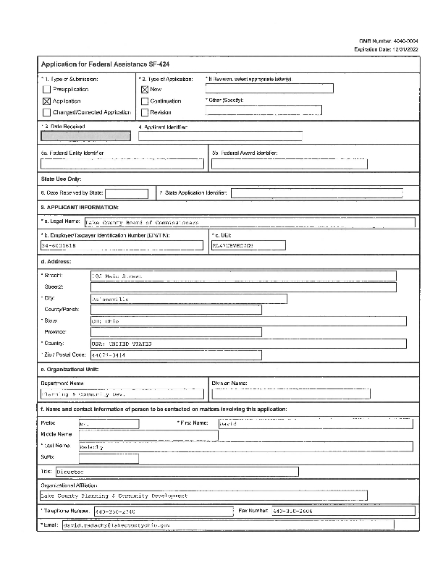
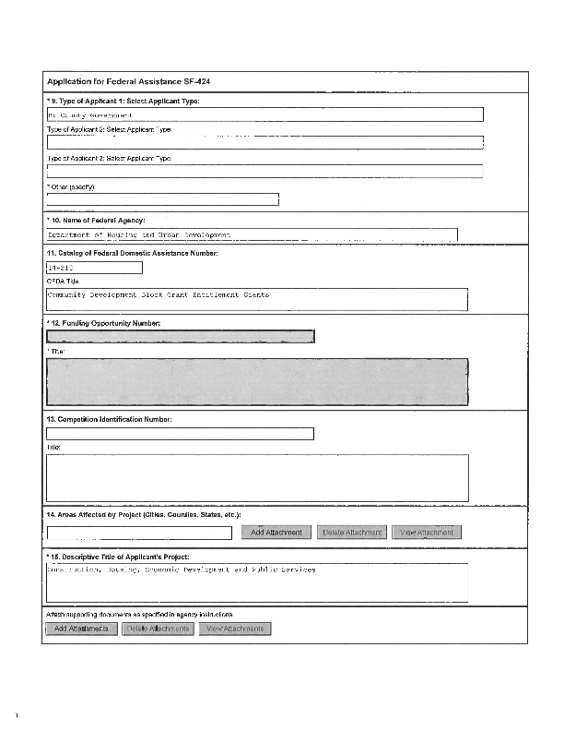
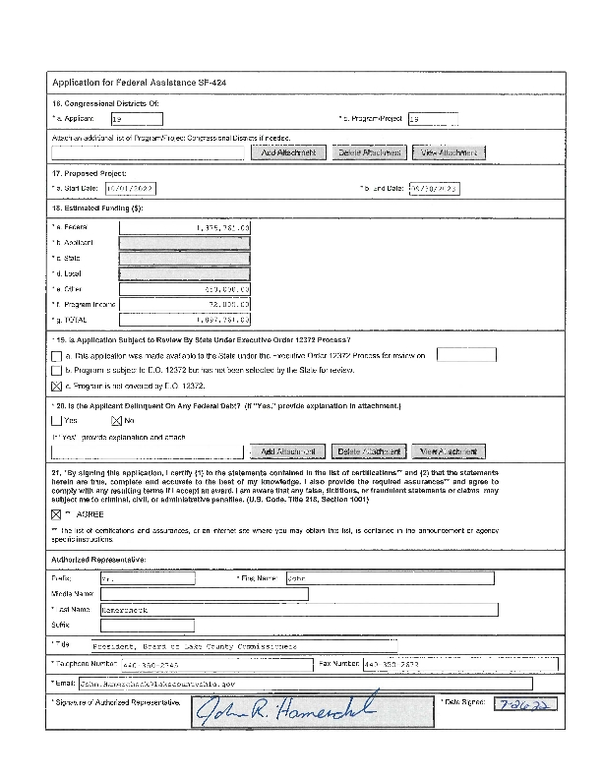
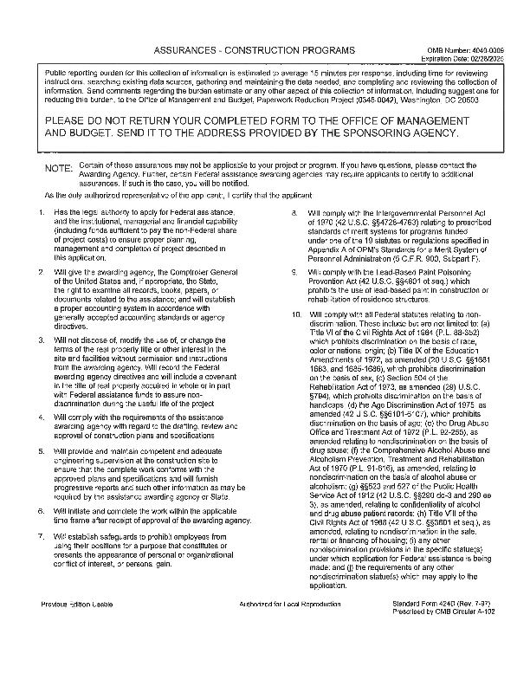
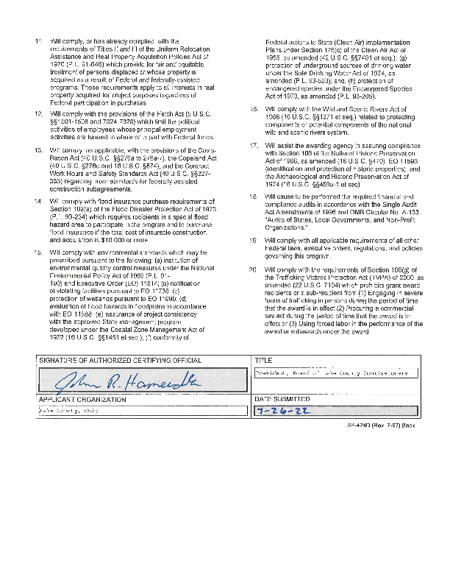
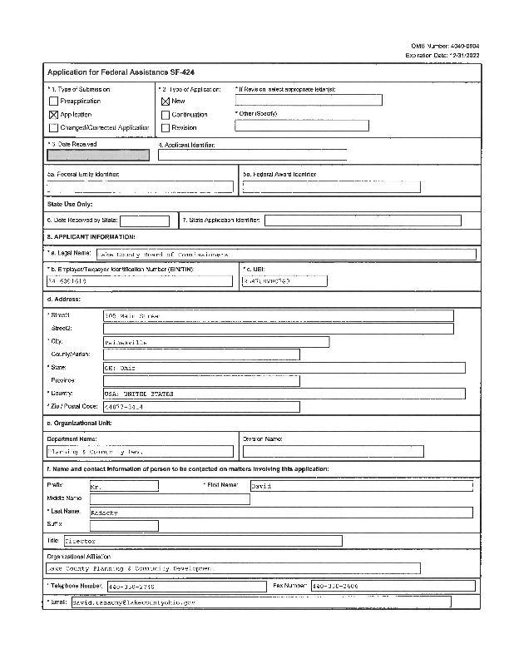
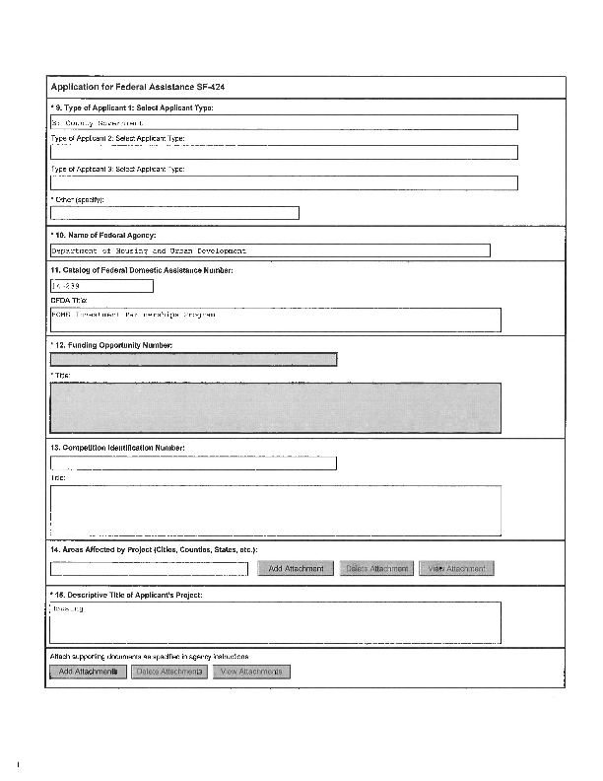
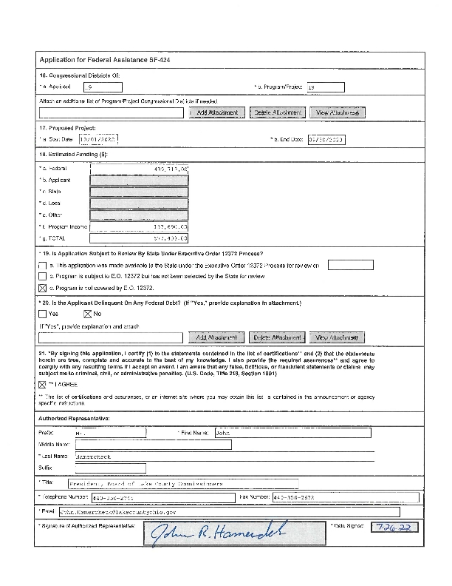
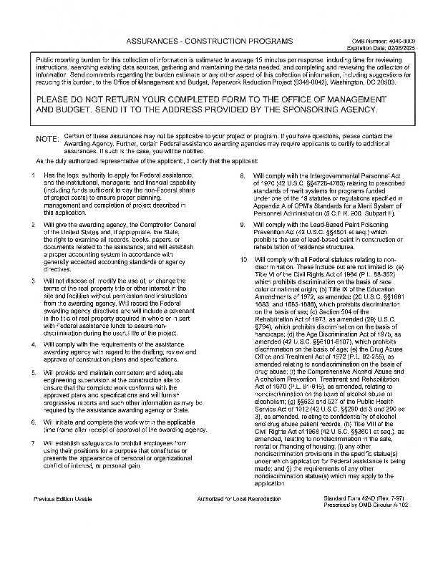
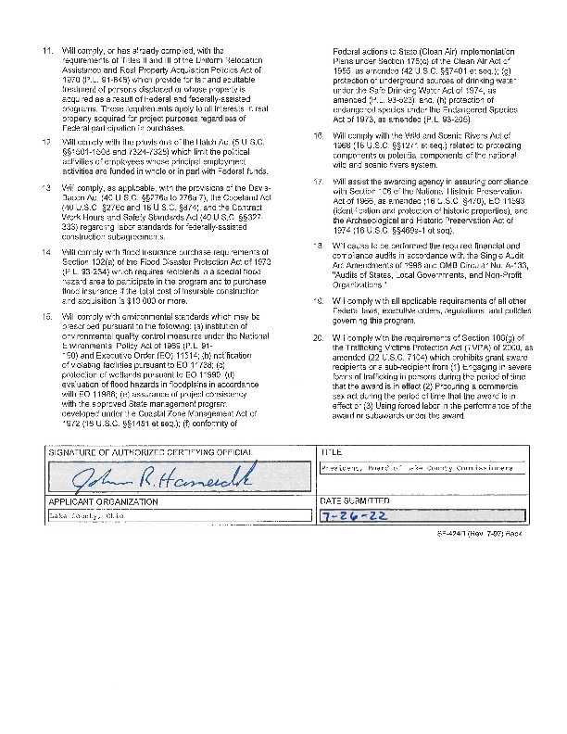
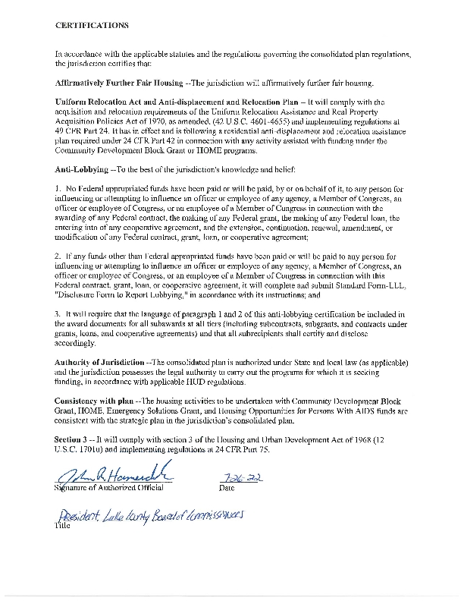
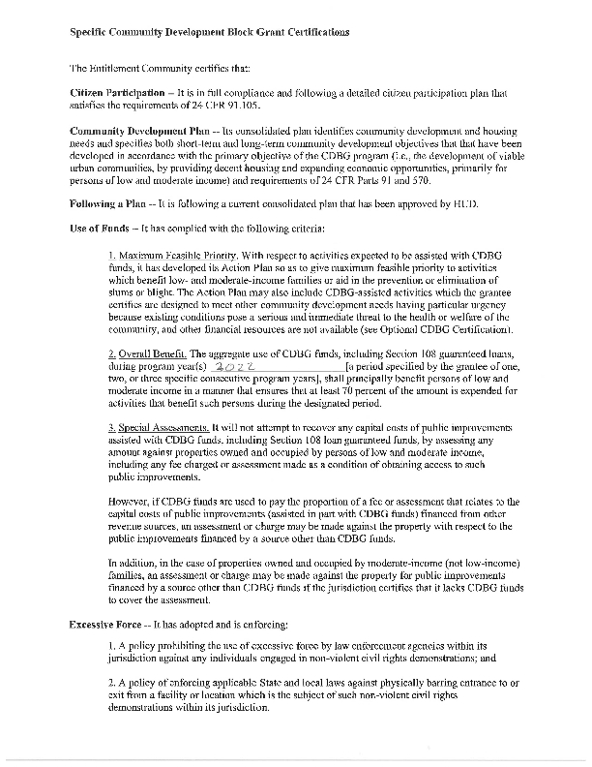
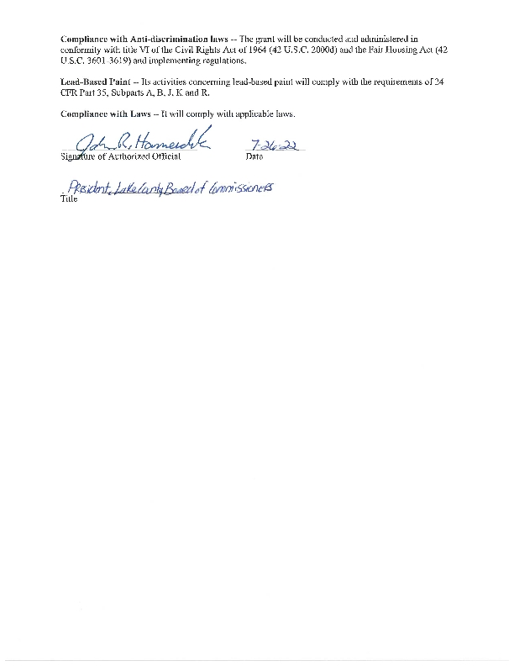
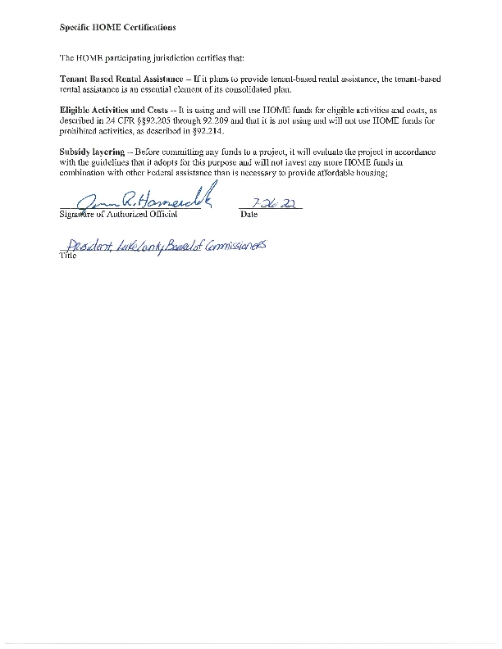
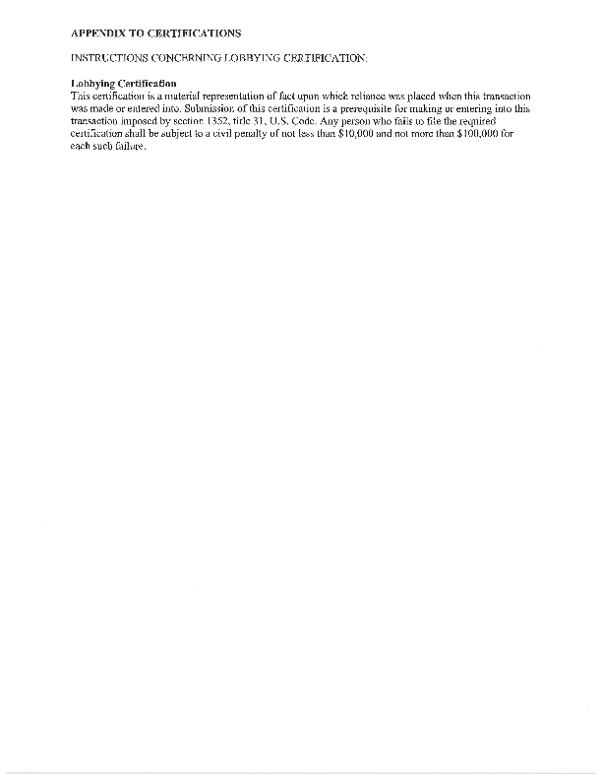

Appendix - Alternate/Local Data Sources

