Area #5/Lake County Local Workforce Development Plan

Lake County, Ohio: Who are we? We are the north coast neighbors to Cuyahoga County, home of the 20th President of the United States James A. Garfield, home of the Major League Baseball affiliate Lake County Captains, and birthplace of legendary Ohio State Football coach Jim Tressel. Lake County has a diverse population and economy, with a variety of historic, recreational, and cultural offerings that provide for a high quality of work and life. But, we are much more than twenty-three communities, nine cities, nine villages and five townships. We represent….“The Gateway to Lake County”, “Great Living on a Great Lake”, “Where the City Meets the Country”, “Together We Take Pride”, “The City of Choice”, and “A City of Faith & Beauty”. These tag lines used by some of our cities and villages, symbolizes our identity, says something about the people that live here along with their values and what they view as important. We might be small, but we are mighty!

Lake County is geographically the smallest of the 88 counties in Ohio but ranks 11th in population. Located on the Lake Erie Coast, about twenty miles east of Cleveland, Lake County is situated near Interstate 90 and State Route 2. The Grand River and the Chagrin River dissect the County and provide the area with many economic and recreational activities in the area. The plentiful Lake Erie water source supplies public, domestic and industrial uses.

Currently, the leading industrial products are medical and metal products, musical and scientific instruments, chemicals, plastics, packaging and labeling. Lake County’s employers are diverse and represent a variety of industries:

- Lake Health (now part of University Hospitals) is Lake County’s largest employer and has been an integral part of our community for over one hundred years. Lake Health/University Hospitals is a private, non-profit leader in community healthcare in Northeast Ohio and has nine healthcare facilities throughout Lake and Geauga County. The network includes 600 physicians, 2,900 healthcare professionals and boasts 1,000 volunteers.

- Steris Corporation is a global leader in infection prevention, decontamination, and surgical products and services. Their World Headquarters is located in Mentor, where they focus primarily on healthcare, pharmaceutical and research markets. Steris operates at four locations in Lake County. They employ approximately 1,043 individuals in Lake County.

- Avery Dennison, is a giant in the packaging industry as a leader on the cutting edge of the labeling business. In 2016, they struck a deal with the “Facebook for things” firm, named “Evrythng”, to create unique web identities for at least ten billion pieces of apparel over the next three years on brands such as Nike, Adidas, and Hugo Boss. They have a total of six facilities in Lake County, employing approximately 1,454 people.

- Lubrizol Corporation, a wholly-owned subsidiary of Berkshire Hathaway is an innovative, technology-driven global company that employs about 1,300 people from their local base of operations in Lake County. They are a leader in Lake County and in our Region as an International producer and distributor in specialty chemicals in global transportation business and industrial and consumer markets.

- Lincoln Electric employs approximately 3,000 individuals. They are the world leader in the design, development and the manufacturing of arc welding products, robotic arc-welding systems, plasma and oxyfuel cutting equipment and have a leading global position in the brazing and soldering alloys market.

In addition to our largest employers, Lake County’s economy is driven by several industry clusters including: Manufacturing, Agriculture and Energy. These industry clusters play a crucial role in the maintenance and expansion of our communities.
- Manufacturing plays a huge role in Lake County’s employment and overall quality of life. In 2020, there were 22,000 people employed in manufacturing in Lake County. A 5% increase from 2015 and is expected to grow by 2% by 2025. Statewide, manufacturing was 17% of Ohio’s GDP, the largest sector in the state. In addition to adding the most jobs, Manufacturing also has the highest location quotient (LQ). Industry LQ provides a measure of how “concentrated” an industry is in a region compared to the nation, with a measure of 1.00 indicating the same concentration as the nation. In this analysis, LQs greater than 1.25 are considered to be the threshold for identifying an industry as relatively strong for the county’s economic base. The only other sector that meets that threshold in Lake County is Utilities (2.62).
Organizations like Alliance for Working Together (AWT) and Chamber of Commerce organizations play an active role in promoting rewarding careers in manufacturing. They are changing the face of manufacturing by introducing grade school students to careers in manufacturing, providing apprenticeship programs to high school students starting in the ninth grade and through their much-publicized robotics competitions. These endeavors promote partnerships between students and businesses in manufacturing industries. The AWT foundation realizes that there is a critical shortage of skilled workers to satisfy growing demand. As a result, the AWT has partnered with Lakeland Community College to develop Associate of Applied Science degree in Manufacturing. AWT also promotes training programs in manufacturing/machine trades at Auburn Career Center, Cleveland Industrial Training Center, and Precision Machining Institute. These Programs are identified on the States’ Eligible Training Provider List. In 2020, OhioMeansJobs Lake County partnered with AWT to launch the first apprenticeship in Lake County funded through the Workforce Innovation and Opportunity (WIOA) Act.
- Lake County’s agricultural economy is buoyed by horticulture and viticulture (the wine and grape industry). These industries produce sales from goods and services valued at over $160 million annually and supports an estimated 1,500 job and a payroll of approximately $30 million annually. Viticulture is making a significant and growing contribution to the Lake County economy with an estimated output of $15 million annually. Lake Counties Nursery industry is ranked #1 in the state of Ohio. It is estimated that over one-half million people annually visit the regions wineries as a destination location.
- The Perry Nuclear Power Plant is the largest single unit in the FirstEnergy generating fleet and one of the largest plants of its type in the United States and provides about 720 high quality jobs. The skill level of these jobs led to the creation of the Nuclear Engineering Technology Program at Lakeland Community College. In addition, Auburn Career Center, Lakeland Community College and Willoughby –Eastlake Schools offer a variety of Training Programs in Welding. These programs are identified on the States’ Eligible Training Provider List. As of 2020, utilities provide 926 jobs with an average annual wage of $188,000, the largest average wage in Lake County.
The Perry plant produces enough electricity to power more than 1 million homes daily. It is also one of the largest taxpayers in Lake County, paying more than $14 million annually to support local schools and vital services. Employees at Perry contribute their time to the community through organizations such as the Perry Plant Community Action Group, which raises thousands of dollars and devotes countless hours each year to charitable causes.

The Lake County Workforce Development Board’s mission is to understand the employment skills needed by our businesses for their job openings to both efficiently match job seekers with jobs and provide job training programs for in-demand industries. We focus training individuals who are unemployed, under-employed, under-skilled, or in need of assistance to move into jobs with family-sustaining wages.

LOCAL WORKFORCE DEVELOPMENT BOARD & STRUCTURE

Workforce Innovation and Opportunity Act (WIOA):

Congress passed WIOA with broad, bi-partisan support to replace the Workforce Investment Act (WIA). Most of WIOA’s provisions for the nation’s employment and training system became effective on July 1, 2015. WIOA continues a federal-state-local structure for workforce programs that provides flexibility to the Chief Local Elected Officials (CLEOs) and to the required local Workforce Development Boards that they appoint. WIOA requires the development of Local, Regional and State Workforce Development Plans.

For Lake County, the structure is:

Lake County WDB WIOA Structure

U.S. DEPT. OF LABOR
YOUTH SERVICES

OhioMeansJobs|
Lake County
Lake County Board of County Commissioners
STATE OF OHIO ODJFS
Fiscal/Administrative Agent
Chief Elected Officials

Lake County Department of Job & Family Services
Workforce
Development Board

Executive Director

PARTNERS
SERVICE PROVIDERS
Auburn Career Center
Goodwill Industries
Lake Co. Small Business Corp.
Lakeland Community College
Lake Metro. Housing Authority
Lifeline
Vantage Services
Ohio Department of JFS
O.O.D.
TANF
Catholic Charities
OhioGuidestone
United Labor Agency
Harbor

One-Stop Operator for WIOA – Lake County Department of Job & Family Services

The key elements of WIOA’s workforce development system are:

- Provide Universal Access to those who seeks employment and training services through a local One-Stop Career Center (OhioMeansJobs Lake County). WIOA requires that ten other workforce programs be Integrated and Located at the Center so that jobseekers can get what they need in “one stop.”
- The ten partner programs must each execute a Memorandum of Understanding (MOU) with OhioMeansJobs Lake County annually to describe the commitment being made to the one-stop center operations. MOU attached.
- Services must be demand driven in order to match training investments to the skills needed by employers for current and projected jobs. WIOA emphasizes the development of sector strategies and career pathways with employers.
- Results must be Outcomes Based across a Common Set of Performance Measures. Specific local performance metrics are negotiated with the state based on the local priorities and strategies. Performance Measures are attached.
- Priority of Services for all programs to veterans; priority of services for the adult program are to low-income, public assistance recipients and those with basic skills deficiencies.

Lake County Workforce Development Board (LCWDB)

The Lake County Workforce Development Board (LCWDB) is a twenty-three (23) member board appointed by The Lake County Commissioners, with the majority representing private businesses and the balance representing higher education, economic development, organized labor and other workforce related programs and partners. The Governor designated Lake County to continue as Local Workforce Area #5, one of the twenty Ohio Workforce Boards under WIOA. LCWDB is also one of the five distinct Workforce Development Boards (WDBs) in the new Northeast Ohio Workforce (NOW) Planning Region made up of Cuyahoga, Lorain, Lake, Geauga, Ashtabula, Portage, Summit and Medina counties. Lake County’s Local Workforce Development Plan is a supplement to the NOW Regional Workforce Development Plan.

The Lake County Workforce Development Board (LCWDB) has established itself as one of Ohio’s Workforce Development leaders. Under the Board’s direction, Area #5 has regularly led the state or been at the top of the statutory Common Measures performance outcomes.

The Board’s development of a local Return on Investment Tool (ROI) is unparalleled in its methodology of measuring the taxpayer’s ROI in payback months. Ongoing operational goals are set and monitored on the Lake County Balanced Scorecard which has been recognized as an industry best practice.

The Lake County Workforce Development Board is committed to the following guiding principles:

- Generate a jobs-driven system based on business retention and expansion.
- Create an economy that works for all people willing and able to work.
- Make Lake County a premier place to live, work, and play.
- Continuously strive to strengthen both our public and private sector partnerships.
- Strive to provide excellent customer service and to be proactive to effectively meet the changing needs and expectations of our employers and job seekers.
- Remember that our local employers, big and small, are the lifeblood of our economy.
- Continue to implement strategies and approaches that are data driven and recognized best practices.
- Commit to offering training services for in-demand occupations with the belief that our investment of time and money in human capital most always provides a significant return.
- Believe that everyone deserves the dignity that comes from employment and self-sufficiency.

The LCWDB created an operating structure to assist in accomplishing its goals which includes the creation of five Standing Committees. The committees are: Executive Committee; Planning & Programs Committee; Youth Committee; One-Stop Committee, and Marketing Committee. Board members through these committees, have been engaged in the development of this plan. Our dedicated Board members come from a vast representation of disciplines and industries get things done and they are actively and regularly engaged. The list of Board members and their representation is attached.

OhioMeansJobs Lake County (OMJ|LC)

The LCWDB provides oversight to the Ohiomeansjobs center located at 177 Main Street in Painesville, Ohio. Satellite services are offered at library branches throughout Lake County to expand services.

The “One-Stop Operator” of the Ohiomeansjobs center is the Lake County Department of Job and Family Services (LCDJFS). LCDJFS is a quadruple-combined agency which provides Income Maintenance Programs, Medicaid/ Food stamps, Child Support, Child and Adult Protective Services and Employment and Training Services. Partners and their staff located in and around the “one stop” expand and improve the quality of services making this a true “one-stop” system.

The Planning Process

- The five Workforce Development Board Directors representing the eight counties in northeast Ohio (Cuyahoga, Lorain, Lake, Summit, Medina, Geauga, Portage and Ashtabula) began working together in the fall of 2015 on an approach to conduct the regional planning process. Regional planning funds were provided by the Ohio Department of Job and Family Services to the Cuyahoga County Workforce Development Board (CCWDB); a Planning RFP was issued, and a consultant team was selected and began work on the Regional Plan. All five Workforce Boards are represented on a Northeast Ohio Workforce (NOW) Steering Committee which met and worked with the consulting team on a regular basis.
- In addition, input was solicited from: Local Elected Officials; all five WDBs and Committee members; four community colleges; various economic development entities; a number of businesses and business intermediaries and associations; workforce employment and training providers; OMJ staff; and, other leaders in education, philanthropy, research institutions, etc.
- The planning team conducted and extensive analysis of the regional economy and labor market which is incorporated into the Regional Workforce Plan.
- The WIOA Youth Program is now part of The Comprehensive Case Management and Employment Program CCMEP as mandated by the state of Ohio. CCMEP is driven by its own plan. The data and information obtained from the CCMEP planning process is an integral part of local workforce initiatives.
- Action strategies were developed for the Regional and Local plans based on the data analyses and all the input received through the planning process and supportive of the State Workforce Plan.
- The Draft Plans will be published for public comment and once those are received and incorporated, the Final Plans will be submitted to the Ohio Department of Job and Family Services by May 28th, 2021. Once approved, they set the workforce agenda for the next four years to 2025.

Workforce Resources

Included in this report is a review of the labor market of Northeast Ohio. Workforce development strategies must be responsive to the needs of businesses for jobs and skills in demand as well as an understanding of the supply-side. These notes summarize Workforce Demand and Workforce Supply highlights from the following sources:

CHARACTERISTICS OF LAKE COUNTY’S WORKFORCE

Workforce Demand:

- 53% of jobs in the eight county region are located in Cuyahoga County while 20% are located in Summit County.
- The identified commuting patterns helps us to understand our workforce relationship with other counties.
  - The Lake County workforce of 125,900 people. A total of 119,900 are currently employed. Approximately 37,515 workers commute to Lake County from other counties for employment. 41,635 live here and work here, while 56,850 live here and work outside of the county.
  - The City of Mentor has the largest number of employed workers working within the city, with 35,000 people going to work within city limits every day. Followed by the City of Willoughby with 23,945 people working within their city limits every day.
- Lake Health/University Hospital Systems, Inc. and Lake County Government are the #1 and #2 employers in Lake County based on number of employees followed by Lubrizol Corporation and Steris Corporation.
- About 91% of businesses in Lake County are small businesses with 49 or fewer employees; only 4 employers have more than 1000 employees.

The following charts provide a more in-depth look of the Lake County Workforce:

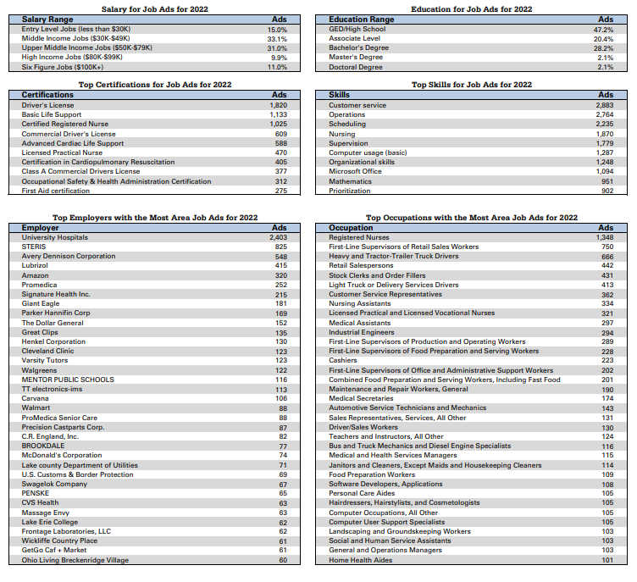

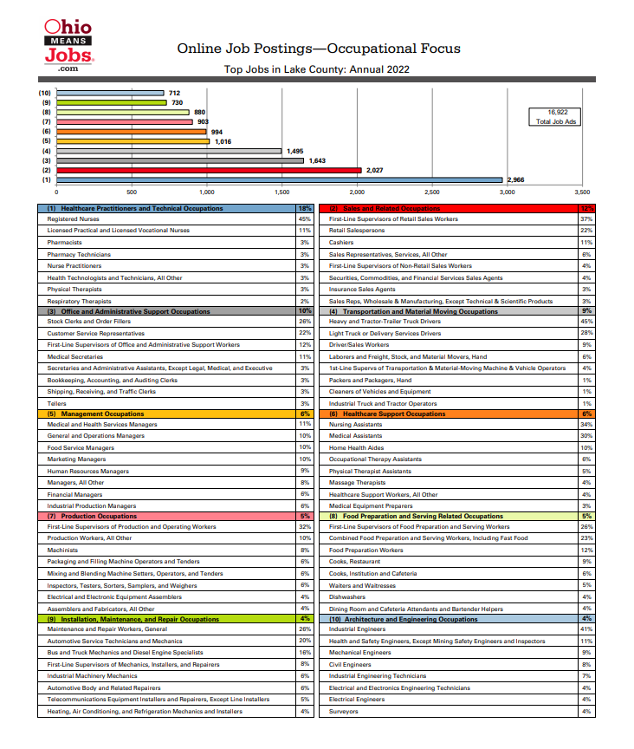
Source: Ohio Department of Job and Family Services, Labor Market Information Division

REGIONAL DATA
Team NEO initiated a “deep dive” analysis of this issue in northeast Ohio ad published its 6th annual edition of its work on “Aligning Opportunities in Northeast Ohio, 2022 Report.” This report provides excellent documentation regarding the skills in-demand and the credentials being produced. This work focuses on the three key industries in this region which are: Healthcare, Manufacturing, and IT. (Team NEO’s 2022 Annual P&I Report (northeastohioregion.com). Some of the key findings are:
- The region is not producing enough high-skilled workers.
  - By 2025, 65% of workers will need a 2- or 4-year degree to qualify for the available jobs. Currently, 38% of the population have a 2- or 4-year degree, and 21% have some college/training but no degree.
  - The workforce in the region does not possess the skills that employers are seeking to fill their jobs in sufficient numbers. In 2021, the number of unfilled entry level jobs in these key industries was: Manufacturing: 10,191; Healthcare: 18,259; and IT: 5,902. This totals over 34,000 entry-level jobs going unfilled in these three industries.
  - African American, Hispanic and other minority groups have lower levels of educational attainment, higher unemployment rates, and are more likely to work in lower wage occupations.

Soft/Essential/Work Readiness/Baseline/Foundational Skills:

- These skills are most needed in occupations that involve higher levels of personal interaction relative to technical activities. Customer Service Support, Clerical and Administrative, Human Resources, Hospitality, Sales, and Management are all areas where employers place an emphasis on these skills. LightCast (a proprietary LMI tool) has conceptualized the broad range of these skills into six clusters: customer service, presentation & persuasion, detail oriented, supervision, positive disposition, and project management, research & strategy.

Workforce Supply:

- We continue to experience a relatively low unemployment rate in Lake County. According to the Ohio Office of Workforce Development - Bureau of Labor Market Information, Lake County has an unemployment rate of 3.3 % as of December 2022, which is around the state average of 3.9%.
- The labor force in Lake County is approximately, 125,900. With 6,000 being unemployed.
- We have a 5.9% poverty rate in Lake County, approximately 13,581 people.
- An estimated 17,340 Individuals receive assistance through The Supplemental Nutrition Assistance Program (SNAP) designed to expand buying power and safe guard the health and well-being of low-income individuals.
- Collectively, 95.2% of our population has a GED or higher.

Jobseekers have other barriers to employment:

- In neighboring Cuyahoga County, and estimated 3,700 Ex-offenders are returning citizens to the community per year. This is the highest in the state.
- Lake County has an estimated 20 ex-offenders per month returning to the community.
- In Lake County there are 221 Adults receiving TANF, 16 have a disability noted in Ohio Benefits.
- We have 10,138 adults on SNAP, 4,350 are over 60 or have a disability noted in Ohio Benefits.
- Transportation to jobs can be a barrier for those working nontraditional hours or for those who are not on a bus line or employers who are not on a bus line. Some jobseekers are unable to pass a drug test as part of the hiring process.

Hurdles to improving skills:

- Weak literacy, numeracy and academic skills leave some in need of remediation to increase reading, math, etc. before they can start job training/skill upgrading courses.
- Lack of information about labor market, colleges, career technical training courses and, therefore, good jobs and career paths.
- Enrollments/completions of post-secondary courses in fields with little labor market value or low demand for workers. Students expect to transfer a Liberal Arts associate degree to a four-year school, but most don't follow through.
- High School Diploma or Equivalency is not easily accessible. GED has become more challenging academically, more expensive to take, and only accessible on the internet.
- Support services like childcare are not widely available.
- Many low-skilled workers are working and cannot stop working to take training.
- Not enough "Learn and Earn" opportunities like apprenticeships, internships, co-ops, work experience opportunities, etc.

Lake County Population

Table 1: Population by Age, 2020
 | 2020 Population | 2020 % of Cohort | Change  (2015-2020) |  | Projected Change  (2020-2025)
Under 5 years | 11,556 | 5.0% | (32) | (0.3%) | 1,502 | 13.0%
5 to 19 years | 38,548 | 16.8% | (2,654) | (6.4%) | (2,074) | (5.4%)
20 to 34 years | 40,788 | 17.7% | 1,335 | 3.4% | (609) | (1.5%)
35 to 54 years | 55,427 | 24.1% | (4,622) | (7.7%) | (1,352) | (2.4%)
55 to 64 years | 35,200 | 15.3% | (24) | (0.1%) | (4,228) | (12.0%)
65+ years | 48,668 | 21.1% | 6,347 | 15.0% | 6,967 | 14.3%
Total | 230,187 | 100.0% | 349 | 0.2% | 206 | 0.1%

Table 2: Population by Race/Ethnicity
Race/Ethnicity | 2020 Population | 2020 % of Cohort | 2015-2020 % Change | 2020-2025 % Change
White | 200,666 | 87.18% | (2.1%) | (1.5%)
Hispanic | 11,128 | 4.83% | 18.6% | 11.9%
Black | 10,860 | 4.72% | 26.8% | 14.3%
Two or More Races | 3,727 | 1.62% | 11.5% | 7.3%
Asian | 3,481 | 1.51% | 7.0% | 3.4%
American Indian or Alaskan Native | 281 | 0.12% | 17.2% | 6.7%
Native Hawaiian or Pacific Islander | 43 | 0.02% | 2.3% | 7.2%

Table 3: Poverty Rate & Median Household Income 2020
 | Poverty Rate | Median Household Income
Lake County, OH | 5.9% | $65,814
Ashtabula County, OH | 15.3% | $47,925
Cuyahoga County, OH | 15.9% | $51,741
Geauga County, OH | 6.3% | $83,730
Ohio | 13.4% | $58,116
United States | 12.8% | $64,994

Table 4: Educational Attainment for the Population 25 Years and Over, 2020
Education Level | 2020  County Pop. 25 and Over | 2020 % of County Pop. 25 and Over | 2020 % of  OH Pop. 25 and Over | 2020 % of U.S. Pop. 25 and Over
Less Than 9th Grade | 2,637 | 1.6% | 2.7% | 4.8%
9th Grade to 12th Grade | 5,466 | 3.2% | 5.5% | 5.9%
High School Diploma | 53,943 | 31.9% | 32.8% | 26.3%
Some College | 36,382 | 21.5% | 19.2% | 19.3%
Associate’s Degree | 17,506 | 10.4% | 9.0% | 8.8%
Bachelor’s Degree | 34,054 | 20.2% | 18.9% | 21.2%
Graduate Degree & Higher | 19,010 | 11.2% | 11.8% | 13.8%

Source: U.S. Census, 2020 American Community Survey

Four-Year Action Strategies

The goals and reform principle strategies identified in the Combined State Plan are supported by Regional Plans. In conjunction with the State and Regional Plans, by utilizing effective “One-Stop” operations and following the Workforce Development Board’s guiding principles, locally we will strive to accomplish the following:

- Assist more individuals to join the workforce;
  - Expand outreach efforts to identify potential consumers to our services.
  - Require all job seekers to register and to utilize the ohiomeansjobs.com system.
  - Operate an effective CCMEP enabling approximately 100 young adults (age 16-24) on TANF to move into jobs with continued support and training and provide career services to approximately 50 WIOA young adults, annually.
  - Facilitate an effective WorksFirst Program for TANF adults over age 25 to move into jobs with continued coaching support, and training when appropriate.
  - Continue to place between 150-200 Adults and Dislocated Workers into jobs annually.
  - Provide Priority of Service to valuable, talented Veterans as a “ready workforce”.

- Assist low-skilled workers to improve their skills to meet workforce demands in the labor marketplace;
  - Encourage and assist school-aged youth to remain through graduation.
  - Promote the use of ABLE Services to help reduce the number of residents without a high school diploma/GED.
  - Perform statewide common assessment strategies to identify literacy and numeracy deficiencies and other barriers that deter employment.
  - Provide and promote case management programs that offer assistance in mitigating barriers to those that have the potential of entering the workforce and retaining employment.
  - Promote paid and unpaid work experience opportunities.
  - Fund soft skills and skills training when appropriate for in-demand occupations

- Assist workers to improve their skills to meet employer demand for talent and to earn better wages;
  - Provide labor market data so consumers can understand workforce needs and have confidence in their career decisions.
  - Ensure career counseling opportunities for individuals accessing workforce programs.
  - Promote “learn and earn” opportunities, including apprenticeships, try-out employment, on-the-job and incumbent worker training with businesses.
  - Embed job readiness and soft-skills preparation in all workforce training programs.
  - Provide programs that allow co-enrollment between programs and services.
  - Identify and develop career pathways and promote awareness of good “middle-skills” jobs and careers for in-demand industries.
  - Pursue the acquisition of non-traditional sources to fund new and innovative program offerings.
  - Assist dislocated workers with timely and effective re-employment services to limit the duration of their unemployment.

- Work with employers to develop and implement employer specific on-the-job training, customized training and incumbent worker training opportunities;
  - Work with industry groups and clusters to define and promote careers.
  - Operate a high performing demand facing business services unit to assist employers with talent needs.
  - Identify, develop and initiate career pathways opportunities
  - Collaborate with economic development entities to identify avenues to new and expanding employer needs.
  - Provide skills training for in-demand occupations for new job seekers and upskilling employees.
  - Promote the use of ohiomeansjobs.com to employers as a resource for finding candidates and posting job openings.

The Lake County Workforce Development Board (LCWDB) will implement the action strategies identified below within the next four years to work toward the following workforce goals:

- A workforce with the skills that are needed for business growth.
- Career Pathways to prepare under-skilled and low-income workers for family-sustaining wage jobs.
- A coordinated local workforce system.

Additionally, LCWDB will ensure compliance with all requirements of WIOA, will oversee the operations and performance of programs provided through the OMJ|LC centers and other contractors and operators, and will provide local leadership on workforce issues. There are five categories of Action Strategies:
- Regional Action Strategies developed in the NOW Regional Plan.
- Lake County Workforce Development Board Strategies.
- Business Strategies.
- Strategies for Adults, including Dislocated Workers.
- Youth Strategies.

