Go to Clerk of Courts web page https://www.lakecountyohio.gov/coc/
• Click on Court Record Search
• Scroll to the bottom of the page and click on I agree
• You may search by name or case number (making sure all numbers are included)
• Sample 18CF001009

Step 1

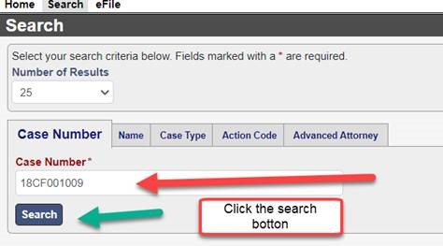

Step 2

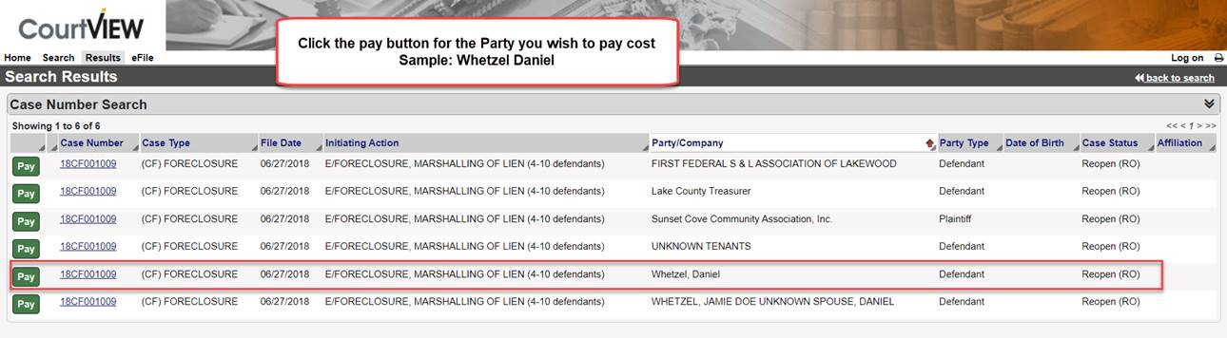

Step 3

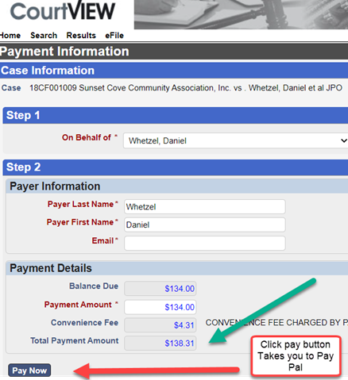

NOTE: Unless your case is closed, costs could still be assessed. Please note that the amount you see listed may NOT be the final costs owed. It is recommended that you wait until your case has been closed before making payment.

